CHEMICAL FACT WORKSHEET Chemical Name_______________________________________
Use the Safety Data Sheet (try Sigma Aldrich online) and help from your research advisor to fill out this form.
SDS section 2 (Hazard Identification) Signal Word: Danger ☐ Warning ☐ No Signal Word ☐
Information can also be found in SDS section 8, 11, and 16.
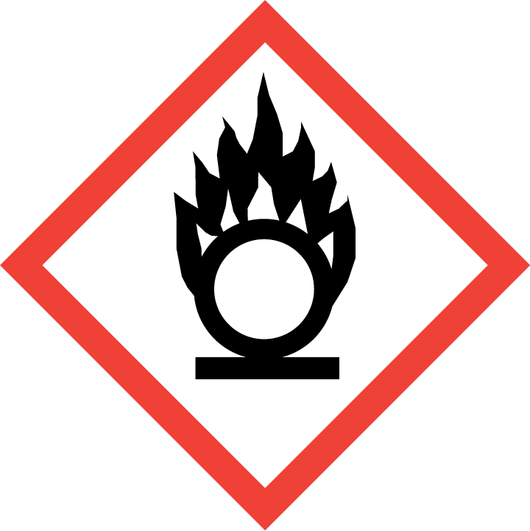
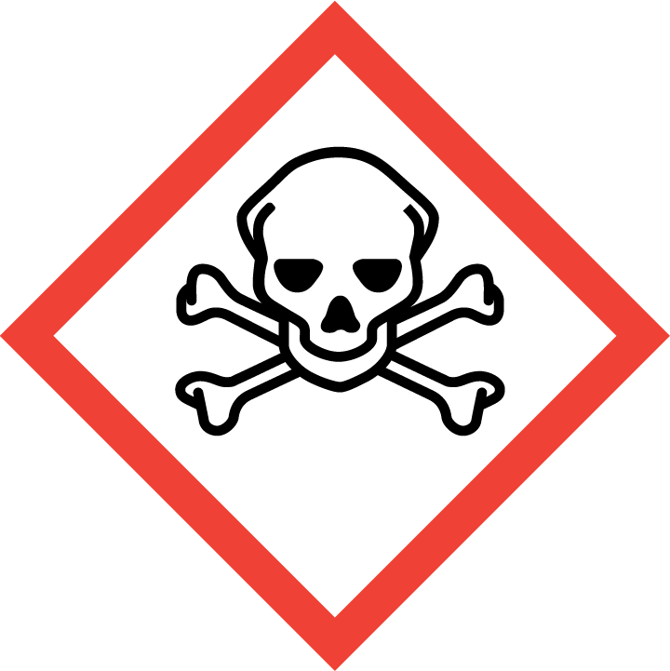
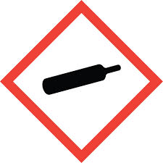
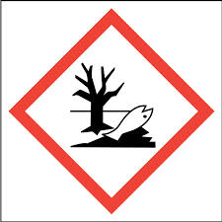
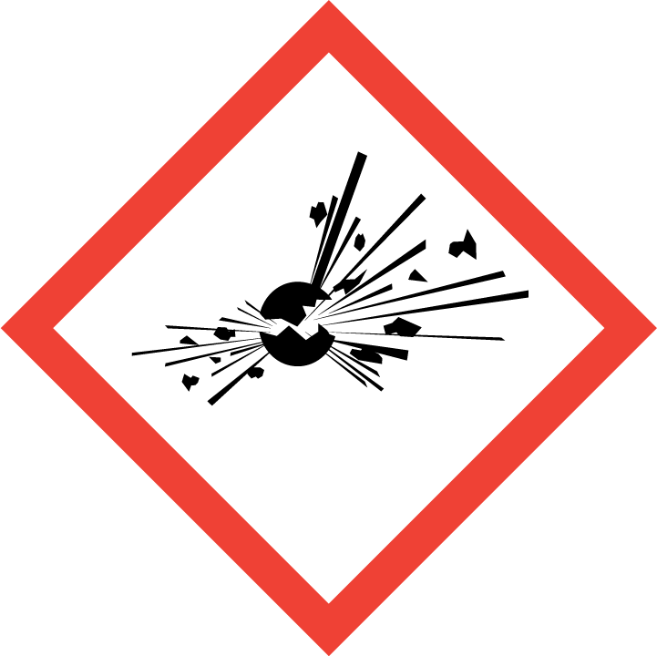
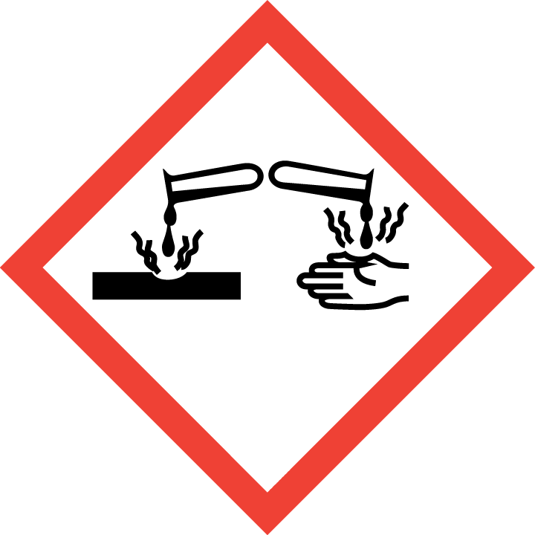
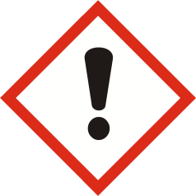
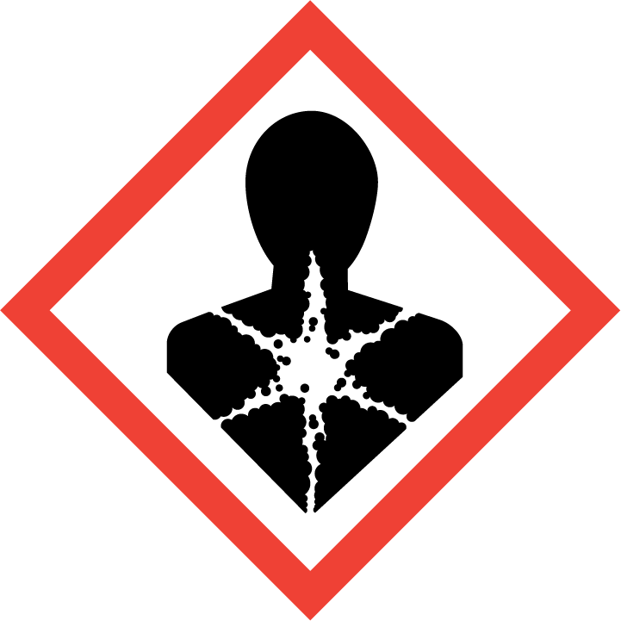
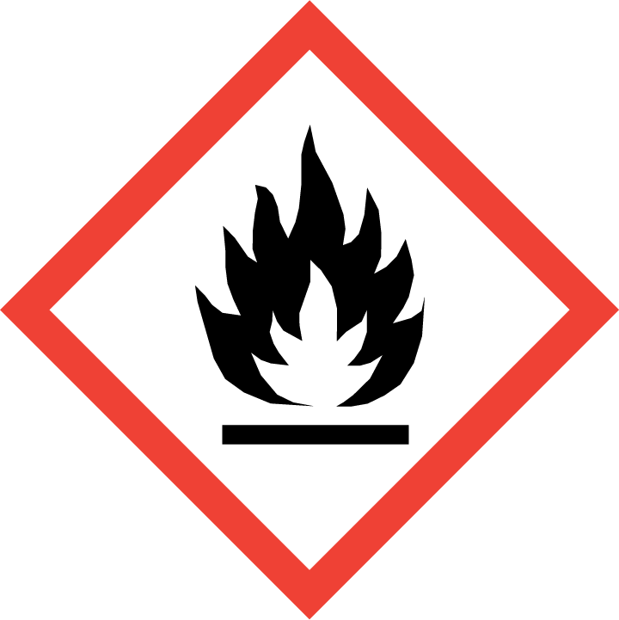
Circle all pictograms and check all hazards that apply. Toxicity ☐ Oral (mouth)☐ Dermal (skin) ☐ Inhalation (respiratory tract) ☐
- Oxidizers
- Acutely Toxic (severe)
- Gases Under Pressure
- Toxic to aquatic environment
- Explosives
- Self Reactives
- Organic Peroxides
- Burns Skin
- Damages Eyes
- Corrosive to Metals
- Acutely Toxic (harmful)
- Irritant to skin eyes or respiratory tract
- Skin sensitizer
- Hazardous to the Ozone layer
- Carcinogen
- Mutagenicity
- Respiratory Sensitizer
- Reproductive Toxicity
- Target Organ Toxicity
- Aspiration Toxicity
- Flammables
- Self Reactives
- Pyrophorics
- Self-Heating
- Emits Flammable Gas
- Organic Peroxides

SDS section 3 (Composition/Information on Ingredients) (may also be found at https://pubchem.ncbi.nlm.nih.gov/)

Synonyms:
Formula:
Molecular Weight (or SDS section 9):
CAS #
SDS section 8 (Exposure Controls/Personal Protection): Check all necessary personal protective equipment.
Safety (Impact) Glasses ☐ Splash (Lab) Goggles ☐ Nitrile Gloves ☐ Double Dipped Gloves ☐ Specialty Gloves ☐ _______________
Apron/Lab Coat ☐ Dust Mask ☐ Fume Hood ☐ Face Shield ☐ Other ☐ ___________________________
SDS section 9 (Physical and Chemical Properties) (may also be found at https://pubchem.ncbi.nlm.nih.gov/)

Phase (Solid,Liquid,Gas):
Color:
Odor:
Density:
Boiling Point:
Melting Point:
Solubility:
Flashpoint:

SDS section 10 (Stability and Reactivity) Incompatibilities: _____________________________________________

SDS section 11 (Toxicological Information) LD50 (Oral rat): LC50 (Inhalation Rat): LD50 (Dermal Rabbit):

SDS section 12 (Ecological Information) LC50 (fish):

How will you store this chemical. Check all that apply. May not be found in SDS; consult with your research advisor.
Flammable or Organics Cabinet ☐ Acid Cabinet ☐ Base Cabinet ☐ Refrigerator ☐ Freezer ☐
Darkened Space ☐ Under Nitrogen ☐ Cupboard ☐ Room Temp ☐ Other ☐ ________________
Container Type → Glass ☐ Plastic ☐ Clear ☐ Dark ☐ Other ☐ ________________
What will you do with your chemical waste? Check all that apply. May not be found in SDS.
Sink Disposal ☐ Trash Disposal ☐ Neutralize ☐ Properly Label and Contact SIT for pickup ☐
Container Type → Solid waste container ☐ Liquid Waste Container ☐ Glass ☐ Plastic ☐ Other ☐ ________________
What will you personally do if you spill this chemical? Please describe your procedures for BOTH small and large spills
In hood:

Outside hood:

Student Name:_____________________________
Date:_____________________________________
Faculty Name:______________________________
Faculty Signature:___________________________

