River Flow for Riparian Health

By

Robert S. Cole

Abstract
For more than eighty years the Skokomish Nation on Hood Canal in Washington State has been in dispute about the diversion of the North Fork of the Skokomish River for a hydroelectric project. The diversion of the North Fork’s flow left no water downstream, which negatively impacted the salmon population that the Skokomish had traditionally fished. The attempts to relicense the two dams on the North Fork resulted in a protracted legal struggle that is still ongoing. However, Tacoma Power (owner of the dams) agreed in March of 2008 to release a fraction of the water that they had been diverting, and agreed to release this water in a constant flow. The manner in which water is released from a dam on a river has a huge impact on the downstream health of the riparian system. This case will examine constant flow and variable flow options for release of water from dam on the North Fork of the Skokomish River. It is a case about making Tribal judgments based on scientific approaches.

Why Study Rivers?
Throughout the world people have put dams on rivers. Dams can be used to control floods, they can store water from wet to dry seasons, they can be used to generate electricity, and dams can be used to facilitate recreational activities in the lakes they produce. However the downstream effects of water released by dams can have a large negative effect on the riparian ecosystem. In many cases the water released by a dam is colder (being from the bottom of the lake) than original river water, and this has the possibility of altering the species of fish that can survive downstream. Water released downstream by dams doesn’t carry small rocks, gravels, and silts. This can result in the eradication of salmon breeding habitat, since salmon rely on small gravel as a place to deposit their eggs. The flow of water past a dam can vary by the hour if the dam is generating electricity, since electrical demand varies throughout the day. This rapid variation in flow generally causes havoc for the biological organisms downstream. Moreover, dams usually don’t permit flooding downstream, and this too is a detriment for some kinds of organisms that can thrive in the riparian habitat, and may even depend upon flood stages. Flooding also helps control some invasive plants that might otherwise take over riverside habitat (this is occurring on the Colorado River below Glen Canyon Dam). However, for humans, the flood control potential of a dam is very positive, so we have a conflict between human wants and ecosystem health.

This particular case is important because it examines river flow management in a setting that deals with the need for salmon and riparian ecosystem restoration in apparent conflict with the human needs for flood control and electricity generation. The controversy about flow management on the North Fork of the Skokomish River can be generalized to other river systems where flow management and riparian health are being increasingly an issue of concern in the twenty-first century. The science of riparian health and flow management is new, the methods are evolving, and the topics involved are sure to generate controversy.

Background
The Skokomish Reservation is at the mouth of the Skokomish River at the ‘elbow’ of Hood Canal in Washington State, near the town of Union. Two dams were built by Tacoma City Light (now Tacoma Power) in the 1920’sand 1930’s on the North Fork, and Cushman Dam Number 2 (Lower Cushman Dam in the figure below) diverted all of the water of the North Fork to its hydropower plant on Hood Canal. This total diversion of the North Fork’s water basically eliminated salmon from swimming and spawning in the river. The elimination of the North Fork’s water below the dam added to siltation problems in the lower Skokomish Valley, including the Skokomish Reservation at the mouth of the Skokomish River. The history of this diversion of the water is a classic tale of governmental agencies taking advantage of Indian tribes by not always acting in a fashion that benefitted tribal peoples. Issues of land acquisition, land usurpation, condemnation of Reservation land for power line right-of-way, effects of water diversion on the downstream Reservation all are tied up in the history of the building of dams on the North Fork of the Skokomish River. A detailed outline of these historical events is found in Appendix A.

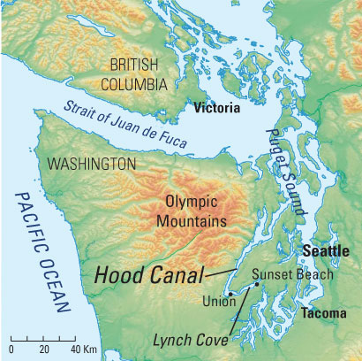
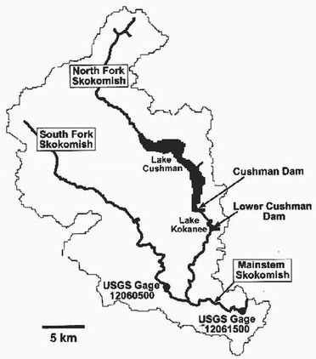

Figure 1 Location of Hood Canal
Both Maps courtesy of the United States Geological Survey, USGS

In 1974, Tacoma City Light applied to relicense the dams on the North Fork. The Federal Energy Regulatory Commission (FERC) issued a one-year license “for the continued operation of the Lake Cushman Project No. 460 subject to the terms and conditions of the original license.” This started a long and complex legal battle between Tacoma, the Skokomish Tribe dealing with some of the land acquisition issues dating back to the 1920’s, along with Tribal concerns about the elimination of salmon on the North Fork. Since 1974 the dams have been relicensed one year at a time because of the ongoing legal battles. By the 1990’s the Washington State Department of Ecology became interested in the legal aspects of relicensing the dams, and as salmon became a listed species, several federal agencies (principally the U.S. Fish and Wildlife Service (FWS), National Oceanographic and Atmospheric Administration (NOAA), entered into the legal proceedings. The legal tangle of issues here is immense, and the cases have moved back and forth between several levels of courts (see Appendix A for some of the details). As of mid-2009, the legal issues are not yet fully resolved.

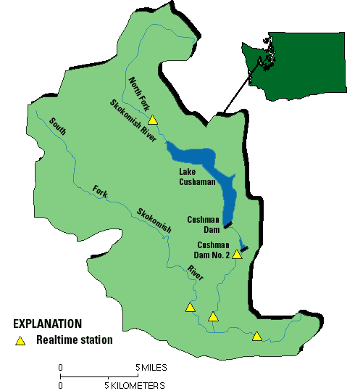
During the time of all these legal battles, the science of river flow and riparian health emerged. Scientists have found that constant flow in rivers is not healthy for the species that live in a river, or in the land alongside a river in the riparian zone. This case study will explore some of the management options of releasing water downstream from a dam that might be more beneficial to riparian health.

Early work in the 1990’s in South Africa resulted in an important understanding of the connections between river flow and the associated ecosystem health. Scientists in South Africa summarized their work in a publication (Tharme and King, 1998) outlining a “Building Block Methodology” for in-stream flow
assessments. This work was elaborated Map courtesy of the United States Geological Survey, USGS
upon by others (Baron et .al. 2002, and
Richter et. al., 2003). Rivers in Australia,
Europe and more recently in North America have begun to be managed in accordance with the ideas first articulated by South African scientists.

Two points from all of this work have emerged as central: (1) occasional flooding of a river habitat is essential to the biological health of the river system, and (2) low-flow time intervals are also essential to the health of the river system. Both the floods and the low-flow periods should occur at approximately the same season they would in natural cycles.

These two points may well be at odds with human wants. In many cases dams are seen as a means of preventing floods in high water seasons, and as a means of increasing river flow during the low-flow season by using water from the reservoir. Thus the health of the riparian system and the desires of humans may be in conflict. Scientists, water managers, and the public have engaged in fruitful negotiations over these issues, and an increasing number of rivers have water released to them from dams that helps benefit the riparian ecosystem’s health (Poff, et.al 2003, and Richter, et.al. 2006).

A very brief history of the water released by Tacoma Power from Cushman Dam Number 2 on the North Fork is as follows: The North Fork of the Skokomish River has had a dam on it since 1925 (Cushman 1), with the second dam (Cushman 2) completed in 1930. Cushman 2 is the location of the diversion of the river’s flow to the powerhouse on Hood Canal. From 1930 to 1988 Cushman 2 released no water downstream from the dam– all of the water was diverted to a hydroelectric plant on Hood Canal.

As a result of the early legal struggles, in late June of 1988, Tacoma Power agreed to start releasing 30 cubic feet per second (cfs) below the dams. That is seen in the graph below where the flow jumps from roughly 5 cfs to roughly 30 cfs. Note that the vertical scale is logarithmic.

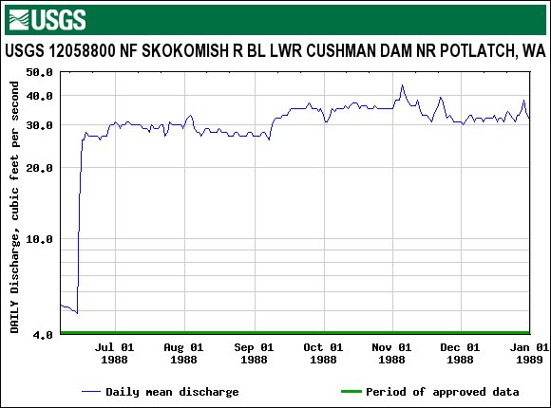

North Fork Flow in cubic feet per second (cfs) for June through December 1988

Then in 1999, as a result of the ongoing legal battle between the Skokomish Nation and Tacoma Power, the utility agreed to another increase the North Fork flow again from roughly 30 cfs to 65 cfs as the next graph shows. As a means of testing your ability to read this graph, try to describe in words what the graph shows about the flow from roughly the first of March to the first of July of 1999.

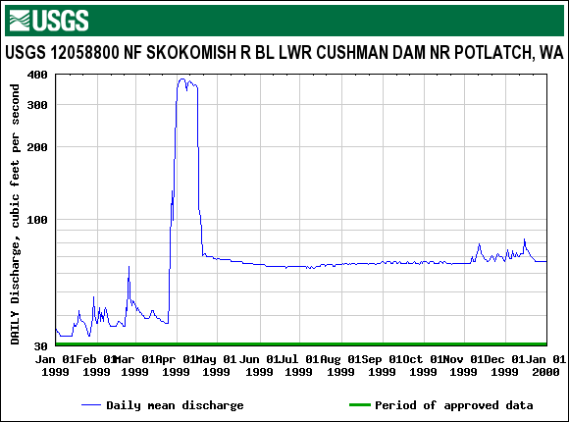

North Fork Flow in cubic feet per second (cfs) for Calendar 1999

The legal battle intensified during the early part of the 2000’s, with many governmental agencies participating in legal arguments about threatened and endangered species, and about the role of federal agencies in relicensing the dams. In March of 2008, Tacoma Power agreed to release a minimum of 240 cfs from the dam into the North Fork as mandated by a 2004 federal order from the Federal Energy Regulatory Commission (FERC) in order to protect fish listed as threatened under the U.S. Endangered Species Act. The graph below shows the flow for calendar 2008. In particular, note the increase in flow from approximately 65 cfs to roughly 240 cfs in early March of 2008.

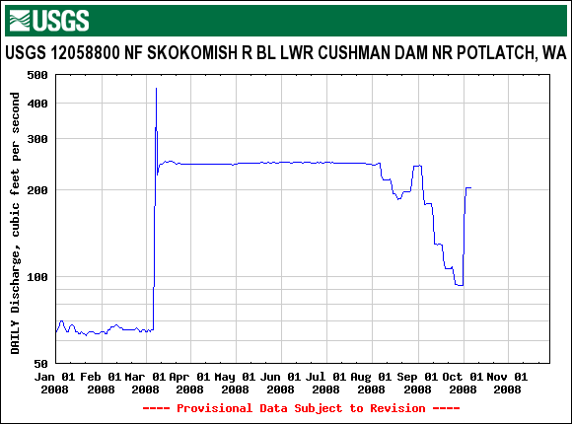

North Fork Flow in cubic feet per second (cfs) for Calendar 2008

Summarizing, the North fork flow has gone from essentially zero cfs (1930 – 1988) to roughly 30 cfs (1988 – 1999) to roughly 65 cfs (1999 – 2008) to 240 cfs (March, 2008 onward). With rare exceptions, these flows have remained constant during the listed intervals. An exception in the graph above is the period of August and September 2008, when the amount of rainfall was minimal, and Tacoma Power elected to restrict flow from Cushman Dam Number 2, presumably to maintain lake levels behind the dam.

The management issue for the North Fork of the Skokomish can be thought of in simplest terms as a choice between releasing water below the dam as a constant flow (which is what Tacoma Power is doing), or as a variable flow (which scientists say is essential for healthy riparian habitat). Constant flow (which has been the case since 1988) has a predictability for downstream landowners and ranchers, but does not build a healthy riparian ecosystem. It can be used as a means of flood control, something that downstream landowners and ranchers generally appreciate. Constant flow does not bring new gravels into the stream, with the consequence that salmon breeding grounds are degraded. This is particularly important because the dam impounds all sediments from upstream, and the downstream riverbed becomes void of sands and gravels, and consists primarily of fist-sized and larger rocks. This is not good habitat for salmon reproduction. On the other hand, if a management decision is made to release a variable flow, then downstream flows have a potentially negative effect on the landowners and ranchers because of the need to let the river flood at least once a year. Moreover, the stream managers have to determine the magnitude and frequency of variability of the flow with an eye to restoring the riparian habitat.

The status of the re-licensing of the North Fork Dam has been in litigation for over twenty-five years, and remains there in early 2009. However, assuming that this litigation will be resolved in the reasonably near future, the task of this case study is to try to determine an appropriate strategy to release water from the dam to insure better riparian health than in the past.

The Task
In groups of three, you are to assume that you are part of a consulting team that has been asked to advise the Tribal Council of the Skokomish Nation. Your task will be to determine whether the flow below Cushman Dam Number 2 should be constant, or whether it should be made variable.

First, you should make a list of all the advantages and disadvantages of constant flow, and another list of all the advantages and disadvantages of variable flow.

Second, you should try to determine what “variable flow” might mean for the North Fork. Even if you think the flow should remain constant, you need to explore what a variable flow would look like if the goal of the variable flow was to restore riparian habitat. The method for this determination, listed below, is a method used by scientists who are working with river habitat restoration below dams. This method will have you take the historic flow data from the main Skokomish River, determine appropriate levels and frequencies of flooding, and then determine appropriate levels and frequency of low-flow regimes. You will base your determinations on actual data measured daily at the Skokomish River from 1943 to 2009. Note that the data for Oct. 1, 2008 on into 2009 is listed as “provisional” by the USGS – they will publish final data after the end of the water year in 2009. At the time of this writing, the data was gathered through June 15, 2009. Obviously, more data beyond mid-June 2009 could be obtained from USGS at the time that this case is used in the classroom.

This data for the Skokomish River near Potlatch (USGS Site Number 12061500) is presented online:
(http://waterdata.usgs.gov/nwis/dvstat/?format=sites_selection_links&search_site_no=12061500&amp;referred_module=sw , accessed 6-16-09), or it is in either spreadsheet format or graph format in the Appendix. The spreadsheet is presented in “water years” which is the time interval from October 1 of one calendar year to September 30 of the next calendar year. Water years are a common way of delineating the water season (northern, temperate zone!) for most hydrologists. The spreadsheet and graphical data in the Appendix are displayed in water years. One can alter the online data to display as calendar years if one cares to.

The Method
Your instructor will give you graphs of data showing the daily flow of the Skokomish River (USGS Site Number 12061500) for different years. In your groups of three, take about six years of data to analyze – each group should take a different set of six years of data with the goal of all groups aggregating their analysis to cover the total set of data available. Each graph has three years of data plotted, so each group should have two time-sequential graphs to get six years worth of data.

For example for 1952 – 1955, the discharge curve is:

The discharge (vertical scale) in the graph above is measured in units of cubic feet per second (cfs). The vertical scale is a linear one. The horizontal scale measures time in days after the start of the water year beginning on October 1, 1952.

Firstly from the set of graphs given you, try to determine the “low-flow” years and the “high-flow” years. This requires some subjective judgment, but the determining of the “dry” and “wet” years will be important in later discussions.

Flood events Next as you look at your set of two graphs, try to distinguish the “high water” events from the “flood” events. So-called flood events don’t usually occur every year. There is no general definition of a “flood” event that can be used on all rivers, so this determination by your group will be somewhat subjective. Think in terms of a “flood” event occurring once or twice in a six year period, perhaps even three times in a six year period.

Try to set a discharge that determines the lower limit of the “flood” stage – that is at what point (lower limit) does a “flood” begin? Given your definition of flood stage, how many floods do you see in your three-year graph? How many floods in the six years depicted on your two graphs? Compare your determination of a “flood” stage with those of the other groups. Try to reach a general consensus between groups of what the lower limit of flood discharge should be.

Low water events Then repeat this process for low-flow times (generally in the late summer before the autumn rains set in). Two numbers are important to try to obtain: (1) the discharge of the low-flow period, and (2) the approximate duration in days of the annual low-flow event. Both of these numbers will have an influence on the organisms in the riparian zone that rely on low-flow for their health. Again, compare your results with those from other groups, and try to reach a consensus as to what the low-flow discharge should be, and for how many days it should occur each year.

Summary of determinations You’ve now made two major determinations of flow goals for water released by the dam, the flood stage and frequency, and the low-flow stage and duration. Scientists have found that it is important for dam-released flood stages to occur in riparian habitat, but that they need not last for as many days as a “natural” flood. This will be an important pint in actual water management of dam-released flood waters. Scientists have also found that the length of duration of the low-flow stage should be approximately as long as it would be in the “natural” flow. Summarize your determinations below:

Flood discharge (cfs)
Flood discharge length (days)
Low water discharge (cfs)
Low water discharge length (days)

Scaling these numbers to the North Fork You now need to scale the flow numbers you’ve obtained for the Main Fork of the Skokomish to the North Fork. The North Fork, in its natural state, would transmit only a fraction of the discharge flows you’ve been examining. How would you determine that fraction? Take a close look at the USGS website (accessed 06-16-09) on the next page for stream flow in Washington State to make this determination:

http://waterdata.usgs.gov/nwis/dvstat?referred_module=sw&state_cd=53&index_pmcode_00065=1&index_pmcode_00060=1&format=station_list&sort_key=site_no&group_key=NONE&sitefile_output_format=html_table&column_name=agency_cd&column_name=site_no&column_name=station_nm&list_of_search_criteria=state_cd%2Crealtime_parameter_selection
Note in particular that the inflow for the North Fork at Staircase (USGS Site Number 12056500) has a much greater flow than the North Fork at Cushman Dam (USGS Site Number 12058800), or the North Fork near Potlach (USGS Site Number 12059500) because of the water diversion for electric power generation by Cushman 2.

Use this USGS website as follows: Scroll down to USGS Site 12056500 which is the North Fork of the Skokomish at Staircase Rapids (USGS 12056500). Click on it. Then click on the box for parameter code “00060,” Discharge, cubic feet per second. Then set the “data range for statistics calculation of selected parameters” to range from 1924-08-01 to 2008-09-30. Then click on the button that says “Table of Mean of daily mean value for each day.” Then click on the “Submit” button. You will obtain a table of the mean flow values from 1924 to 2008 for each day of the year. Copy this entire table to a spreadsheet. Then, in your spreadsheet, take the mean value of each of the twelve monthly columns. You could then take the mean value of these twelve numbers to obtain one mean for the discharge averaged over each of the days for the 1924 – 2008 period of time.

Repeat this process for the Main Fork Skokomish near Potlatch, USGS Site Number 12061500. You now have two numbers that represent mean discharges for each fork in question where these means represent the daily average flow averaged over a large number of years. The North Fork at Staircase Rapids average will be smaller than the Skokomish near Potlatch average. But the ratio of the two can be used to scale the Flood Discharge and the Low Flow Discharge numbers you determined for the Skokomish at Potlatch to the North Fork. Summarize your results for the North Fork of the Skokomish below:

North Fork Flood discharge (cfs)
North Fork Flood discharge length (days)
North Fork Low water discharge (cfs)
North Fork Low water discharge length (days)

Your instructor may ask you to make further determinations about frequency and duration using the ability of spreadsheets to make statistical calculations.

Discuss within your group of three, and then as a whole class whether or not you think dam-released flood from the North Fork should coincide with the natural flood that occurs on the South Fork. As potential water managers, you do have control over the timing of the dam-released flood on the North Fork. As long as the downstream North Fork riparian habitat gets its floods, do they need to be added at the same time to those of the South Fork, or might they be added at a different time (for example a week later)?

Write up the results of the aggregation of all the groups as if you were presenting that data and your recommendations to the Tribal Council.

*******

References

Baron, JS, et.al. 2002. Meeting Ecological and Societal Needs for Freshwater, Ecological Applications, 12(5), 2002, pp. 1247-1260

Poff, NL, Allan, JD, Palmer, MA, Hart, DD, Richter, BD, Arthington, AH, Rogers KH, Meyer, JL and Stanford, JA. 2003. River flows and water wars: emerging science for environmental decision making. Frontiers in Ecology, 1(6), 2003, pp. 298-306.

Richter, BD, Mathews, R, Harrison, DL, Wigington, R, 2003. Ecological Sustainable Water Management, Ecological Applications, 13(1), 2003, pp. 206-224.

Richter, BD, Warner, AT, Meyer, JL, and Lutz, K, 2006. A Collaborative and Adaptive Process for Developing Environmental Flow Recommendations. River Res. Applic. 22, 2006, pp. 297-318.

Tharme, RE, King, JM. 1998. Development of the Building Block Methodology for in stream flow assessments, and supporting research on the effects of different magnitude flows on riverine ecosystems. Water Research Commission, Cape Town, South Africa, Report No. 576/1/98. 452 pp.

Rob Cole is a member of the faculty at The Evergreen State College. This material is based upon work supported by the National Science Foundation under Grant No. 0817624. Any opinions, findings, and conclusions or recommendations expressed in this material are those of the author(s) and do not necessarily reflect the views of the National Science Foundation. Copyright 2009. Cases and teaching notes can be downloaded at http://www.evergreen.edu/tribal/cases/ Please use appropriate attribution when using our cases

