Diaspora:
The Journey of the Cowlitz Indian Tribe
To Regain Its Heritage
by
Jacqueline Lee Sund, EdD

Abstract: This narrative is a prehistoric, historic, and contemporary view of the Cowlitz Indian Tribe of Washington State, ending with its final success in achieving recognition by the United States as an Indigenous tribe. It is, also, the story of the determined men and women who refused to give up their rights to prove their case, despite one hundred- fifty years of struggle.

There never seems an end to theories of how the earliest humanoids managed to migrate around the world from their beginning on the African Continent. Anthropologists and ethnologists believe pre-Columbian inhabitants of North and South America migrated to these continents by several routes, over eons of time, by land and by sea.

South American migration possibly came directly from the African Continent, as witness the similarities of pyramid building and hieroglyphic writing, unknown on the eastern and western shores of the North American Continent. Thor Heyerdahl, the noted Norwegian ethnologist, demonstrated that it was possible to sail from the coast of Africa to Central America. In 1970, Heyerdahl and his crew sailed from Morocco in a papyrus boat built from drawings and models found in ancient Egyptian tombs. Sailing on the Canary Current, the Ra II landed on the island of Barbados in the Caribbean, fifty-seven days from their departure. (“Voyages into History.”)

There is evidence that a land bridge from the Asian Continent, connected to what is now known as Alaska’s Aleutian Chain, existed in the far distant past. There is also evidence that Japanese fishermen may have been blown across the North Pacific and landed on the far reaches of the North American Continent. Comparing facial characteristics and artifacts of the folk art of the Japanese culture and that of the Indigenous peoples of Alaska and the Pacific Northwest provides striking similarities in physical features and artistic style.
This is only a prelude bringing us to the more contemporary history of the Indigenous peoples of the Northwest, and particularly the story of the Cowlitz Indian Tribe. The word diaspora is well suited to describe the trials met by the Cowlitz people as they were driven from their original homeland and left to their own devices to survive in an alien culture. But survive they did, and thrive they did. This is their story.

From time-to-time within this narrative, individuals will be introduced whose interaction with the Cowlitz Indian Tribe had a profound impact on their past, present, and future fortune. For good or for evil, they cannot be ignored.

Cowlitz: The People Who Seek Their Medicine Spirit
Prehistory

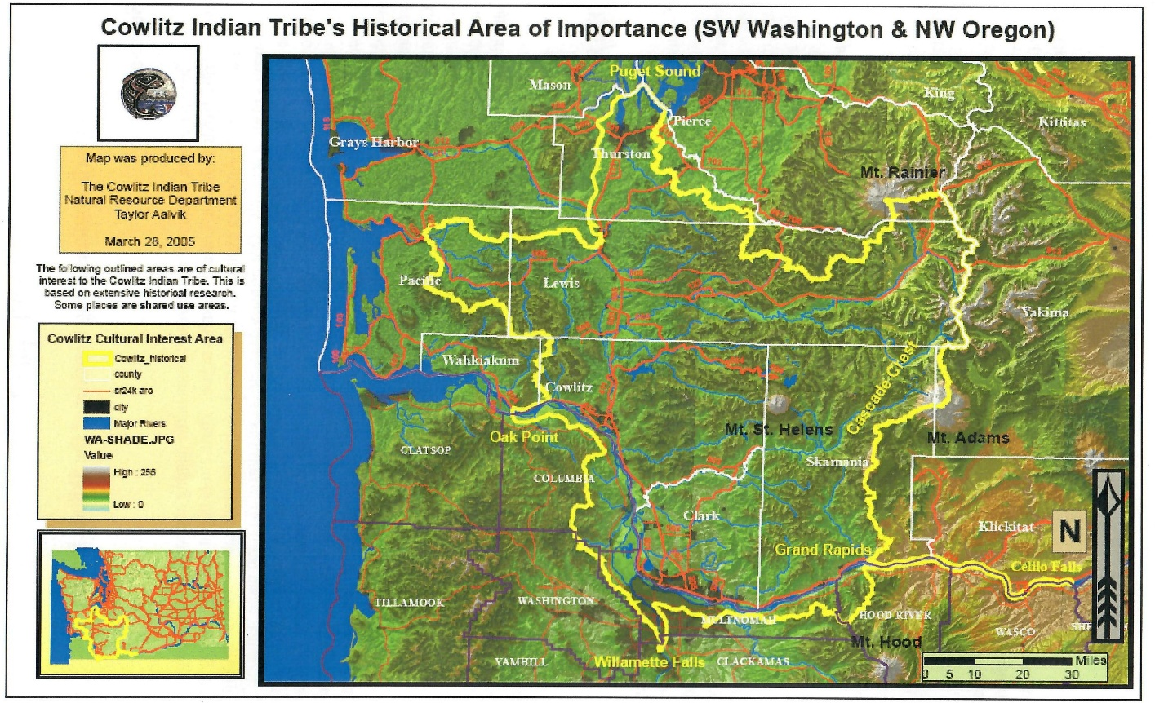
Traditional lore has the Cowlitz land base extending from the south end of Puget Sound to the Columbia River (and somewhat south of that into the Willamette Valley of Oregon) and from the Coast Range to the Cascade Range, a zone still identified as the Cowlitz Corridor.
Map used with permission of the Cowlitz Indian Tribe.
This land, blessed with a moderate climate, rich resources of vegetation, fish and fowl, deer and elk (as well as the more predatory animals), provided a near idyllic homeland. With open prairies and dense forests, rivers and streams, very little was required to sustain life.

The original extent of the Cowlitz lands exceeded some 3,750 square miles or approximately two million acres of highly desirable land and represented the largest land-base of all the tribes of Western Washington. This was the land of the Cowlitz Nation. (The Cowlitz Indian Tribe. U.S. History.com) (Wilson, R. page 101)

With many villages scattered through this immense land mass, they identified among themselves as Upper Cowlitz (those settled on the shoulders of the Cascade Range) and Lower Cowlitz (those living on the long valleys and rivers to the west of the Cascade Range).
(The Cowlitz Indian Tribe. US History.com)

Even within those two geographic zones existed two still smaller bands thus totaling four distinct bands who identified as Cowlitz Indians.

Lewis River Cowlitz band
Lower River Cowlitz band (Stu-pu-la-muks)
Kwalhiokwa Cowlitz band, Willapa Hills
Upper Cowlitz band (Taidnapum)

Social Structure

Tribal leadership was not based on inheritance alone, but, rather, could be selected by the worthiness of an individual to become chief. Plural marriage was quite often a means of forming ties between the various bands. Slavery was not unknown among the various tribes of the Northwest, and the Cowlitz bands were no exception.

New-born infants were subject to head flattening, which was not uncommon among the Chinookan people. It was generally considered a mark of status and distinguished between tribe members and slaves. The process began shortly after birth and continued for eight to twelve months, permanently reshaping the infant’s head. (Kane, P. “The Chinook Indians.”)

While not a nomadic people, the Cowlitz took advantage of the seasons. As spring approached the families moved to the prairies where wapato (Indian potato) and camas bulbs grew. The warm summer months found them camping along the Cascade Crest where they gathered berries, hunted game, and, in general, began to prepare the food stores needed for the coming winter.

Fall and winter would find them returning to their cedar plank longhouse villages along fish-laden rivers and streams. Typically, these dwellings housed multiple family units, each one occupying an apartment of sorts, open to the common area. Cooking fires were down the open center with two families sharing a single fire pit. The size of a longhouse was described by the number of fire pits present. Thus, an eight-fire longhouse would have sixteen families, and so on. According to Roy Wilson, the Cowlitz historian, “It was not uncommon for these longhouses to be 100 feet long. Each longhouse sheltered all of the living members of an extended family of several generations.” (Wilson, R. pages 19 and 21)

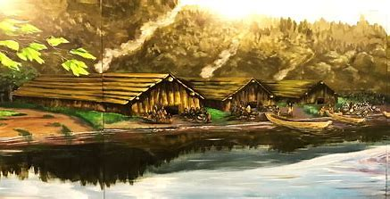
Illustration used with permission of Cowlitz Indian Tribe.

Frequent visits occurred between relatives in other Cowlitz communities and neighboring tribes for the traditional Potlatch celebrations. These celebrations were the occasion for generous gift-giving to commemorate marriages, memorials to a deceased family member, or name-giving, often so lavish that it bankrupted the hosts in trying to out-do another host. Storytelling, dance and song occupied the long winter days and nights of these villages.

There were twenty-nine villages just in the Lower Cowlitz band with more than four hundred longhouses. The Hudson’s Bay Company estimated the total population of the Cowlitz bands at this time to be around fifty thousand souls. (Ibid. page 40)

Sadly, with the coming of outsiders, this was soon to change.

Recorded History

Undoubtedly, the first white men to have contact with the Indian tribes of the Northwest were the seafaring explorers, beginning with the Spanish, who explored as far north as the coast of modern-day Oregon. For over two hundred years, Spaniards had dominated exploration of the west coast of North America. In the mid-18th century, the advent of traders - Russian, British, and American - saw the change of nationalities with different goals than the Spaniards. Seeking the fur trade, they found their way to the more northerly coastline. There is evidence that these traders were frequently visiting the area around the mouth of the Columbia River as early as 1762. Between 1788 and 1803 more than one hundred American ships had been engaged in the fur trade operations. (Ronda, J. Lewis and Clark Among the Indians.)

In 1778, when Captain James Cook mapped the coast from California to the Bering Straits, he noted brown water in that area but did not take time to investigate as he progressed up the coast. Captain Robert Gray entered the mouth of the Columbia River May 11, 1792, on his ship, Columbia Rediviva, and proceeded up the river a distance of about thirty miles. In honor of his ship, he named the river Columbia. In one of his reports, he noted the abundance of beaver in the river. As a result, his report inspired Thomas Jefferson to send Merriweather Lewis and William Clark on an exploratory expedition – the Corps of Discovery – to gain more knowledge of the area to the west which ended where the Columbia River entered the Pacific Ocean giving the United States an interest in the lands to the Northwest.

Trading vessels were frequent visitors to the area thereafter. It was within this time period the United States started on the path to become the dominant power on the west coast of North America.

In 1805, thirteen years after Gray’s modest exploration of the Columbia River, members of the Lewis and Clark Expedition found evidence of trade from these early seafarers as far inland as what is now known as Skamania County in Washington State. Clark noted in his journal, dated November 4, 1805, “The Indians at the last village have more Cloth and uropian [European] trinkets with few Beeds [beads] only. …[T]he men were dressed with a variety of articles of European manufactory.” (Lewis and Clark Journal. November 4, 1805)

Later, on their return east, they camped on the banks of a river they recorded by its Indian name, the ‘Cowliskee’. (Ibid. March 23, 1806)

By most accounts, the earliest sustained contact with the tribes along the Columbia River began in 1811 with the arrival of the Pacific Fur Company and its agent, Jacob Astor, who established Fort Astoria at the mouth of the river. In 1813, the North West Company bought out the Pacific Fur Company and renamed the settlement to Fort George, thus began and expanded its zone of exploration. Shortly after, the Hudson’s Bay Company, which had merged with the North West Company in 1821, established a permanent settlement further up the river naming it Fort Vancouver and, in 1825, began bartering for beaver pelts. With such a strong presence of British influence converging along the Columbia River and northward, the United States government was concerned that its western expansion plans would be challenged and began encouraging American citizens to settle in the area to establish a foothold in the Northwest. Now begins the clash of societies. To the Indigenous tribes, the concept of land ownership was unheard of. To the newcomers, land ownership was the reason they had made the difficult journey from ‘civilization’ to the unknown lands to the west as the story evolves.

The French Connection

It wasn’t until 1818, with the arrival of a young Canadian, that the Cowlitz story was to change. Simon Plamondon was of French ancestry. Born April 1, 1800, at Francois Du Lac, Quebec, his predecessors were known by the colorful name, coureurs des bois – runners of the forest, and he continued this tradition. As independent trappers and traders, these men were well accustomed to living with Indigenous people. Simon, himself, carried Abenaki Indian blood, as it was not uncommon for those early French adventurers to marry into local tribes. From a young age, Simon was captivated by the stories of the trappers who had journeyed west and desired to follow their trails. Although his family attempted to dissuade him, he set out on his personal odyssey, eventually following the trail that would take him to the Columbia River.

With his brother, Joseph, and a friend, the group traveled by horseback until they crossed the Rocky Mountains and found themselves at the Columbia River. There they traded their six ponies for canoes and proceeded down the river to The Dalles. This is where Simon and Joseph parted from their friend, continuing down to Fort George (present day Astoria) at the mouth of the Columbia River where they were hired as trappers. The year was 1816.

The story of his introduction to the Cowlitz Tribe is a tale of adventure when Simon made his first trip up the Cowlitz River. To that time there is no record of any white person visiting this area. As the story goes, Simon was captured by a group of braves and taken to their village. There he met Scanewa, the chief of the Lower Cowlitz bands. “He was taken to the chief who made it quite clear that he was expected to stay. Scanewa admired the splendid physique and recognized the fine personality of Simon. He then and there schemed to keep him in his tribe.” (Wilson, R. page 3)

“He was a very pretty man, and his prettiness saved him.” his daughter, Mary Ann Plamondon St. Germain, related in an article in the Tacoma Daily News. She went on with the story explaining that Scanewa let Simon stay on condition that Simon marry his daughter, Thas-e-muth. Scanewa then allowed Simon to return to Fort George with two braves to bring back trade goods to be exchanged for furs. (Tacoma Daily News, March 29, 1916. page 6)

It is reported that Simon asked that his Indian companions be treated with respect and that, undoubtedly, did a great deal in establishing his reputation as a fair individual, regardless of the circumstances. Such respect for Native Americans was not unusual in the French-Canadian connections with the Indigenous peoples of the New World. From the very beginning the French enjoyed excellent relationships, the main reason being they did not try to take over their land, but, instead, established strong ties that were mutually beneficial, exchanging goods that were desired by both – furs for the French and European wares, such as horses and metal items (swords, axes, guns, pots, etc.) for the native population. (⁽Marxaney, Aryan. “French, Spanish, and English Relations with Native Americans.”)

Simon became a scout for Chief Factor John McLoughlin, of the Hudson’s Bay Company (HBC). Thus began the close association between the Cowlitz Tribe and HBC. Simon provided the invaluable link between two societies that became even more important as the years went by. His honorable relationship with Scanewa proved him to be a reliable person who could be trusted, and John McLoughlin recognized Simon’s abilities as the intermediary between the Hudson’s Bay Company and the Indigenous people with whom he wished to do business.

Simon’s marriage to Thas-e-muth produced four children; Thas-e-muth died with the birth of the last child.

In 1828, Scanewa was murdered and his heir, Richard, was too young to assume the role of chief. Simon was so well loved by the Cowlitz people by that time that he was persuaded to take the leadership of the Tribe until Tyee Dick (tyee meaning leader) came of age to replace his dead father.

Other French-Canadian trappers and traders with the Hudson’s Bay Company were interacting with the bands up and down the Cowlitz Corridor. “The [Cowlitz] river became a regular highway of commerce for the Hudson’s Bay Company.” (Wilson, R. page 46)

These early adventurers, accustomed to interacting with the Indigenous peoples of Canada, readily found wives among the Cowlitz people and sought to bring their Catholic faith with them. They became concerned that their marriages and children were not being recognized by their church. Simon traveled east to plead with the Catholic authorities to send priests to the Pacific Northwest. The petition was granted, and two priests, Father Francis Blanchet and Father Modeste Demers, made their way west to establish a mission for the Cowlitz in 1838. When these Catholic missionaries arrived in the area, Simon had Thas-e-muth posthumously baptized and named Veronica.

As these French-Canadians married into the Cowlitz Tribe, they became more settled and established colonies within the traditional Cowlitz homeland. “Many of today’s Cowlitz trace their ancestry back to these early French-Cowlitz Indian families.” (Ibid. page 38)

Mary Ann Plamondon was no exception. With her marriage to Joseph St. Germain, the path was set as by many others to integrate with Indigenous natives and French adventurers.

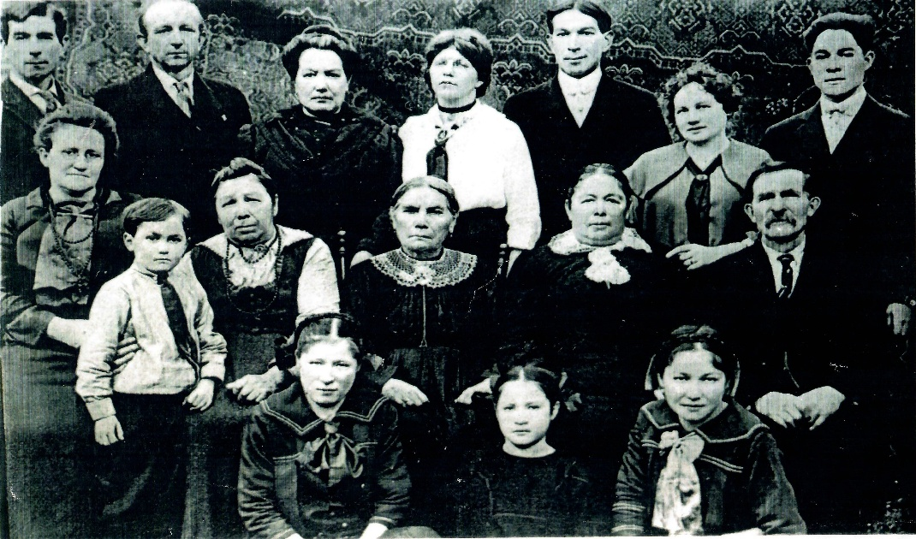
Mary Ann Plamondon St. Germain (center) with six of her children, their spouses, and several grandchildren. Photo from the personal collection of the author.

In 1829, George Simpson wrote, “The country is densely populated … much greater than any other part of North America I have visited … the shores are actually lined with Indian lodges.” (Ibid. page 20)

That statement was soon to change. There is some dispute over the cause of the mass deaths that happened in the years 1829 to 1830, but there is no doubt that such a catastrophe occurred. Some rumors were that blankets distributed to the Tribe by various trading operations had been infected with small pox. The more likely cause was the unfortunate exposure to a virulent Asian flu carried by Captain John Domines’ American ship, The Owyee. The once thriving communities were decimated. As previously noted, the Hudson’s Bay Company had initially estimated the population of the Cowlitz Tribe to be over 50,000 souls. At the end of this epidemic, barely 2,500 were still living and many villages were never lived in again.

The people of the Cowlitz Indian Tribe had two choices - learn to live with the white pioneers who were beginning to flood to the Pacific Northwest or to perish as a unique nation. The Cowlitz proved to be a resilient people. Because of their existing relationship with Hudson’s Bay Company and the French-Canadian trappers, they had become familiar with an alien culture and established land claims. Those who wished to retain their native heritage retreated to their historic lands along the Cascade Range.

For some time, they managed to retain their life-style as a hunter/gatherer society. Others, who had become used to the society introduced by the French-Canadian trappers, remained on the lowland valleys and rivers of the Cowlitz Corridor. They were able to find their historic skills useful to the white strangers who were in need of food resources, laborers, and guiding services.

In 1827, Simon made claim to 640 acres on the Cowlitz River and established a farm known as Cowlitz Landing. Simon remained on the Hudson’s Bay payroll until 1838 when he was tasked to open a four-thousand-acre farm, the Puget Sound Agricultural Company, to supply food for the Hudson’s Bay Company. Under Simon’s direction, the Cowlitz people now turned this subsidiary to producing crops to sell to the British company.

In 1824, the Bureau of Indian Affairs was created by the War Department, and, subsequently came under the jurisdiction of the Department of the Interior in 1849.

The next twenty years were to see dramatic changes in the lives of this Indigenous people. Disputes between the Hudson’s Bay Company and the influx of Americans were finally resolved in 1846 with the Oregon Treaty. Great Britain released all claims to the area and the Oregon Territory was established.

From then on, settlers were arriving by the numbers seeking to establish land claims. “The United States government was to send representatives to the region. Their duties were to enlarge land claims for the government and the colonists, to settle land claim disputes, to survey the route for a railroad, to reserve lands for the Indians and to organize and develop the reservation system.” Emphasis added. (Wiggins, E. page 45)

The Oregon Donation Land Act was passed by Congress in 1850 whereby each settler was allowed to claim 160 acres. This violated the Indian Intercourse Law of 1834, that required the Federal Government to cooperate with Indian groups to determine who could and who could not settle within their traditional land. At that time there were already nearly five hundred settlers waiting in the Washington/Oregon Territories to make their claims, all the while there had been no settlement for the tribes of the Northwest.

In 1848, Isaac Stevens, then acting as Superintendent of Indian Affairs for the Washington Territory, set aside 640 acres on the Cowlitz River expressly for the Cowlitz people. At this time, the tract of land was referred to as the Cowlitz Reservation, but in fact, it was Simon Plamondon’s Cowlitz Landing claim.

In 1852, a meeting was held at Simon Plamondon’s home at the Cowlitz Landing. Twenty-six settlers attended, many of them the original French-Canadian trappers who had married Cowlitz women. They drafted a proposal that the lands north of the Columbia River be separated from the Oregon Territory.

“It was at this time, 1853, that [it] was noted that the Upper Cowlitz people still chose isolation, not venturing into the settlements. The Lower Cowlitz people had realized the Whites were never going to leave; consequently, they moved aside for them grudgingly, but only because of Simon Plamondon.” (Wilson, R. page 78)

It appears Simon Plamondon was a dominate character in Cowlitz affairs over many years, and this is probably true. His early influence on Scanewa and the subsequent chiefs was based on his trustworthy dealing both with the Tribe and with the Hudson’s Bay Company.

Later, as the Oregon Territory became the states of Oregon and Washington, his name is found consistently on records from territorial activities, tribal negotiations, and the granting of statehood for both. Born March 28, 1801, there is some dispute at his age when he died. Some documents say he died September 11, 1881. Others reported he died in 1901 and was one hundred years old. His tombstone gives the dates 1802 to 1901.

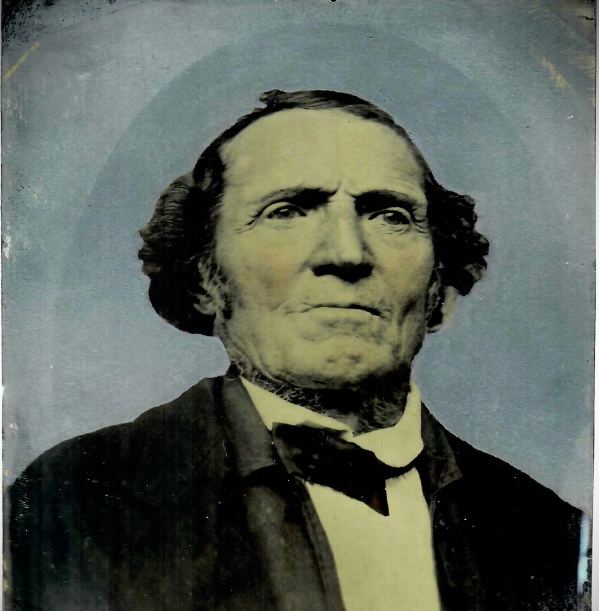

Simon Bonapart Plamondon
From the personal collection of the author.

To Treaty or Not to Treaty?
That is the Question.

Almost from the beginning of our country, the United States has recognized the sovereignty of Indian tribes as separate entities from that of states and having the same status as a foreign nation.

When the United States Constitution was drafted, the Commerce Clause gave Congress charge “to regulate commerce with foreign nations, and among the several states, and with Indian tribes.” (U.S. Constitution. Article 1, Section 8. Clause 3)

In 1850, Anson Dart was appointed as the first Superintendent of Indian Affairs. His instructions were to negotiate treaties with the tribes of the Oregon Territory from the Cascade Range and on toward the Pacific Ocean. The intent of the federal government was to eliminate the tribal title to this prime land and to relocate the tribes to reservations east of the Cascades, an environment totally alien to the Cowlitz people. Dart was directed to offer trade goods made in yearly installments rather than a monetary settlement in exchange for this land grab. Dart and his associates were also charged to purchase all their supplies from American traders and to encourage the local tribes to do so as well.

Rather than trade with the Hudson’s Bay Company, as they had previously done through the fur trade, they were thereby encouraging the native population to associate with the American companies in an attempt to sever their traditional association with the HBC.

Dart proved to be an exceptionally fair man in many cases. He pledged to negotiate honestly and made an offer to pay for the land the tribes were being asked to vacate. His description of the bountiful land he was asking the Indigenous tribes to give up graphically illustrated the rich possibilities that were to come. Of the thirteen treaties Dart negotiated with the Chinook tribes (and six more with tribes south of the Columbia River) only four found their way to Congress; none were ratified. What happened to the other nine treaties has never been discovered, although elders of the Cowlitz Tribe testified that they had made a treaty with Anson Dart. It could be that certain members of Congress were complicit in sabotaging these treaties as being too generous to the tribes, rather than making this valuable land available to the settlers. (Lewis, D. “Anson Dart (1797-1879)”) (Lewis, David. “Anson Dart’s Report on the Tribes and Treaties of Oregon, 1851.”)

In 1853, Washington became a separate territory as had been suggested by Simon Plamondon years before. Isaac Stevens was appointed the first governor and Superintendent of Indian Affairs. There is no doubt Stevens entered into his position with already firm convictions that would influence his decisions going forward. An enthusiastic supporter of western expansion he readily saw the commercial potential awaiting in the Pacific Northwest.
“His handling of Indian affairs in the territory, . . . was controversial even at the time and earned him a reprimand from President Franklin Pierce. The treaties he signed resulted in the rapid removal of the Indian population to reservations.” (Issac L. Stevens Papers, Special Collections, University of Washington)

It was the policy of the U.S. Government to move Native Americans from their historic lands to small reservations. Stevens oversaw this policy without hesitation. The Hudson’s Bay Company settlers, most of whom had Cowlitz wives, were attacked at his instigation in an attempt to remove settlers he believed were aligned with the British. Over the next several years Stevens negotiated six treaties that were signed with fifty-three tribes of Washington.

The Chehalis River Treaty Council of 1855.

Governor Stevens convened a meeting with five tribes that had not yet signed treaties with the United States Government. The greatest obstacle in concluding this negotiation was Governor Stevens insisting that the tribes should agree to give up their rights to their native lands and all interest in the properties there after. Stevens offer, in exchange for these valuable properties, was for the tribes to go to a reservation of unspecified size and location – somewhere between Cape Flattery and Gray’s Harbor on the Pacific Ocean coast. In addition, Governor Stevens insisted that this be one reservation located on the Olympic Peninsula. The only tribes that agreed with this plan were those who already lived in that area. The Cowlitz Tribe was not among them.

Chief Kishkok and the elders representing the Cowlitz Tribe refused to accept this unreasonable offer and expected there would be another attempt at a solution, particularly since Governor Stevens indicated he would return to the negotiations. He did not. The irony of the situation is that Governor Stevens had written instructions to negotiate at the meeting. He was actually tasked to find reservation lands that were suitable for each tribe individually and within their traditional homeland.

Some say Stevens was drunk at the time and became angry when his plan was rejected by the chiefs who were there. When Stevens walked out of the negotiations the chiefs had no option but to leave the meeting themselves with nothing settled and no prospects for any further discussions. With the collapse of the treaty negotiations the United States Government confiscated the land and resources of the Cowlitz Tribe. “On March 20, 1863, a Presidential proclamation directed that the Cowlitz lands be sold, thereby depriving the Cowlitz of its original Indian title without their consent or compensation.” (Wiggins, E. page 46)

That same year, war broke out between several tribes and white settlers. The Cowlitz Tribe was pressured not to engage in this fight with the assurance that they would be given the reservation lands of their choosing. They were encamped in a separate reserve near Fort Vancouver. As a result, no Cowlitz Indian took part in the violence. On their return to their homes, they found their land destroyed and their property had been confiscated. As with previous promises, this one was also ignored. In an ironic twist to this event, the tribes who took up arms against the U.S. Government were given land for their reservations in the settlement agreement, while the Cowlitz who had supported the government were given nothing.

“The [Cowlitz] people were left with three alternatives: to go to another tribe’s reservation and be wards of the government; to work at slave wages for white settlers; or to strike out on their own and be self-sufficient.” (Ibid)

The Cowlitz people, ignorant as to how to protect their heritage and lands, were left in limbo. Some who had the advantage of a relationship with outsiders, such as the families of the French-Canadian trappers, were successful in filing for an allotment based on their membership or enrollment in other recognized tribes. Under this scheme, an individual was given a set amount of land within a reservation which was held in trust until that person was determined to by responsible for handling his or her own affairs. When an allottee died only a fractional interest passed to the remaining family members. (Allotment Records for Indigenous Peoples of the United States. page 1)

Jackie Wannassay was quoted saying, “To me, owning an allotment is like being a prisoner of the government.” (Wilson, R. page 47)

It was at this time that disaster struck the Cowlitz Tribe again when another fever assaulted the Tribe. George Gibbs, Isaac Stevens assistant wrote, “the Cowlitz, a once numerous and powerful tribe, are now insignificant and fast disappearing.”
(Alexander, K. “Cowlitz Tribe of Washington” Legends of America. page 4)

Pressure was put upon the Cowlitz to give up their traditional ways and assimilate into the white society that had invaded their historic land. With the Indian Homestead Act of 1884, many Cowlitz acquired homesteads or bought land outright. Those who remained within their historic homeland were able to maintain ties to their tribal heritage and attempted to take responsibility for themselves within a changing world. Leading to this time of Diaspora, many might call this the time of despair; rather, it was a time of determination.

What kept the men and women of the Cowlitz Indian Tribe dedicated to achieving recognition? Possibly it was their in-born belief that identified the Cowlitz as the spirit-seeking people, the need to hold on to their history, the need to honor the past. Whatever it was gave them the will to persevere over many decades to achieve that goal.

It might have begun with Atwin Stockum, a Cowlitz chief, who, in 1906 sued the federal government to retrieve land for his tribe. In his old age, he was reported as saying, “Long ago all this land belonged to Indians – salmon in the chuck [river], mowich [deer] and moollok [elk] in the hills. Then white men came. Atwin their friend. Now all this land belong to white man.” (Irwin, J. page 6)

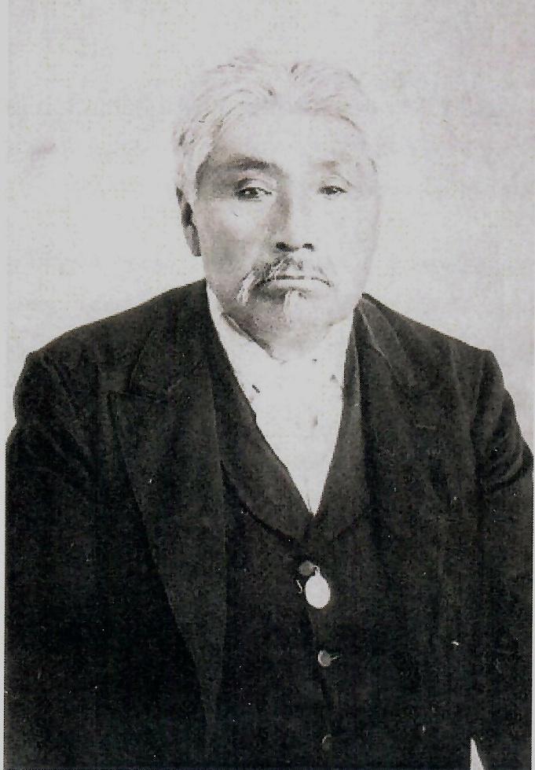

Chief Antwin Stockam, son of a Cowlitz chief, was born circa 1810. This photo was taken circa 1907 in Toledo, WA. Photograph courtesy of Lewis County Historical Museum.

This became the first in a long series of disputes as the Cowlitz attempted to defend their rights. It might be assumed that these suits inspired the Federal Government to attempt to register individuals who could document their Cowlitz heritage through their blood lines.

Special Agent Charles Roblin was given the task of enrolling those Indians in Western Washington who were neither affiliated with or allotted to any other Indian agency. This included taking a census of the Cowlitz Tribe. ⁽Application for Enrollment and Adoption of Washington Indians, 1911-1919) .

Beginning in 1917, Roblin gathered family names and their lineage. His report accounted for those Indians who accepted his invitation to participate. Records taken from federally recognized Indian schools were among the sources of names for the Cowlitz Tribe.

Roblin was quoted as saying, “The Cowlitz was a powerful tribe, and in the early days constituted the blue blood of Western Washington. They were independent, fearless and aggressive and refused to subordinate themselves to the white man by entering into a treaty with them. Their descendants have the same qualities which placed their ascendants in the position of leaders.” (Wilson, R. page 103)

Roblin was successful in listing 877 Cowlitz with their blood quantum. Enrollment required individuals to trace their genealogy to a Cowlitz name with 102 identifying themselves as full-blood Cowlitz; 104 declared they were of half-blood, and so on. Thus, was developed the Roblin’s Schedule of Unenrolled Indians which provides the resource even today for enrollment in the Cowlitz Indian Tribe. Looking at this document, it is apparent that Cowlitz Tribe members were slowly being integrated into the white community as only a handful reported 100% Cowlitz blood at the time. In one hundred years since the Cowlitz people had first laid eyes on white men their culture had changed.

Throughout the early part of the twentieth century numerous bills were passed through Congress authorizing the Cowlitz Indian Tribe to submit claims to the Court of Claims. Between 1915 and 1928, fourteen bills were presented to Congress. In 1924, the Tribe was successful in achieving recognition from Congress through the American Indian Citizen Act only to have it vetoed by President Calvin Coolidge. In defending their case to achieve recognition, the Tribe provided an unbroken record of Cowlitz tribal chiefs, presidents, and chairmen to demonstrate at no time did they cease to exist as an organized nation.

Much can be said about the intervening years from 1924 to today. Year after year, the Cowlitz Tribe sent members to Congress to plead their case. In 1973, a land claim settlement was brought before the Indian Claims Commission. A judgment was paid for the land taken in 1863 without treaty or compensation. The amount settled was $1,550,000 for nearly two million acres of the Cowlitz’ original home land (or about 90 cents per acre). ( The Cowlitz Indian Tribe: Past and Present. page 64)

The Indian Claims Commission (ICC) operated by a set of rules and procedures by which they determined values:

- Plaintiffs could sue only for money, not land, and that value was determined by the value of the land from the date it was taken. (In other words, 1855 for the Cowlitz claim)
- Plaintiffs could not claim interest on the award from the date the land was taken, even though, in the case of the Cowlitz, the land was seized more than 120 years previously.
- Plaintiffs had to accept the decision as final. (Ibid, pages 68-69)

“Following the unsuccessful end of the treaty negotiations on March 3, 1855, the United States dealt with the land of these Indians as public lands, thereby depriving these Indian groups, including the plaintiff Cowlitz Indians, of their original Indian titles without their consent and without payment of any compensation there for.” (Indian Claims Commission (ICC) 21.143,
page 170)

When the tribal leaders requested that a portion of this money be set aside to purchase land to act as a center for tribal affairs, the request was denied as the ICC had ruled. It seems there was no end to obstacles to achieving their goal of recognition

Their perseverance finally was rewarded when the Cowlitz Indian Tribe was recognized by the United States on February 14, 2000.

The door was now open for those individuals whose family names were on the original Roblin Roll of 1919 to claim their membership as Cowlitz Indians. Membership has grown from the 877 listed on that roll to nearly 5,000.

And, where land acquisition had been previously denied, the Tribe has enlarged its holding to include the former Saint Mary’s Convent in Tenino (which has been converted to low-income apartments for Cowlitz elderly), the former Girl Scout regional headquarters in DuPont, Tribal headquarters complex in Longview, and the Ilani Casino and Resort and purchase of a golf course near Vancouver. Plans continue to evolve for future land acquisitions.

As the Tribe has prospered, funds have become available to benefit its membership. A twice-yearly General Welfare Exclusion is sent to each member. College scholarships are available to high school graduates and those seeking higher academic degrees, as well as technical training programs. A generous stipend is given to the elderly members to allow them to continue living in their own homes. Prescription drugs are available at no cost to the members. Frozen fish distribution is a special treat to honor our traditional foods.

Cowlitz and the Community

The stated goal of the Cowlitz Indian Tribe is to be a committed force in building a mutually supportive and long-lasting relationship with the organizations of the community through the Cowlitz Tribal Foundation.

Since building the Ilani Resort, the Tribe has become a good citizen in its neighborhoods contributing money and services to the greater communities as well as to its own members. Over 28 million dollars have been donated to non-profit agencies in Clark County in the past five years as well as to other organizations outside the traditional Cowlitz land with the focus being on art and culture, environmental issues, education, and social services. To benefit the greater communities such donations have included a new fire truck and emergency response vans donated to Clark County Fire Department.

Reclaiming endangered tributaries has been a priority in an attempt to bring these vital waterways back to productive salmon habitats.

The list is long and impressive.



Ilani Casino and Resort
Photograph used with permission of the Cowlitz Indian Tribe

Final Thoughts

What was lost over the nearly one hundred-fifty years of the Cowlitz Diaspora? Their historic culture had gradually been eroded as they became more Americanized. On the other hand, as they lived with and married into another culture, they became exposed to other options than that of their traditional hunter/gatherer society. A goal of the Cowlitz Tribe is now to embrace old traditions, language, history, and practices, particularly involving the younger members of the Tribe.

Native American traditions and wisdom are values that our culture struggles to accept. Our infatuation with technology, our relentless drive for possessions, and our believe that the earth was made solely for humans may be the undoing of society as we know it. We should learn to respect the beliefs of our Indigenous peoples that the earth is our mother and needs to be protected and healed. As people of the dominant culture, it is not too late to benefit by listening and learning what the First People of this continent have to teach us.

REFERENCES

Alexander, Kathy. “Cowlitz Tribe of Washington.” Legends of America. Updated March 2023.

Allotment Records for Indigenous Peoples of the United States. (http://en.wikipedia.org/wiki/Dawes_Act) Explanation of the General Allotment Act and its effects on Native American families.

Applications for Enrollment and Adoption of Washington Indians, 1911-1919. Publication Number: M1343.

Clark, William. “Chinookan Head Flattening.” Oregon Historical Society.

Cowlitz People.
(https://en.wikipedia.org/w/index.php?title=Cowlitz_people&oldid=1277388825

“Cowlitz Tribe reflects upon its past.” The Chronicle, October 7, 2006.

“[The] French and Native American Relations.” Ancestral Findings/Native Americans, Podcast.

Guide to the Isaac I. Stevens Papers – 1831-1892. Special Collections, University of Washington.
Indian Claims Commission, 21.143

Irwin, Judith W. “The Dispossessed: The Cowlitz Indians in Cowlitz Corridor.” Columbia, 1994, Summer.

Lewis, David. “Anson Dart (1797-1879).” Oregon Historical Society.

Lewis, David. “Anson Dart’s Report of the Tribes and Treaties of Oregon, 1851.” Oregon Historical Society.

Marxaney, Aryan. “French, Spanish, and English Relations with Native Americans.” The4Network, September 25, 2021.

Moulton, Gary E., editor. Journals of the Lewis and Clark Expedition. Lincoln: University of Nebraska Press.

Roblin, Charles E. Entry 613 of the Preliminary Inventory of the Records of the Bureau of Indian Affairs. January 31, 1919.

Ronda, James P. Lewis and Clark Among the Indians. Lincoln: University of Nebraska Press, 1984.

Scope of Commerce Clause Authority and Indian Tribes. Constitution Annotated, Analysis and Interpretation of the U.S. Constitution.

Stone, Frances. “State’s Oldest Living Daughter of White Blood Found in Tacoma; Gives Thrilling Light on History.” Tacoma Daily News, March 29, 1916, page 6.

“The Cowlitz Indian Tribe.” U.S.History.com.

The Cowlitz Indian Tribe: Past and Present. Cowlitz Indian Tribal Publication. Longview, Washington, May 22, 2006.

“The French and Native American Relations.” Ancestral Finding.com

Wiggins, Eugene A. “That the People May Live: The Cowlitz Tribe’s Journey of Peace and Justice.” Journal of Pacific Rim Psychology, Volume 1, Issue 2, pp.44-53.

Wilson, Roy I. History of the Cowlitz Indian Tribe. 1995. Uncopyrighted, unpublished. Historical remembrance of a tribal elder. 229 pages.

“Voyages into History.” The Wayback Machine. www.norway.org:80/history/heyerdahlhtm.

Copyright 2025 by The Evergreen State College. Teaching notes are available at www.evergreen.edu/native-cases. Sund (Ed.D) is the great, great, great, great granddaughter of Simon Plamondon and Thas-e-muth, daughter of Cowlitz Chief Scanewa.

