**Who has MMIP Task Forces?**

## Analyzing Tribal, State, and Federal actions taken for Missing and Murdered Indigenous People

## 

## By Emily Washines

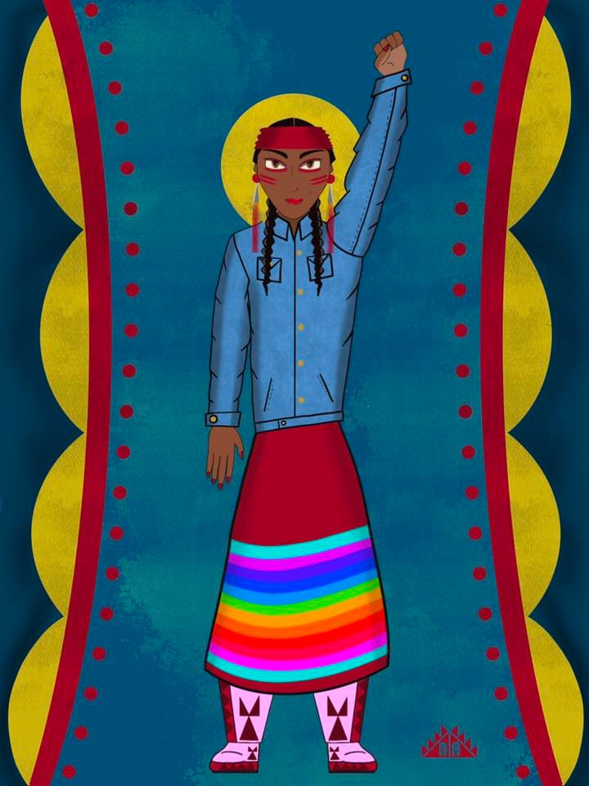

Image: Artwork by Jon Olney Shellenberger, Native Anthro

Abstract

The purpose of this case is to analyze tribal, federal and state actions regarding the crisis of Missing and Murdered Indigenous People (MMIP) in the United States. We will discuss eight examples of task forces. This includes four tribes, three states, and one federal program centered on action to address the MMIP crisis. The four tribes are: Bay Mills Indian Community, Confederated Tribes and Bands of the Yakama Nation, Tulalip Tribes, and Confederated Salish Kootenai Tribes. Of these four tribes, they have headquarters in three states: Michigan, Montana, and Washington. For tribes, there might be some intersectionality with federal and state task force efforts. The actions for MMIP are not limited to these eight examples of tribes, states and the federal government. These were the set selected to examine task forces and actions taken to address MMIP. Each of these eight examples, included an analysis of values, task force construction, goals, and recommendations. There was a set of nine questions to assist with this study. The primary focus of this case study is the Task Forces, Committees, and Working groups focused on protocols and procedures for MMIP. Some broader enduring issues impacting MMIP such as multi-jurisdiction, cold cases, and numbers are included in the case.

# INRTRODUCTION

Within this case we will discuss eight examples of task forces and actions taken for Missing and Murdered Indigenous People (MMIP). This includes four tribes, three states, and one federal pilot program centered on action to address the MMIP crisis. The four tribes that are studied for this case include the following: Bay Mills Indian Community, Confederated Tribes and Bands of the Yakama Nation, Tulalip Tribes, and Confederated Salish Kootenai Tribes. Later in this case we will learn which was the first tribe to create protocols and procedures regarding MMIP in a pilot program. We will share which tribe is the only one that give public access to their protocols for MMIP. This case will review the alarming MMP numbers one tribe faces. There is one tribe that created a large reward for information about a missing tribal member. For tribes there might be some intersectionality with federal and state task force efforts.

There is a study of one federal task force effort selected for this case. Although there are more examples of actions taken by the federal government, the focus of one task force is based on a pilot program created to give technical assistance to multiple tribes to create protocols for their missing tribal members. Each of the four tribes within this case were given the opportunity to be a part of this federal pilot program.

Of these four tribes, they have headquarters in three states: Michigan, Montana, and Washington. As we analyze each state, there is acknowledgement that each tribe is sovereign and some tribes have historical homelands that extend beyond just one state’s boundaries. Discussing tribes alongside states and the federal government in no way limits tribes’ response to the MMIP crisis. In each instance of a state task force, there are tribal representative(s). Those tribal representatives may also be elected to Tribal Council. Thus, a dual or triple role to take steps for MMIP.

The actions for MMIP are not limited to these eight examples of tribes, states and the federal government. These were the set selected to examine task forces and actions taken to address MMIP. In order to analyze the values, construction, goals, and recommendations of each task force, committee, and/or work group a set of research questions was utilized. Those questions were the following: 1. What is the name of the Taskforce, Committee or Work Group? 2. In operation from what timeframe? 3. What is the Task Force Construction Process? 4. Do they have a report? 5. What is the Primary Problem/Need? 6. What are the Recommendations? 7. What is the timeline? 8. Any unique approaches? Trends? 8. Cross-over between tribes’ actions and federal actions? 9. Are there any resources (funding)?

|  |  |
| --- | --- |
| **8 EXAMPLES OF TASK FORCES AND ACTIONS TAKEN REGARDING MMIP** | |
| TRIBES | STATES |
| 1. Bay Mills Indian Community | 1. Michigan |
| 1. Confederated Salish Kootenai Tribes | 1. Montana |
| 1. Tulalip Tribes | 1. Washington |
| 1. Confederated Tribes and Bands of the Yakama Nation |  |
| FEDERAL | |
| * **The Presidential Task Force** of Missing and Murdered American Indians and Alaska Natives. They also went by the name Operation Lady Justice. The MMIP Initiative partnered with Presidential Task Force.This was led by the U.S. Attorney General | |

# Federal Task Force:

Understanding the types of task forces are helpful for knowing how the actions are organized.

An activity-based task force can choose to be a group that coordinates community events, youth activities, and awareness sessions. An issues-based group will focus on internal administrative responses to reduce community and regional risk factors. The task force may try to become both, however the success of managing both responses will be greatly dependent on the expertise of the task force facilitator” (Cuestas, 2022).

The Federal Task force is primarily issues based, with some activity-based events surrounding federal announcements and visits to tribes. The Presidential Task force of Missing and Murdered American Indians and Alaska Natives operated from 2019-2021 under Executive Order 13898. They also went by the name Operation Lady Justice. The primary focus of this task force was consultation with tribes as well as a review of cold cases. They also created a guide for families when an American Indian or Alaska Native adult goes missing (U.S. Department of Justice, 2023).

One consideration was for new and unsolved MMIP cases. Through listening sessions, the Presidential Task Force heard how essential it is for tribes to have a written plan that included their own needs and specific to their tribe. “The task force approach is being relied upon heavily by The Department of Justice to respond to the MMIW/MIP challenge in tribal lands” (Cuestas, 2022). As such, the federal task force provided technical assistance for tribes to develop response plans for missing Indigenous people. One of the seven areas of focus for this federal Task Force was protocols and procedures. Within the Task Force they formed a working group to focus on this area. Parallel work within the federal government was taking place alongside this task force working group. In November 2019, the Department of Justice Attorney General established November 2019 Initiative on Missing and Murdered Indigenous Persons Initiative (MMIP Initiative). They partnered to help tribes develop Tribal Community Response Plans (TCRPs). The MMIP Initiative spent $1.5 million to hire 11 MMIP coordinators that would be housed within U.S. Attorney’s offices in 11 states. “The States were Alaska, Arizona, Michigan, Minnesota, Montana, Nevada, New Mexico, Oklahoma, Oregon, Utah, and Washington” (Department of Justice, Department of the Interior, & Department of Health and Human Services, 2022, p. 21).

While the federal government was vague in their selection choice for states, there is an opportunity to cross reference the 11 states the DOJ Attorney General selected with the reported Top 10 States with highest number of MMIWG cases (Lucchesi & Echo-Hawk , 2018, p. 14). There are 8 states that are on both lists: Alaska, Arizona, Minnesota, Montana, New Mexico, Oklahoma, Utah, and Washington. The focus of this case study will be on three of eleven of those states.

|  |  |  |
| --- | --- | --- |
| TOP 10 STATES WITH HIGHEST NUMBER OF MMIWG CASES | FEDERAL GOVERNMENT SELECTED THESE STATES FOR MMIP COORDINATORS (11): | ON BOTH (8) |
| New Mexico (78) Washington (71) Arizona (54) Alaska (52)  Montana (41) California (40) Nebraska (33) Utah (24) Minnesota (20) Oklahoma (18) | Alaska, Arizona, Montana, Oklahoma, Michigan, Utah, Nevada, Minnesota, Oregon, New Mexico, and Washington state | Alaska, Arizona, Minnesota, Montana, New Mexico, Oklahoma, Utah, and Washington |

The focus of the Tribal Community Response plans is to develop protocols and procedures for missing people within the tribe. Chris Cuestas, content expert with the National Violence Prevention Resource Center said, “One of the biggest challenges for tribal families is learning how the system is supposed to function and who to turn to during a crisis” (2022). Tribes would also consider the federal, state and local law enforcement and other organizations. The MMIP Coordinators helped facilitate the process of tribes developing and/or improving these protocols.

Due to the sensitive nature of information within the response plans, most tribes have not publicly shared their plans. The Bay Mills Indian Community is the only tribe that has their response plan available to the public. Law enforcement may access tribal response plans through either an agreement with the tribe or through the Law Enforcement Portal known as LEEP.

“The Confederated Salish and Kootenai Tribe of Montana created the first-ever plan, followed by Tribes in the other districts that have either completed their own TCRPs or are in the process of doing so” (Department of Justice, Department of the Interior, & Department of Health and Human Services, 2022, p. 21).

Within Michigan, “…the Bay Mills Indian Community and Sault Ste. Marie Tribe of Chippewa released Murdered and Missing Indigenous Persons (MMIP) Tribal Community Response Plans May of last year [2021]” (Clark, Missing, Murdered: Silent endemic plagues Native American Communities, 2022).

Even when there was a change in presidents, the commitment to assisting tribes with planning remained consistent. President Biden’s November 2021 Executive Order 14053 regarding MMIP stated, “…promote coordination of Federal, State, local, and Tribal law enforcement, including, as appropriate, through the development and support of Tribal Community Response Plans” (Biden, 2021, p. Sec. 3 iii)

The MMIP Initiative that is housed in the U.S. Attorney’s office is set to end in spring 2023. “A federal program to support tribal communities, and investigations into missing or murdered indigenous persons, is coming to a close….This is significant because we just didn’t have anything like this before. And really significant in that I think it helped strengthen the lines of information and communication between law enforcement agencies and tribal agencies and families,” said Holly T. Bird, an attorney in Michigan (Froehlich & Monroe, 2023). A spokesperson for the US Attorney’s office in Michigan stated, “The MMIP funding was special, one-time funding for a predetermined amount of time. Above that, our office committed additional funds to extend the timeframe of the position to continue the ongoing work” (Froehlich & Monroe, 2023).

Further, some federal departments including assistance for MMIWP within their 2022-2026 strategic plans. “The Justice Department will prioritize working alongside Tribal law enforcement partners to deter and address serious crimes in Indian country. At the same time, the Department will work to empower Tribal justice systems, including by providing services, technical assistance, and other resources to allow Tribal communities to protect their members from harm” (U.S. Department of Justice, 2022, p. 35).

Additional federal action includes launching websites. In 2021, the federal government launched a couple of websites that include missing Indigenous People cases. The Bureau of Indian Affairs site called Missing and Murdered Open Cases. On the FBI site it’s called Indian Country Cases. “The FBI is seeking public assistance and information on the cases below, many of which involve missing or murdered victims in Indian Country. The FBI has investigative responsibilities for federal crimes committed on nearly 200 Indian reservations nationwide and shares the federal jurisdiction with our partner, the Bureau of Indian Affairs”  (Federal Bureau of Investigations, 2023).

Overall, there is a shift happening. “Law enforcement is currently experiencing a transition from traditional management of personnel to a more community responsive balanced response. Communities will be called upon for input and assistance with this transition. A community-based task force can serve as the vehicle for this transition” (Cuestas, 2022). One of the avenues was tribes organizing to create a response plan.

# What is a Tribal Community Response Plan (TCRP)?

“A TCRP is a guide for how a Tribal community will respond to a report of a new missing person case. The TCRP is individualized and tailored to the needs, resources, and culture of the community” (U.S. Department of Justice, 2023). One of the limitations to research the different plans is a majority of the plans are not publicly available, however the process and general guidelines are available on the Department of Justice website.

These plans should be viewed as a recommended tool as these are not mandatory plans for tribes. The federal government created a guide to develop a response plan. This way each tribe can have a draft to edit to meet the needs within their tribe. The focus is primarily on missing, though there are process and next steps when the missing is found to be a homicide. Additionally, each tribe can expand their response plans.

In October 2020, Savanna’s Act was signed which includes guidelines for federal law enforcement. “…Savanna’s Act requires the Attorney General to direct U.S. Attorneys to develop different regionally appropriate guidelines with very specific requirements to respond to cases of missing or murdered AI/AN persons” (Department of Justice, 2022, p. 4). Although TCRP’s are primarily a tribal planning and response document. “TCRPs may be helpful in developing Savanna’s Act guidelines and vice versa. While the TCRPs are focused on emergent missing person cases, and include disciplines in addition to law enforcement, the Savanna’s Act guidelines are focused on law enforcement agencies and all MMIP cases” (U.S. Department of Justice, 2023).

There are a variety of roles in eveloping a plan within a tribe. “A TCRP is multidisciplinary and, as such, numerous organizations should be involved in the development of a TCRP. Often the Tribal law enforcement agency may take the lead in the development of a TCRP, however, Tribal victim services agencies, Tribal communications staff, and community organizations may all play significant roles in the development” (2023). There is no specific timing for drafting and finalizing a Tribal Community Response Plan. “This process is likely to take several months to complete,” (2023).

# Tribes

Each of the four tribes will include information about background, values, and action taken. We will discuss the location and membership of the tribe followed by the values of the tribe. In order to understand their values since time immemorial, we will also include each tribe’s language. The basis of their tribal identity is intertwined with their teachings that are rooted in traditional knowledge. This case study will review the MMIP actions taken by four tribes.

When tribes take action, they are providing the steps they expect for law enforcement response both internally and externally. For MMIP cases these plans centers on urgency and accountability.

Look where we're at ladies and gentlemen, the MMIW/MMIP crisis has shown that we need to get involved we can no longer rely on outside entities to be upfront honest successful and even responsive to our challenge of missing murder indigenous women and missing Indigenous persons. I think we've all learned a very hard lesson with thinking that those individuals and those entities that are responsible to our communities that we rely on either through by law or by treaty; they're not holding up their end. So, we need tribes to become more aggressive in the form of accountability to find out why (Cuestas, 2022).

# Bay Mills Indian Community (Gnoozhekaaning)

We will begin by discussing the location and history of the tribe. Bay Mills Indian Community has headquarters that are located in Michigan. They also refer to themselves as Gnoozhekaaning. “The Bay Mills Indian Community is federally recognized tribe of Ojibwe people located on the southeastern shore of Lake Superior” (Bay Mills Indian Community, 2018, p. 3). Bay Mills Indian Community reserved their usual and accustomed rights in their ceded areas through the1836 Treaty of Washington. “Our home is known as “Gnoozhekaaning” (tr: “The Place of the Pike”), and much of our culture and history is defined by the lands and waters that surround us” (p. 3).

There are 2,258 tribal citizens. For the tribal government, they have a General Tribal Council which consists of tribal citizens that are 18 years and older. That General Tribal Council consists of 1,657 tribal citizens. (Bay Mills Indian Community , 2023).

The basis of their tribal identity is intertwined with seven of their teachings that are rooted in traditional knowledge. This knowledge is passed from the elders to the youth to help them live well. "Helping our community find healing and restorative justice through the seven grandfather teachings -dbaadendiziwin (humility), aakwa'ode'ewin (bravery), gwekwaadziwin (honesty), nbwaakaawin (wisdom), debwewin (truth), mnaadendimowin (respect), and most of all zaagidwin (love)" (Bay Mills Indian Community Victim Services, 2023).

## Action – Tribal Community Response Plan

While looking at the actions by tribes, there is a primary focus on the process to create a Tribal Response Plan. Though we will not review each item in the 28-page document, we will look at sections of the plan as well as highlight key components such as terms, how they approach multi-jurisdiction, how they coordinate services, and communication.

The importance of tribes leading their planning efforts for missing and murdered within their community is shared by Bay Mills Indian Community. “This Tribal Community Response Plan (TCRP) for Missing Persons Cases provides guides tailored to the specific needs, resources and culture of the Gnoozhekaaning, Place of the Pike, or Bay Mills Indian Community, to utilize when responding to missing and murdered persons cases” (Bay Mills Indian Community, 2022).

“Tribal governments and American Indian and Alaskan Native (AIAN) organizations have serious and legitimate concerns of missing and murdered members of tribal communities” (p. 3)

Bay Mills Indian Community was one of the tribes within Michigan that had a Michigan MMIP Coordinator provided technical assistance for their plan. They also are the only tribe to provide public access to their response plan. As a result, we can compare the plan for their tribe with the general plan the government provides.

Their Tribal Community Response Plan has a framework that consists of four sections which are the following:

1. Law Enforcement Agency Guidelines for Missing Persons Cases
2. Victim Services Guidelines for Missing Persons Cases
3. Media & Public Communications Guidelines for Missing Persons Cases
4. Community Outreach Guidelines for Missing Persons Cases

In comparing Bay Mills Indian Community sections to the general federal guide. They are nearly identically. Within the federal guide you see the following sections:

1. Developing Law Enforcement Agency Response Guidelines
2. Developing Victim Services Response Guidelines
3. Developing Media and Public Communications Response Guidelines
4. Developing Community Outreach Response Guidelines

As a result of the pilot programs with tribes, the federal government utilized the information from tribes’ planning to adjust their guidelines. “Lessons learned from these pilot projects were used to improve the original draft guidance documents” (Department of Justice, 2022, p. 3). As a part of their process, they conduct an annual review and approval by Tribal Council of the TCRP.

**Law Enforcement**

Within the response plan, the Bay Mills Police Department reiterates there is no waiting period for reporting a missing person. “Bay Mills Police Department will give cases involving a missing person high priority by responding to take the report, initiating a search if necessary, and quickly entering the information into the appropriate local, state, and NCIC law enforcement databases” (Bay Mills Indian Community, 2022, p. 4)

“Because cases involving AI/AN communities often require a multijurisdictional response, missing person guidelines should include procedures for resolving jurisdictional questions. An early determination of which agency will take the lead in a case helps avoid unnecessary delays in time sensitive investigations. Jurisdictional questions in AI/AN communities are complex” (Department of Justice, 2022). Bay Mills Indian Community includes a chart for jurisdiction. This illustrates how Law Enforcement evaluates their respective roles with regards to jurisdiction on missing person cases and other crimes.

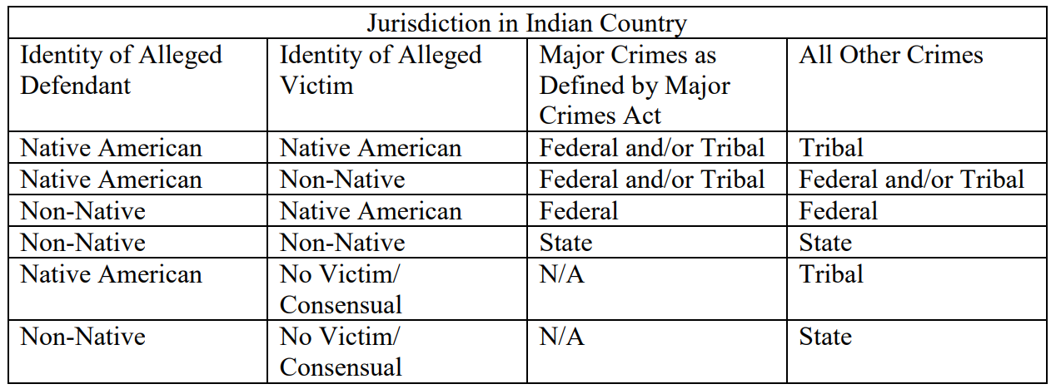

Source: (Bay Mills Indian Community, 2022, p. 5)

Additionally, there are a lot of terms utilized with missing persons cases. “The tapestry of legal terms applicable to missing person cases across federal, Tribal, state, and local agencies can be confusing even for experienced practitioners” (Department of Justice, 2022, p. 18). Bay Mills Indian Community shares 12 definitions. The full definition can be found in the appendix. Adult, Amber Alert, Ashanti Alert, At-Risk Missing Person, Endangered Runaway, Indian Country, Indian Tribe, Law Enforcement Agency, Missing Adult, Missing Child, Risk Factors, Silver Alert. (Bay Mills Indian Community, 2022, pp. 4-5)

In the definition for risk factors, Bay Mills Indian Community added the fact that some of their tribal citizens travel to remote areas for traditional cultural practices. The consideration for hunting and gathering within the response plan means the tribe was able to include tribally-specific definitions for their purposes.

**Victim Services Guidelines**

Multi-jurisdictional response should also be considered with the missing person, family and the community. “Essential victim support can help people during the most difficult times of their lives while also helping law enforcement engage the family of the missing person during an investigation” (Department of Justice, 2022, p. 43).

Bay Mills Indian Community states, “We envision giving immediate family of a missing or murdered Indigenous person(s) an understanding of the investigative process, resources, and emotional support during their time of need. They matter and their voices matter” (Bay Mills Indian Community, 2022, p. 6)

The Victim Services Response Team (VSRT) includes three Liaisons which are the following: Family & Support Liaison, Law Enforcement Liaison, and Cultural Specialist Liaison whom “can offer spiritual guidance, prayer, fire, story-telling and or any other traditional practices requested by the family” (pp. 7-8). There are additional services the Victims Services Response Team provides which includes transportation, activities for children that may be in temporary locations, crisis counseling, case updates, emergency housing assistance and overall coordination with the response team.

**Community Outreach Guidelines**

The general federal guidance is that tribes should look at their own resources and then build upon those as needed with regional, state, local, federal resources (Department of Justice, 2022). Bay Mills Indian Community has four community liaisons that assist with missing persons. “The Community Response Team is comprised of community members and staff such as a Law Enforcement Liaison, Volunteer Coordinator Liaison, Meal and Shelter Liaison, Community Resources Liaison and Behavioral Health Services Liaison” (Bay Mills Indian Community, 2022).

Both guidelines for the Victims Services and Community outline next steps in the event the missing person(s) identified safely, missing person(s) Identified deceased and missing person(s) turns cold case (2022).

**Media & Public Communications Guidelines**

Communicating when a tribal member is missing and being able to validate that through official channels is important. There is also a preventative approach tribes can communicate. “The Media and Public Communications Team (MPCT) will utilize public awareness tactics such as Public Service Announcements (PSA), social media, public outreach & training to bring awareness of the issue. Law enforcement will coordinate with the Media and Public Communications Team to share information and create trust within the community…” (p. 14) For missing persons specifically, the team “…will provide local media outlets with the following information: recent picture, name, age, attire, distinct characteristics (i.e. piercings, tattoos, etc.), tip line information, and location of where the missing person was last seen” (p. 14).

In addition, this committee’s work is centered on being able to coordinate with the lead agency to ensure timely communication that is both necessary for the community and will not compromise the case. The tribe also outlined steps in the event there is a trial related to the case. (p. 15)

There is a broader theme of being community-orientated that comes with sharing their plan. “Bay Mills Indian Community takes great pride in developing a guide that will be used by tribal governments and U. S. Attorneys’ Offices, working with other partners, to develop TCRPs for tribal communities nationwide” (p. 3).

# Confederated Salish & Kootenai Tribes

The Confederated Salish & Kootenai Tribes (Salish & Kootenai or CKST) has 8,400 tribal members with headquarters on the Flathead Indian Reservation. Their reserved rights are from the Hellgate Treaty of 1855 (War Cry Podcast, 2021). The tribe operates with a value centered on “Honoring the Past to Ensure the Future...” Specifically, they created “…a body of knowledge about the environment closely tied to seasons, locations and biology. This way of life was suffused with rich oral history and a spiritual tradition….. By learning from our Elders and teaching our children, those Tribal ways of life continue to this day” (The Confederated Salish and Kootenai Tribes, 2023).

The CSKT Tribal Community Response Plan is not public due to the sensitive nature of content. Additionally, CSKT and other tribes assisted with the Montana MMIP Task Force. There is additional work by the CSKT that will be referenced in Montana’s section. Currently, the Salish & Kootenai have no missing tribal members reported through the MMIP portal, this portal covers the Flathead reservation, the Urban areas of Billings and Missoula.

## Action – Tribal Community Response Plan

During a Task Force meeting in Montana the members said, “The TCRP process is a positive solution to improving the jurisdictional barriers in missing persons cases, and cross-jurisdictional agreements on reservations increase response times and resource allocation in missing persons cases” (Montana Department of Justice, 2022). The focus of this tribe’s section will include an interview I conducted with Councilwoman Ellie Bundy as a part of War Cry Podcast. This interview gives insight about the process of MMIP response planning. “My name is Ellie Bundy I am the Tribal Council Secretary for the Confederated Salish and Kootenai tribes (CSKT), I’m a member of our CSKT MMIP work group, and I am a member of our tribal community response plan core team currently as the presiding officer for Montana’s Missing Indigenous Persons Task Force” (War Cry Podcast, 2021).

Here's insight regarding how Councilwoman Bundy has so many MMIP roles and continues this work.

Consider these numbers: 14, 16, 18, 20, 21, 22, and 23 the ages of these young ladies when they went missing or were gone murdered. Think of someone in your family who may be that age perhaps a daughter or a niece can you imagine the heartache the anxiety the sleepless nights the constant pit of worry and devastation and the desperation. Those thoughts remind me about why we need to continue to do this work because if it were my daughter, I would be begging for help much like the families of these young ladies are doing today or have had to do in the past (2021).

In addition, Councilwoman Bundy remembers the women and girls ages along with learning what they are remembered for as a way to honor them. This is a pathway illuminated so the focus on them is not solely on what happened to them, or any unanswered questions regarding their case. She discussed the Missing and Murdered Indigenous Women and girls from other tribes as follows:

1. Ashley Loring Heavy Runner (Blackfeet): Missing since June 2017. She was 20 years old when she vanished. She loved riding horses a skill she learned growing up on a ranch near Heart Butte Montana located on the Blackfeet Indian Reservation. Many rumors and false leads have been pursued to no avail. The family indicated that law enforcement officials failed to respond immediately stating she's of age she can leave when she wants to.
2. Hannah Harris (Northern Cheyenne): Found deceased July 8, 2013. She was 21 years old and had a son. She was last seen when she went to watch fireworks with friends. Two people were charged and sentenced for their roles in her death. Each year on her birthday May 5, many tribes help bring awareness for MMIP.
3. Selena Not Afraid (Crow): Found deceased January 20, 2020. She was 16 years old. She went missing on January 1, 2020. She loved riding horses and was practicing to be a future Indian relay race champion. She loved sports, sewing, baking and being with family and friends. She danced jingle at powwows. She was found less than a mile from an 1-90 rest stop where she was left by “friends.” Authorities indicated she died of hypothermia based on results of her autopsy; a finding that many continue to question.
4. Henny Scott (Northern Cheyenne): Found deceased December 2018. She was 14 years old. She dreamed of becoming a doctor. The BIA Police did not release a missing person alert for her for 2 weeks after her parents filled a report. She was found 21 days later, 200 yards away from her residence. A forensic examination determined she died of hypothermia and the manner of death was accidental. Her family questions that cause of death.
5. Kaysera Stops Pretty Places (Crow): Found deceased August 26, 2019. She was 18 years old. She played basketball, football, participated in wrestling, ran cross country and performed in several school theater productions she had dreams of becoming an actress. She was reported missing on August 24, 2019, she was found deceased two days later in the backyard in Hardin, Montana less than a mile off of the crow reservation. Her family was not notified that she had been found until September 11, 2019. Law enforcement was unable to determine the cause of her death.
6. Savanna Lafontaine-Greywind (Spirit Lake Nation): Found deceased August 27, 2017. She had just moved into her own apartment in Fargo, North Dakota with her boyfriend and they were going to welcome their first child in September. She was working as a nursing assistant hoping to fully qualify as a nurse specializing in elder care. She was eight months pregnant when she was abducted and killed her body dumped in a river Her child was born during the abduction and survived. A couple who lived in the same apartment building were charged in her death and are now serving life in prison. She inspired Savanna’s Act which was passed in 2020 to improve federal response for MMIP including the coordination between all law enforcement (2021).

Within the tribal response, the Salish & Kootenai Tribes reviewed the capabilities of the tribe when assisting victims and their family. For “Victim Services we were stuck with two agencies that can only do pieces of this work” (2021) Councilwoman Bundy explains that one of the accomplishments is Salish & Kootenai tribes were able to create a liaison. “The Missing Person Liaison developed by CKST will work to fill gaps and communicate with the family” (2021). Bay Mills Indian Community also references and outlines liaisons within their Tribal Community Response Plan.

When CSKT was the first tribe to complete a Tribal Community Response Plan Councilwoman Ellie Bundy said it is "…more than just a document being developed. We are a team coming together to get a job done. It's for those who are missing, those who have been murdered and their families who are forever hurt. This topic is heavy, dark and difficult, but today we celebrate success....This is a silver lining that helps keep our community moving forward" (Mabie, 2021).

# Tulalip Tribes

Tulalip Tribes has a smaller population than Salish & Kootenai Tribes, but a larger population than Bay Mills Indian Community. For Tulalip Tribes, “population is over 5,100 and growing, with 2,700 members residing on the 22,000 acres Tulalip Indian Reservation. We are located north of Everett and the Snohomish River and west of Marysville, Washington” (Tulalip Tribes, 2023).

Approaching this review of Tulalip tribal actions taken for MMIP, we can view how the tribal culture and traditional knowledge is rooted within this tribe. Tulalip Tribes is pronounced Tuh’-lay-lup. Their bands reserved rights through the 1855 Treaty of Point Elliott. The Tulalip tribe has seven teachings that serve as core values. These stem from seven different Tulalip ancestral legends. The values are the following: 1: We respect the community of our Elders past and present, and pay attention to their good words 2. We uphold and follow the teachings that come From our Ancestors 3: It is valued work to uphold and serve our people 4: We work hard and always try to do our best 5: We show respect to every individual 6: We strengthen our people so that they may walk a good walk 7: We do not gossip, we speak the truth (The Hibulb Cultural Center , 2023)

In Tulalip Lushootseed Language, these core values are the following: 1. ʔəshigʷəd čəɬ ti sluƛ̕tədčəɬ čəɬa ʔəsləqəd ti haʔɬ sgʷədgʷadads 2. ɬušəqild čəɬ čəɬa ɬučalad ti xʷdikʷ tuľʔal ti tuyəľyəlabčəɬ. 3. q̓ič syayus tiʔiɬ sšəqild tiʔiɬ ʔaciɬtalbixʷčəɬ. 4. ƛ̕uyayus čəɬ ʔə tə tib; ƛ̕up̓aʔcut čəɬ ʔə tə tib. 5. gʷəl bəɬshigʷəd čəɬ kʷi bək̕ʷ ʔi gʷat. 6. qʷiq̓ʷild čəɬ tiʔiɬ ʔiɬʔaciɬtalbixʷčəɬ dxʷʔal kʷi haʔɬ sʔibəšs. 7. xʷiʔ kʷi gʷəʔudxʷqadaʔaqaʔbčəɬ, yaw̓ təɬ čəɬaʔ ʔilid (2023).

In utilizing these values from their ancestral stories, Tulalip tribal members are able to show the importance of being both situationally aware and take action. Tulalip Tribal member Jessica Bustad further connects this to identity and protection. “We need to be sure that our children can walk firmly in their identity, be proud of their culture, and know where they come from. We need to be sure they know the importance of protecting one another. That’s what it means to be a tribe” (Rios, 2022).

## Action – Tribal Community Response Plan

In May 2022, Tulalip Police Chief Sutter confirmed the tribe has one. “Here in Tulalip, we’ve developed a tribal response plan with four components to help curb this crisis locally” (2022). He further indicated that the sections included a victim’s liaison, community resources, increasing awareness through the media and law enforcement protocols. Although the Tulalip Tribes have not publicly released their TCRP, we can see four similar sections in their response plan as Bay Mills Indian Community.

Mary Johnson-Davis, is a missing woman from Tulalip Tribes. “Police Chief Sutter said, “We are very actively working on Mary’s case. We want to bring her home and give her justice” (Rios, 2022). We can see how they’ve responded to one case of a missing person through the ongoing investigation and communication for their Tulalip tribal member. Mary was reported missing on December 9, 2020. She was walking in Tulalip and planned to get a ride from a friend. “Mary is 5’6”, 115lbs, and an enrolled member of the Tulalip Tribes. She has black hair and brown eyes, a scar across her nose, and a birthmark on the back of her neck. She also has a sunburst tattoo on her upper right arm” (Tulalip Tribal Police, 2023). The FBI and are offering $10,000 reward for information. Mary is currently listed on the FBI Missing person website (Federal Bureau of Investigations, 2023). Tulalip Tribes $50,000 reward brings the total to $60,000 for “information leading to the arrest and conviction of those responsible for Mary’s disappearance” (Tulalip Tribal Police, 2023). It is unclear why Mary is not included on the BIA website for Missing Indigenous people.

In thinking back to the Tribal Community Response Plan, the Tulalip Tribes provided an online media statement when there was a reported sighting, that was not Mary. This level of attentiveness and clarification to missing person cases is what the TCRP’s were designed for.

As Tulalip tribal member Jessica Bustad shared, “Only together can we protect our communities and ensure we have no more stolen sisters and brothers” (Rios, 2022).

# Yakama Nation

The Confederated Tribes and Bands of the Yakama Nation (Yakama Nation) have headquarters in southcentral Washington State. The reserved rights in the Treaty of 1855 (12 stat 951) They have over a 1.3-million-acre reservation and there are over 10,000 enrolled tribal members (Washines, 2018).

We see a consistent approach from tribes intertwining traditional knowledge along with tribal identity while taking important steps regarding MMIP. Yakama core values are carried through oral history, legends and ongoing lessons from the environment. Some common values are the following: 1. Honesty 2. Compassion 3. Peaceful, and responsible 4. Courage 5. Balance and harmony; integrity; honor; nobility in crisis 6. Respect 7. Mindfulness 8. Gratitude 9. Service to others (Wilkins, 2008, pp. 30-31) In the Yakama Language: 1. Ḵ’wyáamtimt[1] 2. Timnák’nik 3. Itmá’áākshá 4. Yáych’unal 5. Pina'tma’ákt 6. Tma’áakni 7. Ataw px̱wíni 8. Piná’īwaat kw’łáni 9. Wapítat Ttáwx̱t (pp. 30-31).

## Action – Awareness & Legislation

Alongside these values, the Yakama Nation has taken some steps. Four of the Yakama Nation actions are highlighted: 1) Awareness and outreach by Yakama Nation Victim Resource Program 2) Yakama Nation support for state and national legislation; 3) Created a Missing Person Form with Yakama Nation Police 4) Updates to the Revised Yakama Code (Voelckers, 2020).

How does the Yakama Nation works on building awareness for missing and murdered Indigenous women?

Nearly every tribe had its own distinctive style of dress, and the people could often tell each other's identities by looking at their tribal clothes…The idea REDgalia was created by our own Victim Resource Program Team when presented ideas across Indian Country of various red campaigns for MMIW. The bold red signifies the red campaign for MMIW, and galia was added as a “portmanteau” word meaning the blending sounds and meaning of two words (Yakama Nation Victims Resource Program, p. 6)

In November 2018, the Yakama Nation Tribal Council created a Special MMIW committee, which consisted of four tribal councilwomen (Voelckers, 2020). In 2022, the Yakama Nation Tribal Council renamed the special committee Missing and Murdered Indigenous People.[2] There is no public report available, nor has there been an Yakama announcement regarding a Tribal Community Response Plan. However, the tribe has been co-host for state and federal meetings regarding MMIP. In a 2019 meeting with Senator Patty Murray, “[Yakama Nation] Councilmembers expressed a need for laws that will help protect all women, children, and men which are consistent and coordinate between law enforcement agencies” (Petruzzelli, 2019).

Based on the numbers, it’s clear the Yakama are facing an MMIP crisis. “FBI Seattle Assistant Special Agent in Charge Kelly Smith said that’s important for public safety on the Yakama Reservation, which has the highest number of missing indigenous person cases of any reservation in the state” (Goodell, 2022). The Washington State Patrol confirm those numbers in Washington State which currently list 128 Missing Indigenous Persons. Yakama numbers, which include Yakima County and Klickitat County are at 34 missing Indigenous Persons (Washington State Patrol, 2023). We see these numbers on a map so the viewer can see the reported missing Indigenous people numbers within each county in Washington. Compared to the BIA website currently lists 42 missing Indigenous people for the U.S. A few of these cases are solved. (Bureau of Indian Affairs, 2023) FBI website currently lists 49 Missing or Murdered Indigenous people for the U.S. In looking through the cases. (Federal Bureau of Investigations, 2023). It is not clear why one state is able to maintain a list that has higher number of missing Indigenous persons than either federal agency which encompasses 50 states. Even while the FBI gives quotes about the alarming number Yakamas face, their website does not align with those press interviews. This is one example of an issue with reporting MMIP numbers and the level of substantiation of those MMIP numbers from different law enforcement.

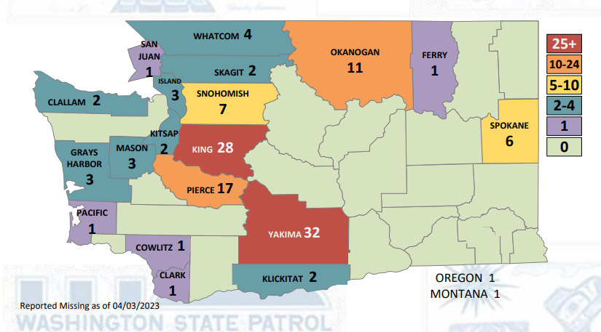

Source: (Washington State Patrol, 2023)

In looking at the missing numbers that Yakama people face, it is important to review the steps or actions the tribe has taken for MMIP. Additionally, the tribe has made several requests stretching back to 1855 regarding murdered Yakama women and girls.

Regarding important matters, you may hear Yakama person say, "Oh, Timnák’nik nash itchi sinwisha. They're speaking from their heart” (Wilkins, 2008).

Do community-based Task Forces work? Research has shown that tribes that use the Task Force approach: “Respond faster to community issues, use the leveraged partnerships to effectively coordinate efforts, may see up to a 40% reduction in criminal activity, encourage other crime prevention initiatives, and have better relationships with law enforcement” (Cuestas, 2022).

# States

State task forces for MMIP can bring a level of coordination, technical assistance, and help address multi-jurisdictional issues. Michigan does not have a task force. Montana and Washington have MMIWP state Task Forces. The set of questions to analyze the state Task Forces are: 1. Name of the Taskforce? 2. In operation from what timeframe? 3. The Construction Process? 4. Do they have a report? 5. The Primary Problem/Need? 6. The Recommendations? 7. The timeline? 8. Any unique approaches? Trends? 8. Cross-over between tribes’ actions and federal actions? 9. The Resources?

## Michigan

Michigan has 12 federally recognized tribes, but they do not have a state task force. Michigan Gov. Gretchen Whiter signed a proclamation in May to observed Missing and Murdered Indigenous Women Awareness Day. This annual proclamation helps bring awareness and acknowledge the work being done by tribes to address the crisis. “Red garments, each hung, flutter in the wind… several dozen of them in different shapes, sizes and shades. They serve as stand-ins for Native American women, and girls, who across the United States, and Canada are taken and/or murdered at unrelenting rates” (Clark, 2022).

Advocates describe the intersectionality within the federal government, tribes, and state for MMIP. “Unfortunately it hasn’t stopped the flow of epidemic violence we have against our women and children and men….But it’s been an improvement” (Froehlich & Monroe, 2023). Specifically, the pilot project is ending for MMIP Coordinator was based in the federal offices in Michigan. Advocates further explain how they are at the beginning phase. “What the initiative allowed thus far was to get the systems set up. And start getting some things in place. It’s a big undertaking you know. Trying to just gather the data we need and do the research to address the issues and to get the funding to address the issues…” (2023).

For MMIP in Michigan, there is a need for numbers. “No one knows for sure the number that have gone missing, or have been murdered, because there has been no single source for reliable data, and the information that is there is often incomplete or inaccurate” (2022). Overall, advocates call attention to focus the need for a state database for MMIP. Holly Bird, an attorney within Michigan commented about MMIP, “There is a lack of foundational knowledge and outreach in reporting purposes,” she stated, “in Michigan there isn’t a database specific to reporting missing and murdered Native Americans” (2022).

## Montana

There are 8 federally recognized tribes in Montana. The Montana Missing Indigenous Persons Task Force, was created in 2019 and had a reappointment in 2021, that is set to continue the Task Force through June 2023 (Silvers, 2021). The Task Force Mission is “To significantly reduce the numbers of Montana’s missing Indigenous persons by identifying barriers, strategies, and root causes with the utilization of education, technology, and specific recommendations to the legislature, to help heal and connect families” (Montana Department of Justice, 2022, p. 10).

“In Montana, Native Americans make up roughly 26% of missing persons cases but account for less than 7% of the state’s population — making them four times as likely to go missing as other residents” (Silvers, 2021). Looking at the 2023 numbers, “According to the Department of Justice’s Missing Persons Database there are currently 41 missing Indigenous people from Montana, 20 of which have been missing more than a year. More than a third of those missing are under the age of 18” (Smith, 2023).

Montana completed two reports in 2020 and 2022. They did significant data analysis in their 2020 report. Overall, the state agencies approached their analysis of missing persons “with the intent to help law enforcement agencies locate missing persons, inform policymakers to craft better solutions, and help communities prevent people from going missing. The data included every missing person entry over a three-year period, 2017-2019, from the Montana Missing Persons Clearinghouse” (2020, p. 24).

Out of 830 total missing Indigenous people they found “there were a disproportionate number of Indigenous females as compared to males the percentage of Indigenous Missing Persons by Gender. For male it was 40% and female it was 60%” (2020, p. 27).

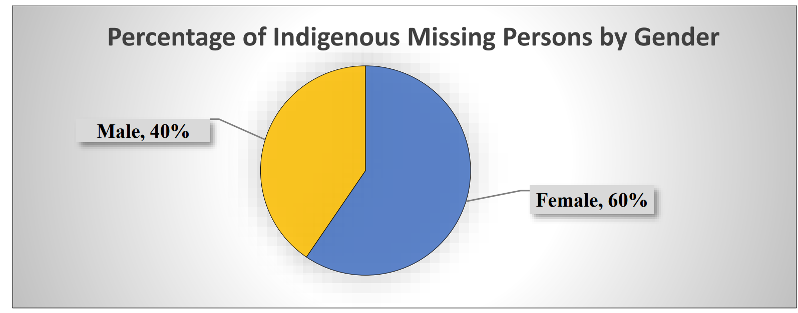

For 2022, we see the numbers for Missing Indigenous persons of any age by gender is 67% female and 33% male. (Montana Department of Justice, 2022, p. 14). One of the limitations is the data did not have an option for two-spirit or trans-individuals.

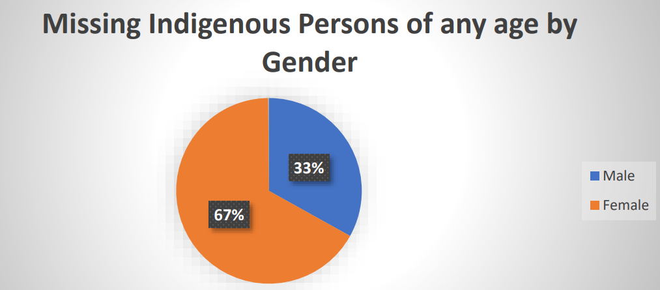

In Montana “…American Indians are 6.7% of Montana’s total population” (Montana Department of Justice, 2022, p. 4). For Montana missing persons, “…26% overall are Indigenous, looking deeper into other data sources may help reveal why these factors exist in Montana” (2020, p. 36).

Through Montana’s LINC ACT, the Task Force created a grant to create a portal for missing Indigenous people in Montana. The state funding was $25,000 and AT&T donated to match that for a total project funding at $50,000. Blackfeet Community college launched the site in November 2021 (War Cry Podcast, 2021). The Task Force’s recommendation #5 states, “currently 3 tribes are active and officially connected to the portal. The Task Force has bridged a gap and needs to continue and assure that the mmipmt.com site is sustainable. The Task Force would like the time to…assure that all [8] tribes have the opportunity to access the site. (Montana Department of Justice, 2022, p. 16). “When a report is entered on the site then the local tribal law enforcement agency receives an electronic alert. To date, the MMIPMT portal has received a total of 8 unique individual reports and 6 of those missing individuals reported on the site have been located” (pp. 12-13). Again, the federal government lists over 40 missing Indigenous People in Montana, compared to the 8 that have been uploaded on this portal. With the Task Force plans to expand the technology tools tribes have available find missing Indigenous, includes an increase of information about Missing Indigenous people on the portal.

One of the sponsors of the bill to reauthorize the Montana MMIP Task Force, Rep. Sharon Steward Peregoy said, “Particularly in Indian Country, and we heard over and over again, and we know as individuals, that the longer you wait, the evidence and trying to find an individual gets harder” (Silvers, 2021).

## Washington State

Washington is home to 29 federally recognized tribes. During the 2021 Legislative Session, advocates, community members and legislators negotiated a budget proviso establishing a MMIWP Task Force within the AGO [Washington Attorney General’s Office]” (Washington State, 2022, p. 10). The Task Force’s was approved from 2021 - June 1, 2023. To continue beyond that, Washington lawmakers would need to pass a bill. [3] One of the Task Force recommendations is to extend the Task Force through June 2025.

There is a continued need to address the safety and violence. “The MMIWP crisis is the culmination of generations of abuse, violence, harmful policy and broken promises by government institutions. The institutional structures and systems within our state, and our nation, do not adequately reflect the experiences of Indigenous people and therefore do not respond in ways that promote healing, justice, and accountability” (p. 6).

The Washington Task Force members are a mixture of tribal, state, and non-profit members. They identify federal agencies as key stakeholders they have outreach and engagement with (2022). The Legislature and GOIA appointed Task Force members during the fall [2021]. The Task Force held the first meeting on December 2 and 3, 2021. The first meeting was a hybrid meeting, hosted by the Yakama Nation.” (p. 14)

The Task Force released their first taskforce report in 2022. This also includes 10 recommendations which are edited for brevity:

1. Extend the MMIWP Task Force through June 30, 2025. 2. Continue data and research on the link between gender and violence. 3. Develop best practices for law enforcement agencies and for social and health services to improve this collaboration and coordination. 4. Utilize inclusive language that reflects the experiences of MMIWP families and survivors. 5. The Legislature should establish and fully fund a Cold Case Investigation Unit 6. All law enforcement agencies should improve communication and transparency with family members in MMIWP cases. 7. Require all law enforcement agencies to use the National Missing and Unidentified Persons System. 8. Update and re-issue the Missing Person’s Resource. 9. Public agencies should consider reducing administrative burdens associated with hosting large events such as MMIWP marches, rallies, vigils and memorials. 10. Continue to provide consultation to federally-recognized tribes (p. 6).

Regarding the third recommendation for law enforcement, there has been some reflection in eastern Washington. Yakima County Sherriff Udell said, “It’s taken agencies across the valley years to get to the point they are now, where they’re better able to share information and support each other in investigations. “We treasure those relationships. There is no one jurisdiction — be it us or anybody else that has the ability to truly affect crime on their own, but together, that’s where the magic happens.” (Goodell, 2022). In addition, with regards to multi-jurisdiction, “The Task Force supports the development and implementation of a Tribal Community Response Plan (TCRP)…” (p. 25).

The fifth recommendation is, “The Legislature should establish and fully fund a Cold Case Investigation Unit within the Attorney General’s Office with a focus on MMIWP cold cases[4]” (p. 26). Attorney Bob Ferguson said, “I look forward to honoring the Task Force’s recommendation and working to create an MMIWP cold case unit in my office… If funded, a cold case unit will direct critical resources toward these cases and help address the crisis of missing and murdered Indigenous women and people,” (Bejarano, 2022). Within this recommendation is the Homicide Investigation Tracking System (HITS). I have read about them for decades to help solve cases as they are often referred to as a repository of information regarding crime, suspects and patterns. They examined numbers regarding MMIP.

According to the data contained in the HITS database, 4.14% of the 10,535 total homicide cases involve an Indigenous victim. Of 2,268 recorded unsolved homicides, 4.98% involve an Indigenous victim. Indigenous people are 1.9% of the state population. These data show Indigenous people are disproportionately homicide victims, particularly unsolved homicides. The current data contained in the HITS database is likely a gross underrepresentation of the true nature of the crisis. (p. 22)

HITS references issues with reporting practices that contribute to the inaccuracy issue with the numbers. “There are more than 2200 unsolved homicides in Washington State. The vast majority are “cold” cases unsolved for years or even decades…. Law enforcement officers, particularly from small and tribal jurisdictions, have shared their experiences of the difficulty finding capacity to dedicate to cold cases while working on more recent cases and emergent issues” (p. 26).

What we do know is the oldest reported missing cold case in the state is a Yakama tribal member. “A little over 50 years ago, then-16-year-old Janice Marie Hannigan vanished shortly before Christmas in 1971 and hasn’t been heard from since. Little is known about her disappearance or what investigators know about her case” (Goodell, 2022). An additional finding was regarding the work families members do. “Further, when cases go cold, family members often continue to search for their loved one using their own resources, without support from law enforcement and other agencies” (Washington State, 2022, p. 26)

One unique Task Force approach is they have meetings for family members, which also includes a video conference option. “…The MMIWP Families Subcommittee hosts talking circles to provide a space for survivors, family members, and impacted community members to gather to share their experiences, find support, and build community” (p. 14).

As a result of the Task Force’s ongoing outreach, they shared 11 findings. One of which was with regards to investigation barriers. “Tribal law enforcement routinely experiences barriers accessing basic investigative tools and resources, including polygraphs and forensic investigators…. tribal law enforcement must contract these services from private companies, causing strain on resources and investigations” (p. 17). They cite jurisdictional issues and a lack of support from the federal government as a source of the barriers.

“The Task Force will produce its following report to the Governor and Legislature on June 1, 2023.” (Bejarano, 2022). Task Force Members stated, “There is much work to be done…We will never stop holding system accountable and searching for answers” (p. 2).

# Conclusion

Though this case study included complex analysis, at the root, these task forces are groups of people that are responding to the MMIP crisis. There are a number of different ways to respond. Advocates and tribal members have been vocal about the injustice caused by loopholes in the multi-jurisdiction, that predators take advantage of the chaotic system to target Native people. While we hold hope for change, we acknowledge that anybody that has a family member of an MMIP may have unanswered cries of hopelessness.

I will share a story that showed me how the some of the younger generation expects quicker response. Two years ago, on the Yakama Reservation my daughters were pumping a bike tire, got distracted, and went next door to play. About 15 minutes later they saw somebody walking away with their bike. It was the same purple color and flat tire. They yelled, “Hey, that’s my bike!” This person turned around and flipped them off. You may think it would stop there but though they kept their distance, they would not stop screaming asking for help. This caused people in the community to respond. Neighbors starting to come out of their homes and people started getting out of their cars from far down the street to run towards this individual. That person dropped the bike and ran as multiple people were chasing them. I thought, “Did my daughters just stop a crime in progress?” We did have a larger conversation with them about this situation. As we reflect back on this, they believe when they call for help the community will come. In just one generation, we see a huge shift from the whisper network my family gave me regarding how the response to crime was different for Native women and girls. By the generational shift in response expectations, my Yakama children illuminated a pathway of hope for me. If we are loud and clear, the community will help. When we apply this small story as an analogy to the central reasoning of what task forces are, we see there are tribal members on reservations, rural communities, and urban areas that are out there crying for help. The momentum is building for people and agencies to respond to our MMIP.

It is with the range of witnessing the emotions that come with unanswered cries for justice along with the answered calls that this case study analyzed the task force actions for MMIP. An enduring question we should ask is what additional actions can we take for families of MMIP?

# References

Bay Mills Indian Community . (2023). Who we are. Michigan. Retrieved April 1, 2023, from https://www.baymills.org/tribal-organization

Bay Mills Indian Community. (2018). Tribal Action Plan. Retrieved February 20, 2023, from https://www.baymills.org/_files/ugd/869f65_5240245e70114abcb19705d889977a3b.pdf

Bay Mills Indian Community. (2022, May 5). Tribal Community Response Plan Missing or Murdered Individuals. Michigan. Retrieved February 20, 2023, from https://www.baymills.org/_files/ugd/869f65_c5e6b0971e2c45168b3fc4e0f1719d53.pdf

Bay Mills Indian Community Victim Services. (2023, April 1). Victim Services Division. Michigan. Retrieved April 1, 2023, from https://baymillstribalcourt.org/victim-services-division/

Bejarano, J. (2022, August 3). Washington’s MMIW/P Task Force Releases First Report. Washington: Northwest Public Broadcasting. Retrieved December 1, 2022, from https://www.nwpb.org/2022/08/03/washingtons-mmiw-p-task-force-releases-first-report/

Biden, P. J. (2021, November 18). Improving Public Safety and Criminal Justice for Native . *Executive Order 14053 , 86*. Retrieved March 1, 2023, from https://www.govinfo.gov/content/pkg/FR-2021-11-18/pdf/2021-25287.pdf

Bureau of Indian Affairs. (2023). Missing and Murdered Open Cases. Washington D.C. Retrieved April 10, 2023, from https://www.bia.gov/service/mmu/missing-murdered-open-cases?title=&field_mmu_case_type_value=missing_person&page=3

Clark, S. (2022, May 5). Missing, Murdered: Silent endemic plagues Native American communities. Traverse City, Michigan. Retrieved April 1, 2023, from https://www.record-eagle.com/news/missing-murdered-silent-endemic-plagues-native-american-communities/article_d3990d22-cbdb-11ec-ac7d-f3e47441a61f.html

Clark, S. (2022, May 5). Missing, Murdered: Silent endemic plagues Native American Communities. Traverse City, Michigan. Retrieved March 1, 2023, from https://www.record-eagle.com/news/missing-murdered-silent-endemic-plagues-native-american-communities/article_d3990d22-cbdb-11ec-ac7d-f3e47441a61f.html

Cuestas, C. (2022, April 19). Chris Cuestas Micro Method Workshop 1. Toppenish, Washington: War Cry Podcast. Retrieved January 15, 2023, from https://youtu.be/aqJo-yRWyTo

Department of Justice. (2022). GUIDE TO DEVELOPING A TRIBAL COMMUNITY RESPONSE PLAN FOR Missing Person Cases. Washington D.C. Retrieved January 20, 2023, from https://www.justice.gov/tribal/page/file/1561361/download

Department of Justice, Department of the Interior, & Department of Health and Human Services. (2022, April 25). Final Report To The President. *Activities and Accomplishments of Operation Lady Justice*. Washington DC. Retrieved March 1, 2023, from https://www.justice.gov/otj/page/file/1511621/download

Federal Bureau of Investigations. (2023). Washington D.C. Retrieved April 9, 2023, from https://www.fbi.gov/wanted/indian-country

Froehlich, B., & Monroe, J. (2023, February 08). MMIP Initiative Could be Epiring this Spring, Tribal Communities Hoping for Solutions. Michigan. Retrieved March 1, 2023, from https://www.9and10news.com/2023/02/08/mmip-initiative-could-be-expiring-this-spring-tribal-communities-hoping-for-solutions/

Goodell, E. (2022, August 4). Yakama Reservation’s 40+ missing person cases could be solved by forming WA cold case unit. Yakima, WA: YakTriNews. Retrieved August 4, 2022, from https://www.yaktrinews.com/news/crime/yakama-reservation-s-40-missing-person-cases-could-be-solved-by-forming-wa-cold-case/article_eb9b6848-5c30-5180-9588-6aad33989a1c.html

Lucchesi, A., & Echo-Hawk , A. (2018, November 14). Missing and Murdered Indigenous Women and Girls. Seattle, Washington : Urban Indian Health Institute . Retrieved January 1, 2023, from file:///C:/Users/Emily/Downloads/UIHI-Missing-and-Murdered-Indigenous-Women-and-Girls-Report-20191009%20(3).pdf

Mabie, N. (2021, April 2). CSKT completes response plan addressing missing and murdered Indigenous persons. Great Falls, Montana: Great Falls Tribune. Retrieved February 20, 2023, from https://www.greatfallstribune.com/story/news/2021/04/01/cskt-completes-missing-and-murdered-indigenous-persons-response-plan/4838947001/

Montana Department of Justice. (2020, September 1). Looping in Native Communities. Helena, Montana. Retrieved March 2, 2023, from https://dojmt.gov/wp-content/uploads/LINC_Report_STRIC_FINAL_Aug.pdf

Montana Department of Justice. (2022, July 1). Looping in Native Communities. Helena, Montana. Retrieved March 3, 2023, from https://leg.mt.gov/content/Committees/Interim/2021-2022/State-Tribal-Relations/meetings/july-2022/MIPTF-2022-report.pdf

Petruzzelli, M. (2019, Aug 9). Senator meets with Yakama Nation Missing and Murdered Indigenous Women committee. Yakima, Washington : YakTriNews. Retrieved February 1, 2023, from Senator meets with Yakama Nation Missing and Murdered Indigenous Women committee: https://www.yaktrinews.com/news/crime/senator-meets-with-yakama-nation-missing-and-murdered-indigenous-women-committee/article_9aa2f866-40ee-5f5d-8ff2-194f0c0c87a7.html

Rios, M. (2022, May 5). Raising awarness for Missing and Murdered Indigenous People. Washington : Tulalip News. Retrieved March 1, 2023, from https://www.tulalipnews.com/wp/2022/05/05/raising-awareness-for-missing-and-murdered-indigenous-people/

Silvers, M. (2021, June 25). Missing persons task force discusses root causes and structural change. Helena, Montana: Montana Free Press. Retrieved March 1, 2023, from https://montanafreepress.org/2021/06/25/missing-persons-task-force-meets-helena/

Smith, E. (2023, March 15). Lawmakers pass bill to fund community-led missing persons responders. Helena, Montana. Retrieved March 17, 2023, from https://www.mtpr.org/montana-news/2023-03-15/lawmakers-pass-bill-to-fund-community-led-missing-persons-responders

The Confederated Salish and Kootenai Tribes. (2023). History and Culture. Montana. Retrieved April 2, 2023, from https://csktribes.org/history-culture

The Hibulb Cultural Center . (2023). Dedicated to Sharing Ancestral Stories. Washington: Tulalip Tribe. Retrieved January 30, 2023, from https://www.hibulbculturalcenter.org/Storytelling

Tulalip Tribal Police. (2023). Mary Ellen Johnson. Washington. Retrieved April 2, 2023, from https://www.tulaliptribalpolice.org/MaryEllenJohnson

Tulalip Tribes. (2023). Who We Are. Washington. Retrieved April 1, 2023, from https://www.tulaliptribes-nsn.gov/#:~:text=Our%20tribal%20population%20is%20over,and%20west%20of%20Marysville%2C%20Washington.

U.S. Department of Justice. (2022). FYs 2022-2026 Strategic Plan. Washington D.C. Retrieved March 2, 2023, from https://www.justice.gov/doj/book/file/1516901/download

U.S. Department of Justice. (2023, January 18). ABOUT DOJ EFFORTS TO ADDRESS MMIP. (U. States, Ed.) Washington D.C. Retrieved January 3, 2023, from https://www.justice.gov/tribal/mmip/about

U.S. Department of Justice. (2023, January 10). TRIBAL COMMUNITY RESPONSE PLANS. Washington D.C. Retrieved January 20, 2023, from https://www.justice.gov/tribal/mmip/tribal-community-response-plans

U.S. Department of the Interior. (2023). Missing and Murdered Open Cases. Washington D.C. Retrieved April 1, 2023, from https://www.bia.gov/service/mmu/missing-murdered-open-cases

Voelckers, S. (2020). Missing and Murdered Indigenous Women. *Indian Law Conference* (pp. 1-27). Spokane, WA: Gonzaga University. Retrieved March 1, 2023, from https://www.spokanebar.org/wp-content/uploads/2020/03/VOELCKERS-MMIW.pdf

War Cry Podcast. (2021, October 14). Ellie Bundy - Salish Kootenai and Montana Tribal Task force for MMIP. Toppenish, Washington. Retrieved January 20, 2023, from https://youtu.be/U3evTApqX80

Washines, E. (2018). About Yakama Nation. Toppenish, Washington: Yakama Nation Fisheries. Retrieved April 1, 2023, from https://yakamafish-nsn.gov/about-us/about-yakama-nation

Washington State. (2022, August). *2022 Interim Report of the Washington State Missing and Murdered Indigenous Women and People (MMIWP) Task Force.* Retrieved March 9, 2023, from Washington State Missing and Murdered Indigenous Women and People Task Force: https://agportal-s3bucket.s3.amazonaws.com/uploadedfiles/Another/News/Press_Releases/MMIWP%20Interim%20Report%202022.pdf

Washington State Patrol. (2023). Missing Indigenous Persons. Olympia, Washigton. Retrieved April 10, 2023, from https://www.wsp.wa.gov/crime/alerts-missing-persons/missing-indigenous-persons/

Wilkins, L. (2008). Nine Virtues of the Yakama Nation. *2*(17). Washington: Democracy & Education. Retrieved March 1, 2023, from https://www.cwu.edu/teaching-learning/sites/cts.cwu.edu.teaching-learning/files/documents/9_virtues_yakama_nation.pdf

Yakama Nation Victims Resource Program. (n.d.). REDgalia. Toppenish, Washington. Retrieved March 1, 2023, from https://d12m9erqbesehq.cloudfront.net/wp-content/uploads/sites/21078/2019/03/13001215/REDgalia.pdf

# Appendix

Bay Mills Indian Community shares 12 definitions which are below and some are summarized for brevity:

1. Adult: any person aged 18 years or older.
2. Amber Alert: a public notification system used to broadcast information about abducted children, aged 17 years of younger
3. Ashanti Alert: a public notification system used to broadcast information about missing adults, age 18 to 75 years
4. At-Risk Missing Person: a missing person aged 18 years or older for whom there is a reasonable concern for his or her safety, or for whom one or more of the risk factors listed below is present.
5. Endangered Runaway: a missing child older than age 12 but younger than 18, where credible information exists that the child has left parents or legal guardians without permission and for whom there is a reasonable concern for his or her safety
6. Indian Country: (a) all land within the boundaries of an Indian reservation, (b) all dependent Indian communities within U.S. borders, and (c) all Indian allotments held in trust or restricted fee by the U.S.
7. Indian Tribe: a federally recognized Indian Tribe or a Native village, Regional Corporation, or Village Corporation
8. Law Enforcement Agency: a federal, tribal, state or local law enforcement agency.
9. Missing Adult: any person over age 18 whose whereabouts are unknown without an reasonable explanation or in circumstances that cause reasonable concerns for their safety or wellbeing.
10. Missing Child: any individual younger than age 18 whose whereabouts are unknown to the individual’s parent or guardian.
11. Risk Factors: Being out of the zone of safety for their age and developmental stage, Having physical, mental, behavioral or cognitive challenges or disabilities, Being drug dependent, including prescribed medication and/or illegal substances, and the dependency is potentially life-threatening, Being in a life-threatening situation, Being in the company of others who could endanger their welfare, Being absent in a way inconsistent with established patterns of behavior and the deviation cannot be readily explained, Being in a situation causing a reasonable person to conclude the person should be considered at risk (e.g., commercial fishing, hunting, gathering, traditional cultural practices in remote locations and adverse weather events)
12. Silver Alert: a public notification system used to broadcast information about missing persons, especially senior citizens and Tribal elders with Alzheimer's disease, dementia, or other mental disabilities, to help locate them.

(Bay Mills Indian Community, 2022, pp. 4-5)

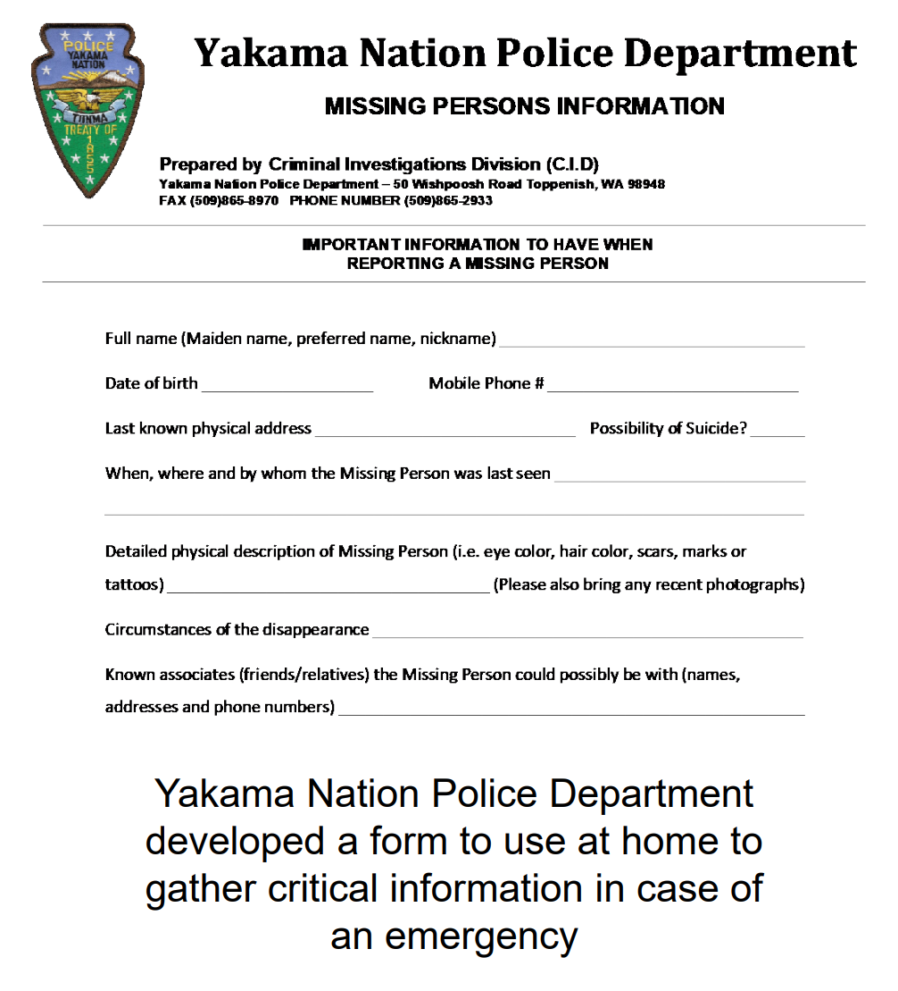

(Voelckers, 2020)

1. Yakama Nation language: Wiinatchapam dialect
2. Yakama Nation Resolution #T-081-22
3. As of April 16, 2023 Washington SB 5477, passed the Senate but is in the House. This would extend the MMIP Task Force.
4. As of April 16, 2023 HB 1177 Creating a missing and murdered indigenous women and people cold case investigations unit passed the Legislature and moved to the Governor.