Indian Gaming: Economic, Social-Cultural, and Political Frames
(A Triptych Case Study)
By Shalin Hai-Jew, Ed.D.

Teaching Notes

Issues / Topics case includes:
- Economic reasoning for Indian gaming
- Social-cultural issues in Indian gaming
- Political issues in Indian gaming

Learning Objectives:
- To introduce the history behind Native gaming
- To address the many economic rationales behind Indian gaming
- To show the social-cultural debates in Indian gaming
- To illustrate the political and legal oversight for Indian gaming
- To encourage logical analysis and problem solving skills as applied to a real-world tribal development situation

Abstract: “Indian Gaming” addresses an issue that has far-reaching economic, cultural and political implications for Native Americans, their leadership, reservation life, and the socio-economic status of many in Indian country.
This three-part case study uses three frames to understand this complex issue: economic, socio – cultural and political frames. These cases use a problem-based discussion model. The economic frame focuses on the challenges of economic development on reservations and how the public land model precludes some economic endeavors. The socio-cultural frame examines the stresses of maintaining a traditional culture in a global political and economic realm where cultural compromises may be forefront. The political frame looks at the legal principles and practices related to Indian gaming and the many layers of oversight for Indian gaming regulation.

The case itself is a “generic” without a specific focus on a particular tribe in order to be more inclusive and open to analysis with a particular focus on any of the hundreds of federally-recognized Native American tribes. An introductory section-- Indian Gaming in the U.S.: A Broad Introduction—sets the stage. The three cases are named as follows:

“All In? Economic Factors to Consider in Native Gaming”

“Smallpox or New Buffalo: What’s the Right Analogy for Indian Gaming?”
- “Setting the Rules for Native Gaming”

Each case includes discussion questions, role playing ideas, digital learning objects, case analytics, vocabulary, and embedded notes for instructors.

Case Versioning:
Given the needs of The Enduring Legacies Project, there are two versions of the cases. One is for face-to-face delivery, and one is for online delivery. The face-to-face is written for upper high school and early college level learners. The online version is for upper-level college learners and involves more in-depth research and citations.

Online Versioning / Pedagogical Strategy

Asynchronous Interactivity
Message board and threaded discussions
Presentation of digital learning objects and presentations online

Synchronous Interactivity
Synchronous (chat and live interaction, guest speaker)
* Look at the benefits of a point-by-point discussion synchronously for depth and a sense of order. Take turns to include everyone.

Archival Aspect
Online presentation of slideshows, speeches, papers, research…and archival in eportfolios or sites

Teaming (asynchronous and synchronous)

Online Sites
Online gaming sites and regulatory resources on the WWW
Tribal sites

Native American Cultural Aspect
Make the stances non-confrontational and cooperative, with a focus on problem-solving.
Help learners work together on teams.

“Hidden Information” from Research
Search for relevant “hidden information” that has not yet made it into the research.

Case Types: Problem-based and Discussion Learning, Analysis of a Generic

Possible Approaches
Re-enactments
Role playing
Plan creation (problem-solving approach for business or leadership structures)
Cultural artifact analysis
Teamwork
Research
Online speeches
EPortfolios

The image below shows how a full-wrap online delivery strategy provides a more holistic learning experience in digital spaces. The learners will engage with experts related to Native American gaming, digital learning objects like slideshows and audio video files, WWW resources, and the planned interactivity in engaging with these facilitated cases.

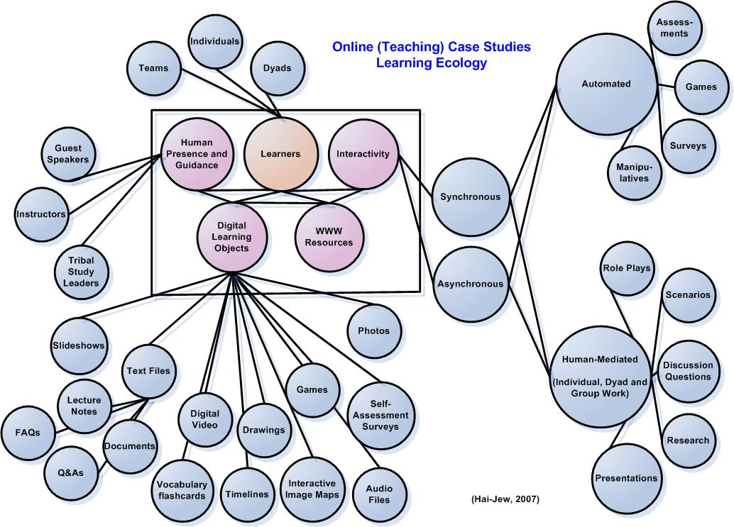

Teaching Notes

Learning Competencies:
Various learning competencies may be addressed by these cases. These have been defined in the following domains: knowledge, attitudes, and skills.

Knowledge | Attitudes | Skills
1. Subject Matter Competencies (Domain Knowledge)
The learners will understand… | The learners will form an attitude of… | The learners will be skilled in…
The economic rationales supporting (and those not supporting) Native American gaming for tribes | Support for the various endeavors to improve the livelihoods of Native Americans | Explaining the economic rationales supporting (and those not supporting) Native American gaming for tribes ; brainstorming various economic strategies to improve the livelihoods of Native Americans ; understanding the up-front costs of setting up Indian gaming ; understanding the need for a diverse economic base for tribes
Knowledge | Attitudes | Skills
1. Subject Matter Competencies (Domain Knowledge) | (continued)
The various socio-cultural issues raised with the advent of Native American gaming. | Empathy with the various socio-cultural stances regarding Native American gaming | Articulating the various socio-cultural issues raised with Native American gaming
The role of Native American casinos in promoting and supporting Native American identities, interests and cultures | Curiosity about the role of Native American tribal casinos in promoting Native American identities, interests and cultures | Promoting various Native American identities and cultural aims through existing social channels
A knowledge of the history of Native American gaming in the US | A logical and informed approach to Native American gaming in the US | Discoursing on the history of Native American gaming in the US
An understanding of the competition between tribes over Indian gaming | An awareness of a range of opinions among Native American tribes | The ability to articulate some of the various stances of differing tribes about Native gaming
A knowledge of the possible negative externalities to tribal gaming | Open-mindedness and analytical thinking about the positives and negatives stemming from tribal gaming | Identifying some positive and negative externalities caused by tribal gaming
An understanding of the rationales behind Native American gaming policies at the federal, tribal and state levels; The laws and policies affecting Native American gaming | Logic analysis regarding the governance and oversight issues related to Native American gaming | Understanding the respective oversight roles at the national, tribal and state levels in regards to Native American gaming  Describing the IGRA and some of the general laws and policies affecting Native American gaming
The styling and branding of particular Native American casinos | Awareness of the multi-layered impacts of Native American gaming, including on the realm of public opinion and perceptions | Identifying some of the styling and branding of various Native American casinos
The internal and external public relations piece in running casinos | Empathy with the various needs of the internal and external publics | Naming the various internal and external publics that Native American casinos face
Knowledge | Attitudes | Skills
1. Subject Matter Competencies (Domain Knowledge) | (continued)
The intrinsic human and hedonic needs satisfied by gaming | Empathy and understanding about why some people “game” | Explaining the aspects of human needs that may be satisfied through gaming
The various Native American spiritual and cultural beliefs as they interrelate with Native American gaming | Empathy about the varied stances that different Native American tribes take towards gaming | Describing a range of Native American spiritual and cultural beliefs related to Native American gaming
The main stakeholders surrounding Native American gaming | Understanding regarding the different stances of the different stakeholders involved in Native American gaming | Naming the various stakeholders surrounding Native American gaming and summarizing their general stances
The roles of various regulatory agencies over Native American gaming | Respect for the various regulatory agencies involved in Native American gaming | An ability to name and describe the various regulatory agencies overseeing Native American gaming
Knowledge | Attitudes | Skills
2. Strategic Competencies
The learners will understand… | The learners will form an attitude of… | The learners will be skilled in…
The factors that may contribute to economic decision-making | Realism in approaching economic issues within a system, a tribe and a casino, with basic understandings based on a free economic system and a business model | Using the terminology and ideas of economics
The need for social and cultural buy-in in the building of a casino in a region | Respect for the various constituencies that may be affected by the building and operating of a Native American casino in a particular area | Listening to the various concerns of stakeholders in a casino’s building and its operations;  Soliciting feedback from various stakeholders in a public venue
Various negotiations and other strategies used in formulating political decisions | Engagement in understanding the elements that feed into policy making and political decision0making | Analyzing and developing strategies to achieve certain political aims
Knowledge | Attitudes | Skills
3. Social Competencies
The learners will understand… | The learners will form an attitude of… | The learners will be skilled in…
The way to communicate with others regarding possibly controversial issues | Listening and respect for others’ opinions and voices | Communicating their own ideas with clarity and listening accurately to the ideas of others
An understanding of various stances on Native American gaming, particularly those that are different from one’s own | Respect for a diversity of opinions regarding Native American gaming | Articulating the various stances of various individuals and entities on the issue of Native American gaming
Form alliances with disparate groups for positive aims | Cooperation in working with disparate groups to push forward shared aims and goals | Negotiate fairly and clearly; articulate shared interests (between entities) logically
Knowledge | Attitudes | Skills
4. Self-Competences
The learners will understand… | The learners will form an attitude of… | The learners will be skilled in…
The importance of Native American sovereignty and self determination | Respect for the strengths of Native American peoples, their histories, and their collective futures | Analyzing whether policies and actions may benefit Native Americans in their sovereignty or not ; advocating for their own rights in a complex and live environment
The importance of the various voices of Native American individuals, groups and leadership organizations | Care for the various voices of Native American individuals, groups, and leadership organizations | Surfacing the various stances of Native American individuals, groups, and leadership organizations
That various Native American issues have underlying complexities that may be better understood through various forms of research | Inquisitiveness about the underlying factors behind various Native American issues, so that they may conduct further research for deeper understanding | Conducting research on complex and live Native American issues in order to promote deeper understanding

Intended Audiences: The intended audience may be upper-level high school learners and lower-level college learners for the face-to-face versions of the cases. The online versions of the cases have been designed for upper-level college learners.

Updating Plan for Indian Gaming Cases: These three (triptych) related case studies will need to be updated for the following elements:
- Legal and regulatory changes
- New Indian gaming policies
- New development of casinos, new business strategies, new games
- New economic development strategies related to the development of casinos
- New tribal leadership and approaches to Indian gaming
- Changes in consumer expectations for gaming entertainment
- Stakeholder changes, different stakeholders to the gambling issues

