Boundless Water and Bounded People:
The Cultural and Social Implications of Shellfish Closures in Boundary Bay

Emma S. Norman, Ph.D.
Northwest Indian College

"Everyone who looks over at the bay sees beauty,
but does not see that the beauty underneath is marred and imperfect,"
- Semiahmoo Nation Chief Bernard Charles

Abstract:

This case explores the closure of shellfish harvesting in Boundary Bay, a small body of water in the Salish Sea of the northwestern continental United States and southwestern Canada. At one time, this bay was one of the most productive shellfish harvesting locations on the Pacific coast. Coast Salish communities relied successfully on these waters for centuries as primary sources of food. However, degraded upland environment and bacterial contamination prompted governmental officials to close the area for harvesting in 1962. In Washington, the bay only recently opened for restricted use; it remains closed in British Columbia.
The Boundary Bay case presents several important themes regarding Native science, particularly within a transboundary context. First, the Boundary Bay case underscores the difficulty in maintaining a traditional food source in a contemporary environment. Second, the case reveals how jurisdictional fragmentation complicates the management of flow resources, such as water. Third, this case explores the practical considerations of ‘governing resources’ for First Nations communities who are often required to operate in a system, which requires expertise and training in a vocabulary and discourse foreign, and perhaps, counter-ethical to their belief system. Fourth, by way of looking forward, the case highlights the work of the Salish Sea Aboriginal Council, which is making great strides in the governance of shared resources – for and by the people of the Salish Sea.

Boundless Water and Bounded People:
The Cultural and Social Implications of Shellfish Closures in Boundary Bay
“When the tide is out, the table is set.”

Shellfish Closure in Boundary Bay

Shellfish have been a mainstay of Coast Salish communities for thousands of years. Clams, crab, oysters, shrimp, and many other species were readily obtainable for harvest year-round. The old saying among many Coast Salish communities, “when the tide is out, the table is set,” reflects how integral harvesting from the sea is to daily life. However, the ability to harvest has faced multiple pressures – both in term of pollution and in terms of access. Many traditional harvest sites along the coastal waters of the Salish Sea are now closed (or impaired) due to pollution. These closures have had serious impacts on the health and culture of coastal tribes and First Nations. In Washington State, access has proven to be an issue.
Boundary Bay, a small body of water in the Salish Sea of Northwestern continental United States and Southwestern Canada, is a poignant example of the difficulties associated with maintaining a traditional diet in a contemporary environment (See Map 1). At one time, this bay was one of the most productive shellfish harvesting locations on the Pacific coast. Coast Salish communities relied successfully on these waters for centuries as primary sources of food. However, degraded upland environments, bacterial contamination, and excess fecal coliform bacteria prompted governmental officials to close the area for harvesting in 1962. In Washington, the bay only recently opened for restricted use; it remains closed in British Columbia.
Map 1: Boundary Bay
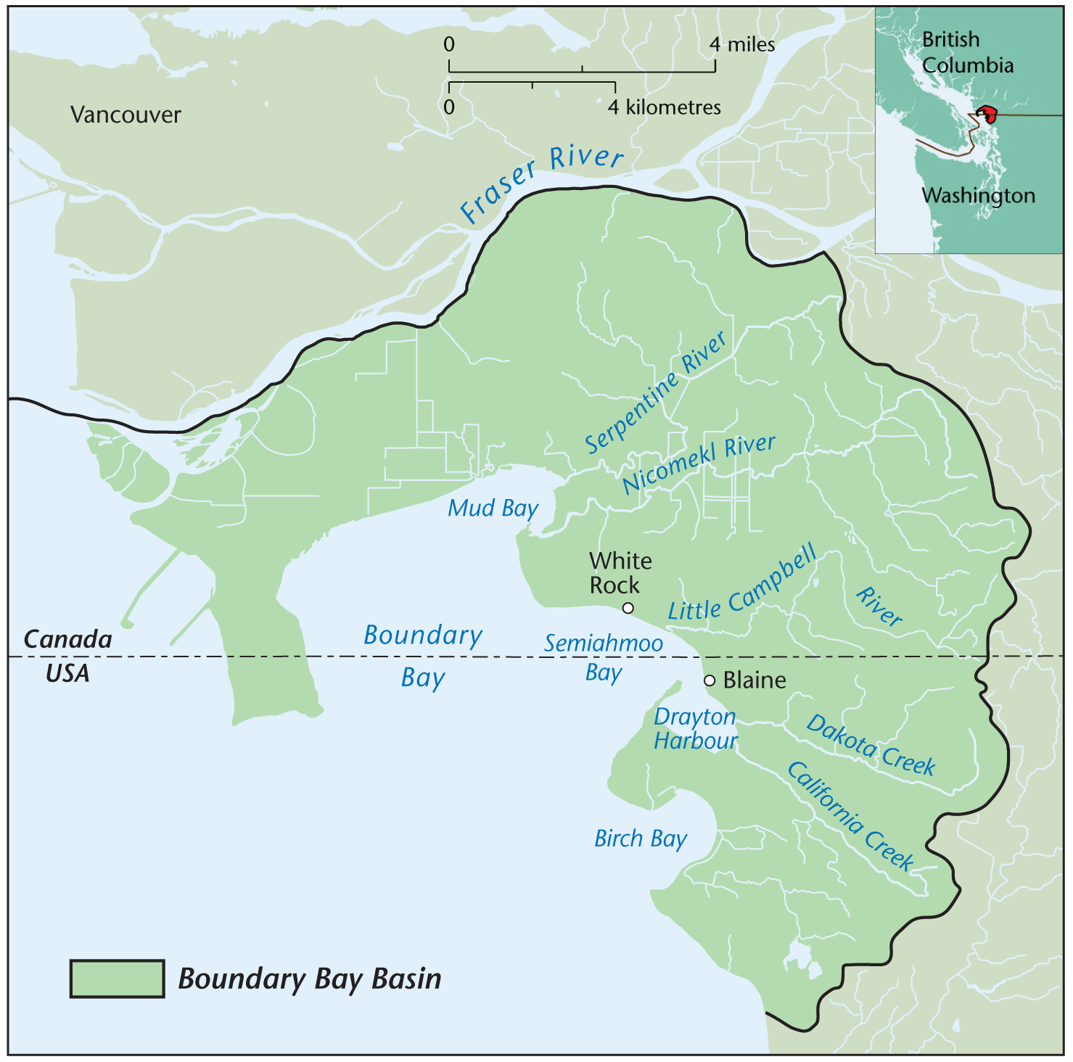
Source: Original Map. Cartographer: Eric Leinberger, UBC
Protection Water of the Salish Sea: Protecting a Way of Life
Water sustains life. For the First Nations and Tribal communities in the Salish Sea ecosystem, protecting water is part of an ancestral responsibility. Revered leader of the Salish community and former chief of the Tsartlip First Nation, Tom Sampson, describes this responsibility and the sacred nature of water:
Water provides our bodies and our spirits with blessing each day of our life as it provides life to all of creations. We know that the water that flows from the sacred mountain will nourish all things that the Creator placed on our sacred mountain. The water that travels to the ocean will nourish and feed all of those things that live in the ocean — the fish, the shellfish, etc. It is the fragrance of the mountain, which guides the salmon back to its place of birth.
We as First Nations have seen water when it was clean and it is sacred to all of creation. We now see other governments and corporations seeking ownership to polluted waters and dying oceans/lakes/rivers/streams. If we are going to save the water and the land, we must change the way we see things and share the protected water so that all of creation will benefit from our true discipline, which was given to us by the Creator.
Protecting the water sources of the Salish Sea is also a practical matter of preserving a way of life. However, over the past 150 years, the sacred waters of the Salish Sea region that have sustained a thriving culture since “time immemorial” have faced increased pollution pressures. Industrial and agricultural runoff, urban build-up, and forest conversion all contribute to the region’s declining water quality. Water quality tests routinely find heavy metals (such as arsenic, copper, cadmium, selenium, mercury and nickel), polychlorinated biphenyls (PCBs), and chlorinated pesticides throughout the marine waters (Donatuto 2005). This is concerning particularly because the toxins are non-water soluble and accumulate in the marine system. The degraded marine environment disproportionately affects the Coast Salish communities, whose traditional way-of-life necessitates a seafood diet (Donatuto 2005; Judd et al. 2005).
In addition, contaminated freshwater sources and conversion of upland habitat places great strain on the salmon population and impairs drinking water sources. In many areas, increased demand on freshwater sources due to growing population pressures and agricultural-industrial needs is surpassing the recharge rates of many underground water sources throughout the region. Compounding this issue, recharge rates are slowing as impermeable surfaces such as roads and buildings replace permeable surfaces such as forests and fields.
The upland conversion of forests, in particular, affects the region’s salmon population. The critical habitat necessary for salmon to spawn – a cold, clear, oxygenated and clean river – is increasingly turning warm, silt-laden, deprived of oxygen, and polluted. In fact, a recent study of the Salish Sea region found that sixty-four percent of the tested sites had conditions that limited the ability for salmon to effectively reproduce (described as “impaired”), as depicted in Map 2: Freshwater Quality in the Salish Sea Basin. The main culprits of the decline in water quality include forest harvesting, agricultural use and urban environments.
Map 2: Salish Sea Basin Freshwater Quality
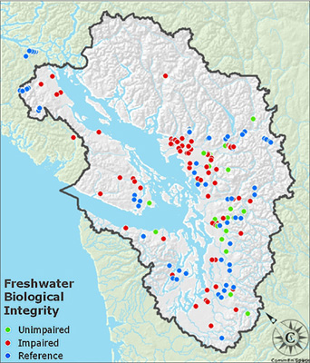

Source: Environmental Protection Agency (2008)

The leaching of industrial pollutants and agricultural waste also pollutes underground freshwater sources within the Salish Sea region (Wei 1993; Hii et al. 1999; Almasri and Jagath 2004). Obtaining their water from well-based systems are particularly vulnerable to the immediate health risks of a polluted water source (Miller, Chudck, and Babcock 2003).
For the Salish Sea region, the political fragmentation of the communities further complicates the management of these shared environmental issues. The transboundary nature of flow resources, such as water and salmon, and non-point source pollutants, such as PCBs and mercury, compounds the need to address these issues multi-jurisdictionally.
The Coast Salish people, whose traditional territory spans and predates the politically fragmented habitat, are likely to lead this ambitious transboundary initiative.

Making Native Space

Boundary Bay is a traditional harvesting site for several Native communities throughout the Straits Salish and Interior Salish communities. Native communities such as the Nooksack and the Semiahmoo have relied on Boundary Bay’s bounty to sustain their livelihood since time immemorial. The Nooksack people, who live in the foothills of the Cascade Mountains and the base of the upper Fraser River Valley, participate in seasonal shellfish harvesting; supplemented by other activities such as hunting of game and gathering of plants. The Semiahmoo, whose permanent villages were centered around Semiahmoo and Birch bays, are predominantly a fishing, especially reef-fishing, oriented community and participate in shellfish harvesting year round (Suttles 1951).
The 1849 demarcation of the Canada-U.S. border placed the Semiahmoo and the Nooksack communities on either side of these new territories and under different political allegiances. The Semiahmoo in Canada (under the establishment of the new colony of British Columbia) and the Nooksack in the United States (under Oregon Territory) were faced with a new set of national identities, laws and policies to navigate. The political demarcation not only severed a cultural continuum that spanned and predated the 49th parallel, it also created a different set of national identities, rights to ownership, and land and resources policies that continues to impact Native communities (Harris 2001; Harris 2002; Boxberger 1993). North of the border, the burgeoning territory of British Columbia looked towards their mother country of Great Britain to guide their government, and the subsequent creation of the Westminster parliamentary system. South of the border, however, the governmental roots are revolutionary-based; rejecting the eighteenth-century British system and creating a distinctive system of checks and balances and separation of powers (Hoberg 2000: 26). As the divergent political systems strengthened and developed national identities, communities whose traditional territories spanned the international divide became increasingly fragmented.
Shortly after the demarcation of the 49th parallel, yet another bounding of space occurred in the western Pacific with the creation of the Reserve system. The physical and political restructuring of Native communities, as well as the managed access to resources such as salmon and shellfish, bound the communities into a “foreign” controlled and designed system. In fact, the social and political structures of Coast Salish communities are not based on “tribes” per se, rather on family-units unified by cultural practice, language, and intermarriage (Suttles 1960, Boxberger 1989). As Suttles (1960: 296), reflects groups of villages like the Semiahmoo, Nooksack and Lummi were linked by “common dialect and traditions as ‘tribes’ but in recent generations these village groupings were certainly not separate “societies." Anthropologist Daniel Boxberger (1989: 12) further recounts,

Allegiance and identification could, and often, did, extend to the other Straits Salish groups, but the primary bound was a shared language and culture, not a unified political structure. Thus, the [Salish communities] …did not exist as an identifiable and separable “tribe” before 1855. Straits Salish individuals’ immediate allegiance was to the house where they resided, but this did not mean that embers of the houses necessarily cooperated in economic activities, particularly fishing.

Thus, the creation of the reserve system significantly altered the settlement, migration patterns and access to resources for the Salish communities. The new system disrupted traditional property rights within the straits Salish communities, which were demarcated through family lineage and class. For example, the best clam beds and salmon weir sites (as well as camas beds, fern beds, and wapato ponds) were owned by extended families with control exercised by individuals. Accesses to the sites were based both within the community and among communities and were secured through civil processes such as potlatch exchanges and feasts (Suttles 1960, Harris 2001). Thus, the political demarcations drastically changed the Native communities’ participation in subsistence activities such as shellfish harvesting in Boundary Bay (and beyond) as access to marine resources are regulated under divergent sets of codes, laws and principles. (See Appendix A for a detailed account of the creation of the Semiahmoo and Nooksack Reserves.)
Divergent Shellfish Closure of Boundary Bay
Shellfish Harvesting in Canada
In Canada, Boundary Bay, Mud Bay and Semiahmoo Bay all are closed to shellfish harvesting in the waters and intertidal shores north of the international boundary. These closures, directed by the Ministry of Health, result from excess fecal coliform bacteria found in the waters, where shellfish, which, if consumed, pose a significant human health risk. The Semiahmoo Band, whose traditional territory (and modern Reserve) center around Semiahmoo Bay have actively fought against the closure of the shellfish beds as it jeopardized their right to harvest as generations had before them. The Semiahmoo who have engaged in subsistence and cultural shellfish harvesting for thousands of years, maintain they have methods to safely harvest and clean the shellfish that reduce, or eliminate, the human health risk. In short, the ability to harvest shellfish is linked to their sovereign rights as First Nations.
Canadian First Nations customary rights to fish and harvest marine resources are protected by a number of mechanisms, including the Constitution of Canada, court rulings, a federal Aboriginal Fisheries Strategy and land and sea settlement agreements (Sutherland 2000). The Supreme Court of Canada legally affirmed the right to fish for food, social, and ceremonial in the 1990 case, Sparrow v. Queen. The Sparrow decision was based on the interpretation of the 1982 Constitutional Act, section 35(1), which states, “the existing aboriginal and treaty rights of aboriginal peoples of Canada are herby recognized and affirmed” (Boxberger 1994: 6). Although the Sparrow decision prioritized Native fisheries over recreational or commercial fisheries, the case left room for government override for issues such as resource conservation. In the Boundary Bay case, the closure of the shellfish is directed through the Ministry of Health.
The Sparrow decision was the first step in securing Native rights to traditional fishing areas. This decision led to further development of agreements between the Canadian government and Native communities. In 1992, for example, the Department of Fisheries and Oceans (DFO) launched the Aboriginal Fisheries Strategies, which “seeks to provide for the effective management and regulation of the Aboriginal fishery through negotiated agreements” (DFO 2009). Furthermore, the Marshall case of 1999 further expanded the legal right to fish, when the Supreme Court of Canada confirmed that the
Mi’kmaq, Maliseet and Passamaquoddy peoples in Quebec and the Maritimes provinces have a right to fish commercially and earn a ‘moderate livelihood’. Although this treaty right was first agreed to 240 years ago between British Columbia and the Mi’kmaq, the case contextualized the treaty into the highly regulated commercial fisheries of the 1990s (Sutherland 2000). Since the Marshall case, the treaty rights to earn a moderate living have extended beyond hunting and fishing to include other resources such as cut timber (as recently upheld in R. v Bernard [2003]) (Harris, D. 2003). However, in the closures associated with perceived and real health risks, these rights are not applicable. An issue of concern raised by the First Nations, and other stewardship groups like the transboundary group, Shared Waters Alliance, is that the provincial authorities in British Columbia are conducting routine water quality and shellfish testing - unlike in the U.S. where the testing affords the opportunity (all be it restricted) to shellfish. One tribal member from Semiahmoo in Canada discussed her frustration with this disconnection, when she spoke of members of the Semihamoo band getting arrested for harvesting shellfish. While the arrests were occurring they could see their relatives across the bay, the Lummi, harvesting. This poignant moment underscores the disconnect that occurs when a connected ecological and cultural system is bifurcated by a political border, and operates under different sets of policies and laws.
Map 3: Map of Shellfish Closure in Boundary Bay, Semiahmoo Bay
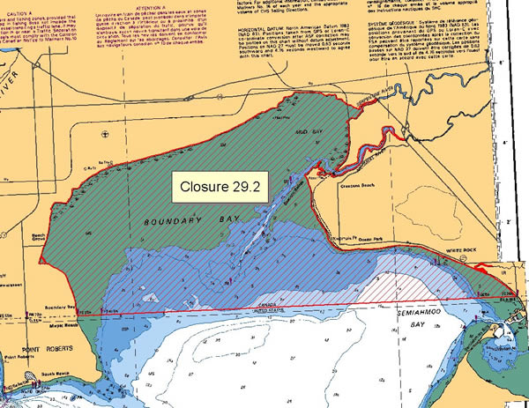
Source: Fisheries and Oceans Canada (2006)
Shellfish Harvesting in the United States
The contaminated waters of Boundary Bay also threaten the tradition of shellfish harvesting in the United States. However, as a result of significant clean-up efforts (and a willingness by the state to routinely test – something that does not occur in British Columbia) – Drayton Harbour has been open for ‘conditional use’ since 2004. This means that certain groups, including indigenous groups and licensed commercial harvesters, are able to harvest when the environmental conditions are amenable to a safe harvest.
In the United States, the “legal” right to harvest shellfish lies within a series of treaties signed with representatives of the federal government in the 1850s. These treaties secured “legal” rights for western Washington tribes access to fish in ‘all usual and accustomed grounds’ (NWIFC 2009) However, it should be noted that Native Coast Salish peoples have always had “inherent” rights to the fishing and shellfish grounds – these treaties represent a negotiation between the “newcomer” and Native communities. And represents a political structure placed upon a community that already had systems in place.
As “shellfish” are “fish” within the meaning of treaties, the shellfish have come to mean the same rights as other fish such as salmon. The treaty of Medicine Creek, the first of six of these treaties signed between 1854-1986, maintained that:

The right of taking fish, at all usual and accustomed grounds and stations, is further secured to said Indians in common with all citizens of the Territory (Treaty of Medicine Creek, 1854, Article 3).

Furthermore, the Treaty of Point No Point stated that:
“The right of taking fish at usual and accustomed grounds and stations is further secured to said Indians, in common with all citizens of the United States; and of erecting temporary houses for the purposes of curing; together with the privilege of hunting and gathering roots and berries on open and unclaimed lands. Provided, however, that they shall not take shellfish from any beds staked or cultivated by citizens.” (Treaty of Point No Point Jan. 26, 1855)
Thus, federally recognized tribes, such as the Nooksack and Lummi, are legally able to harvest shellfish for sustenance and cultural purposes in their “usual and accustomed” (U & A) harvest areas. These rights were upheld by the U.S. District Judge George Boldt, who interpreted ‘in common with’ to mean “sharing equally the opportunity to take fish ... therefore, non-treaty fishermen shall have the opportunity to take up to 50% of the harvestable number of fish ... and treaty right fishermen shall have the opportunity to take up to the same percentage.”
However, the harvesting of shellfish is complicated by the fact that several decades after the Stevens Treaties were signed, Washington State sold their tidelands to private parties. Further complicating the issues is that for more than a century, most western Washington tribes did not exercise their treaty rights to harvest shellfish. Thus, when the tribes began reintroducing harvesting, the private shellfish industry offered tremendous resistance. As salmon populations decline throughout the coastal Pacific due to a triage of overfishing, upland pollution and climate change, shellfish harvesting is becoming increasingly important to the economic livelihood for many Coast Salish communities (NWIFC 2009).
A 1994 court decision, known as the Rafeedie decision (or “Boldt II”), fueled the controversy, as the ruling was almost impossible to monitor. The ruling said that Native harvests had the right to ‘wild’ shellfish, but not the shellfish grown by non-Native commercial growers. The inability to distinguish between wild and farmed shellfish, fueled a two-decade debate between the parties. However, a recent settlement (July 2007) was made between Northwest tribes, private shellfish industry, and the state of Washington, which seem amenable to all parties (Mapes 2007).
Bounding and Governance
Hunters and Bureaucrats: Navigating the Waters of Permitting
The Nooksack Tribe and Semiahmoo Band actively participate in the multi-governance process to help address the pollution of Boundary Bay and the subsequent shellfish closures. Reducing the pollution inputs of Boundary bay is a priority for both communities as shellfish harvesting remains integral to their cultural fabric. Participating in the governance process provides a space for the tribal communities, governmental and nongovernmental actors to exchange information, coordinate projects and dialogue regarding the general state of the bay. The multi-governance forum provides an opportunity for the tribal representatives to give voice to their communities’ needs. It also serves as a reminder that the degraded landscape has wider socio-cultural impacts beyond the polluted water. For these reasons, among others, the participation of Native communities provides an important addition to the governance process.
However, participation in the transboundary governance process has wider political implications for Native communities. By participating in this process, they are operating within ‘foreign’ systems, which are often “incompatible with certain First Nations beliefs and practices” (Nadasdy 2004: 9). The science which the management techniques are based is dependent on the worldview or cultural paradigm of the definer (Littlebear 2000). In Hunters and Bureaucrats: Power, Knowledge and Aboriginal – State Relations in the Southwest Yukon Nadasdy (2004: 8) maintains that, “by accepting and adapting to governments’ bureaucratic approach to Aboriginal-state relations, First Nations people also tacitly accept the assumptions about the nature of land and animals that underlie the rules and functions of that bureaucracy.” Thus, participating in a co-management relationship, or, in this case, a multi-governance structure, places the burden of assimilation of the First Nations communities. On the surface, it appears the process may be empowering to the Native communities, but Nadasdy argues - drawing on sociologist Michel Foucault’s work on power and knowledge - that it may in fact have the opposite effect. This process may undermine their traditional / cultural ways of knowing and ultimately serve as a “subtle extensions of empire, replacing local Aboriginal ways of talking, thinking, and acting with those specifically sanctioned by the state (11).”
Thus, the co-management (or in this case multi-governance), of ‘resources’ such as water, shellfish - or wildlife, as Nadasdy argues - reifies Euro-American power relations and places the Native American and First Nations communities into a dominant discourse outside of their own perspective, and in many ways, counter-ethical to their own belief systems. For example, they are constrained by the “calculable rules” of wildlife management and the implied “non-rational assumptions about the nature of the world upon which these rules are based” (Nadasdy 2004: 8).
One of the fundamental differences between Western and non-Western views of nature are the variant placement of humans within or outside nature. Cajete, in his book Native Science notes, for example, “Western science and society perpetuate the illusion of ‘objective’ detachment and psychological disassociation”, whereas “Native science continually relates to and speaks of the world as full of active entities with which people engage” (2000: 26-7). Thus, the Western tradition of science plays a god-trick as Donna Haraway (1991) calls it, where humans are placed outside of the ‘natural’ system looking down.
The traditions and beliefs outside of the Western tradition, however, have been historically marginalized as Western beliefs are reified (and institutionalized) through policies and nation-building projects. Europeans imported their worldviews to define the policies that have not only carved the physical landscape of the country, but also defined human relationships to nature. The closure of the shellfish beds by the state is a direct affront to Native sovereignty; however, more subtly, the participation in the multi-governance process reinforces the Euro-American [and Euro-Canadian] worldview[s] of science and perspectives of management of Boundary Bay.
The politics are compounded when the governance area is in a transboundary basin – where divergent political systems bifurcate culturally-ecologically connected areas as separate spaces. So, in the case of the Semiahmoo, whose traditional shellfish harvesting area rests both in the U.S. and Canada, the physical placement of their reserve in Canada, bounds them to the Canadian policies of access to resources. In the U.S., where the federally recognized tribes are able to harvest, the Nooksack tribe has rights to harvest in their federally defined ‘Usual & Accustomed territory’. However, the Semiahmoo – unrecognized in the U.S. – have no such rights.
As discussed above, harvesting has reopened conditionally for federally recognized tribes in Washington State. However, in order to participate “legally” in the harvest, the tribal members must navigate a ‘foreign bureaucracy’ with a matrix of rules and regulations. The particulars of ‘when, where, how, whom and how much’ are all meticulously outlined and governed by state officials such as the Washington State Department of Fish and Wildlife. The wording and procedures of the regulations reflect a Western scientific approach to wildlife management rather than a traditional ecological approach.
Below is an example of some of the rules surrounding the harvest of shellfish in Washington State found on the Northwest Indian Fisheries Commission website:
Several steps must be taken before any tribal harvesting can occur on a beach, and the property owner will get notice of these steps. The tribes are required to conduct shellfish population surveys and estimates before any harvesting can occur. It would be impossible to determine what the tribes’ share of naturally occurring shellfish is on a beach without current information.
A population survey can occur no more than once every year, and its cost must be paid for by the tribes. All information will be shared with the property owner and the Washington Department of Fish and Wildlife (WDFW). Surveys will generally be conducted during low tide episodes in the spring and summer.
If the population survey indicates there is sufficient shellfish on the property to sustain a tribal harvest, then a tribal regulation opening that property for shellfish harvesting will be issued. Notice will be sent to the property owner and WDFW.
The notice will include the quantity of shellfish that may be taken, the purpose of the harvest (commercial, subsistence or ceremonial), and the dates and times when the harvest will take place. The name, address, and telephone number of the tribal representative responsible for the harvest will also be included in the notice.
If the shellfish surveys indicate a beach doesn’t contain shellfish in sufficient quantity, no harvesting would occur. The tribes may be interested in entering into cooperative enhancement projects with specific property owners to bolster shellfish populations, providing more resource for both the tribes and tideland owners.

Property owners are entitled to have their own scientifically valid population assessment done at their own expense. If such an assessment differs from the tribe’s results, the property owner may bring that discrepancy to the attention of the tribe in writing. If the property owner and the tribe cannot resolve the difference, either the property owner or the tribe can initiate a dispute resolution process through the federal court.
(NWIFC 2009)

The above passages reveal that although the federally recognized Native tribes have access to shellfish harvesting, unlike the Semiahmoo in British Columbia, they are bound by distinct rules and regulations designed through the application of Western-based-science procedures. Participating in population surveys and estimates, reporting catch, and providing written notification of intention to harvest are all techniques of management that place the rights to harvest within the context of a policed system.
These rules are both internally and externally policed. The tribes themselves are responsible for working within the defined ‘foreign’ system and reporting aberrant behavior. For the system to work, the tribal members have to buy in – or internalize – the regulations. The surveys, calculations and reporting situate the act of shellfish harvesting into a Western-based science. For the Salish fisher, however, distinct rules to access of resources are embedded within the cultural norms and passed down between generations. Traditionally, the rights to fish are earned and all family members are provided for. In this system, in which an intricate organizational scheme exists within a tribe and inter-tribally, everyone within the community has a role in the harvesting, from the net-mending, to the cooking (Suttles 1951; Boxberger 1989; Singleton 1998, 2000).
However, working within the U & A system treats the shellfish as a countable object, disconnected from traditional rights of access. This reporting system also reinforces distinct power relations in which state bureaucracies control key aspects of the harvest. The physical demarcation of political borders - separating cultural landscapes by the Canada-U.S. border, the reserve boundaries, and U & A harvest areas – further contributes to the weakening of the historical-cultural act of harvesting. This is problematic as Coast Salish communities view harvesting an inherent right.
This is particularly problematic in Washington State, where the tribes must access the tidelands through private lands. This monitoring occurs both internally, through tribal resource departments and externally, through the Washington Department of Fish and Wildlife and requires proper identification, such as a valid tribal identification card.
Counting Shellfish
The physical process of enumerating shellfish further places the harvest into a quantifiable framework which lends itself to regulation by the state. This ordering, or enframing, reduces the complexities of shellfish harvesting into a calculable (and manageable) quantity. This transformation lends itself to a new state power that sociologist Michel Foucault argues is a form of modern governmentality (Demeritt 2001; Mitchell 1991). That is, the enumeration, amalgamation and classification of “data” have great political impactions. As Hanna (2001) further observes, the politics of enumeration tend to have greater impacts on underrepresented and marginalized populations such as Native Americans living on reservations (among other groups).
Asymmetry
The demarcation of the Canada-U.S. border, and the subsequent policies towards Native rights to harvest, has altered the pre-border inter-tribal relationships. As one tribal Natural Resource employee noted, the divergent polices complicate the tribe-to-tribe negotiations regarding shared transboundary resources. In the case of the Nooksack and the Semiahmoo, although representatives of each tribe or band attended the multi-jurisdictional roundtable meetings to discuss the shellfish issues facing Boundary Bay, they still faced many hurdles to working cooperatively. For one, the representatives of the tribes and bands are not always authorized to discuss the shellfish issues. As a representative from the tribe reflected,

Right now, [our tribe] is recognized by the federal government as having treaty rights to harvest shellfish in what we call the usual and accustomed location …. And that’s very important to the tribe that these rights are protected and that we want to ensure that they continue.

So when I’ve reported back that the [Canadian band] is trying to make overtures to work in the waters on this side of the border, too; there’s a strong reaction with respect to the fact that they do not have those same federally recognized rights on this side of the border. And if they wish to secure those rights, which is not a small task, they need to be making overtures and meeting with the tribes themselves.

A discussion with me, at that table, is not adequate to do that. They have to be talking to our leaders. And while I did transmit all that information, I don’t actually know what happened in that regard. But, I wasn’t really authorized to work with them because that agreement hadn’t been put in place.

Here, the divergent polices in the U.S. and Canada has perpetuated an internalization of "foreign" borders within the Native communities where differential access to limited resources based on those political borders accentuates their reality with respect to many issues.

Looking Forward: The Salish Sea Aboriginal Council
The Coast Salish Aboriginal Council – A new beginning
The first annual Salish Sea Aboriginal Gathering took place in S’kallam Tribal Center in Sequim, Washington in November 2005, Jamestown. This gathering brought together First Nations chiefs, tribal chairs and council members from around the Salish Sea (Georgia Basin-Puget Sound) region – spanning north of Powell River down the Washington coast. Invited delegates from U.S. and Canadian governments and environmental organizations also participated in dialog with the tribal leaders in an attempt to address environmental issues that pose a threat to the “long-term sustainability of their culture and the shared eco-region that supports their cultural diversity.” The increased difficulties for Coast Salish communities to maintain a traditional way of life due to the serious environmental challenges to the Salish Sea provided the impetus for this meeting. Coast Salish leaders recognized the need to work collaboratively with their relations on both sides of the U.S.-Canada border.
At the end of the three-day meeting, the Coast Salish leaders committed their communities to finding solutions to these pressing environmental issues. The leaders agreed that the most effective way to accomplish this goal was to establish their own governing body and speak with a unified voice. As a result, the Coast Salish leaders formed the Coast Salish Aboriginal Council, which represents more than 70 tribes and bands, and approximately 45,000 square miles of the Coast Salish region. This was an historic event, as several decades have passed since this many Coast Salish leaders convened to address issues of shared concern.
The tribal and band leaders developed the Salish Sea Aboriginal Council as a first step in reconnecting the geographic space, known as the Salish Sea, socially, economically, and politically. Through the development of the Council, the tribes and bands have committed to working together to address shared environmental issues – drawing on a strong connection to their land, shared ancestors, and a commitment to the revitalization of their cultures. As a group, they share the goal “[t]o protect the environment and natural resources of the Salish Sea for the sustainability of the Coast Salish peoples.” The creation of the Salish governing body does not replace participation in other environmental fora; rather, it provides an organization designed for and by Salish people. The Salish Sea Council continues to meet every 12 to18-months, rotating between tribes and bands in the U.S. and Canada. (See Map 3 for a map of the Salish Sea region.)
Map 3: Salish Sea Basin and Participants of Salish Sea Gatherings
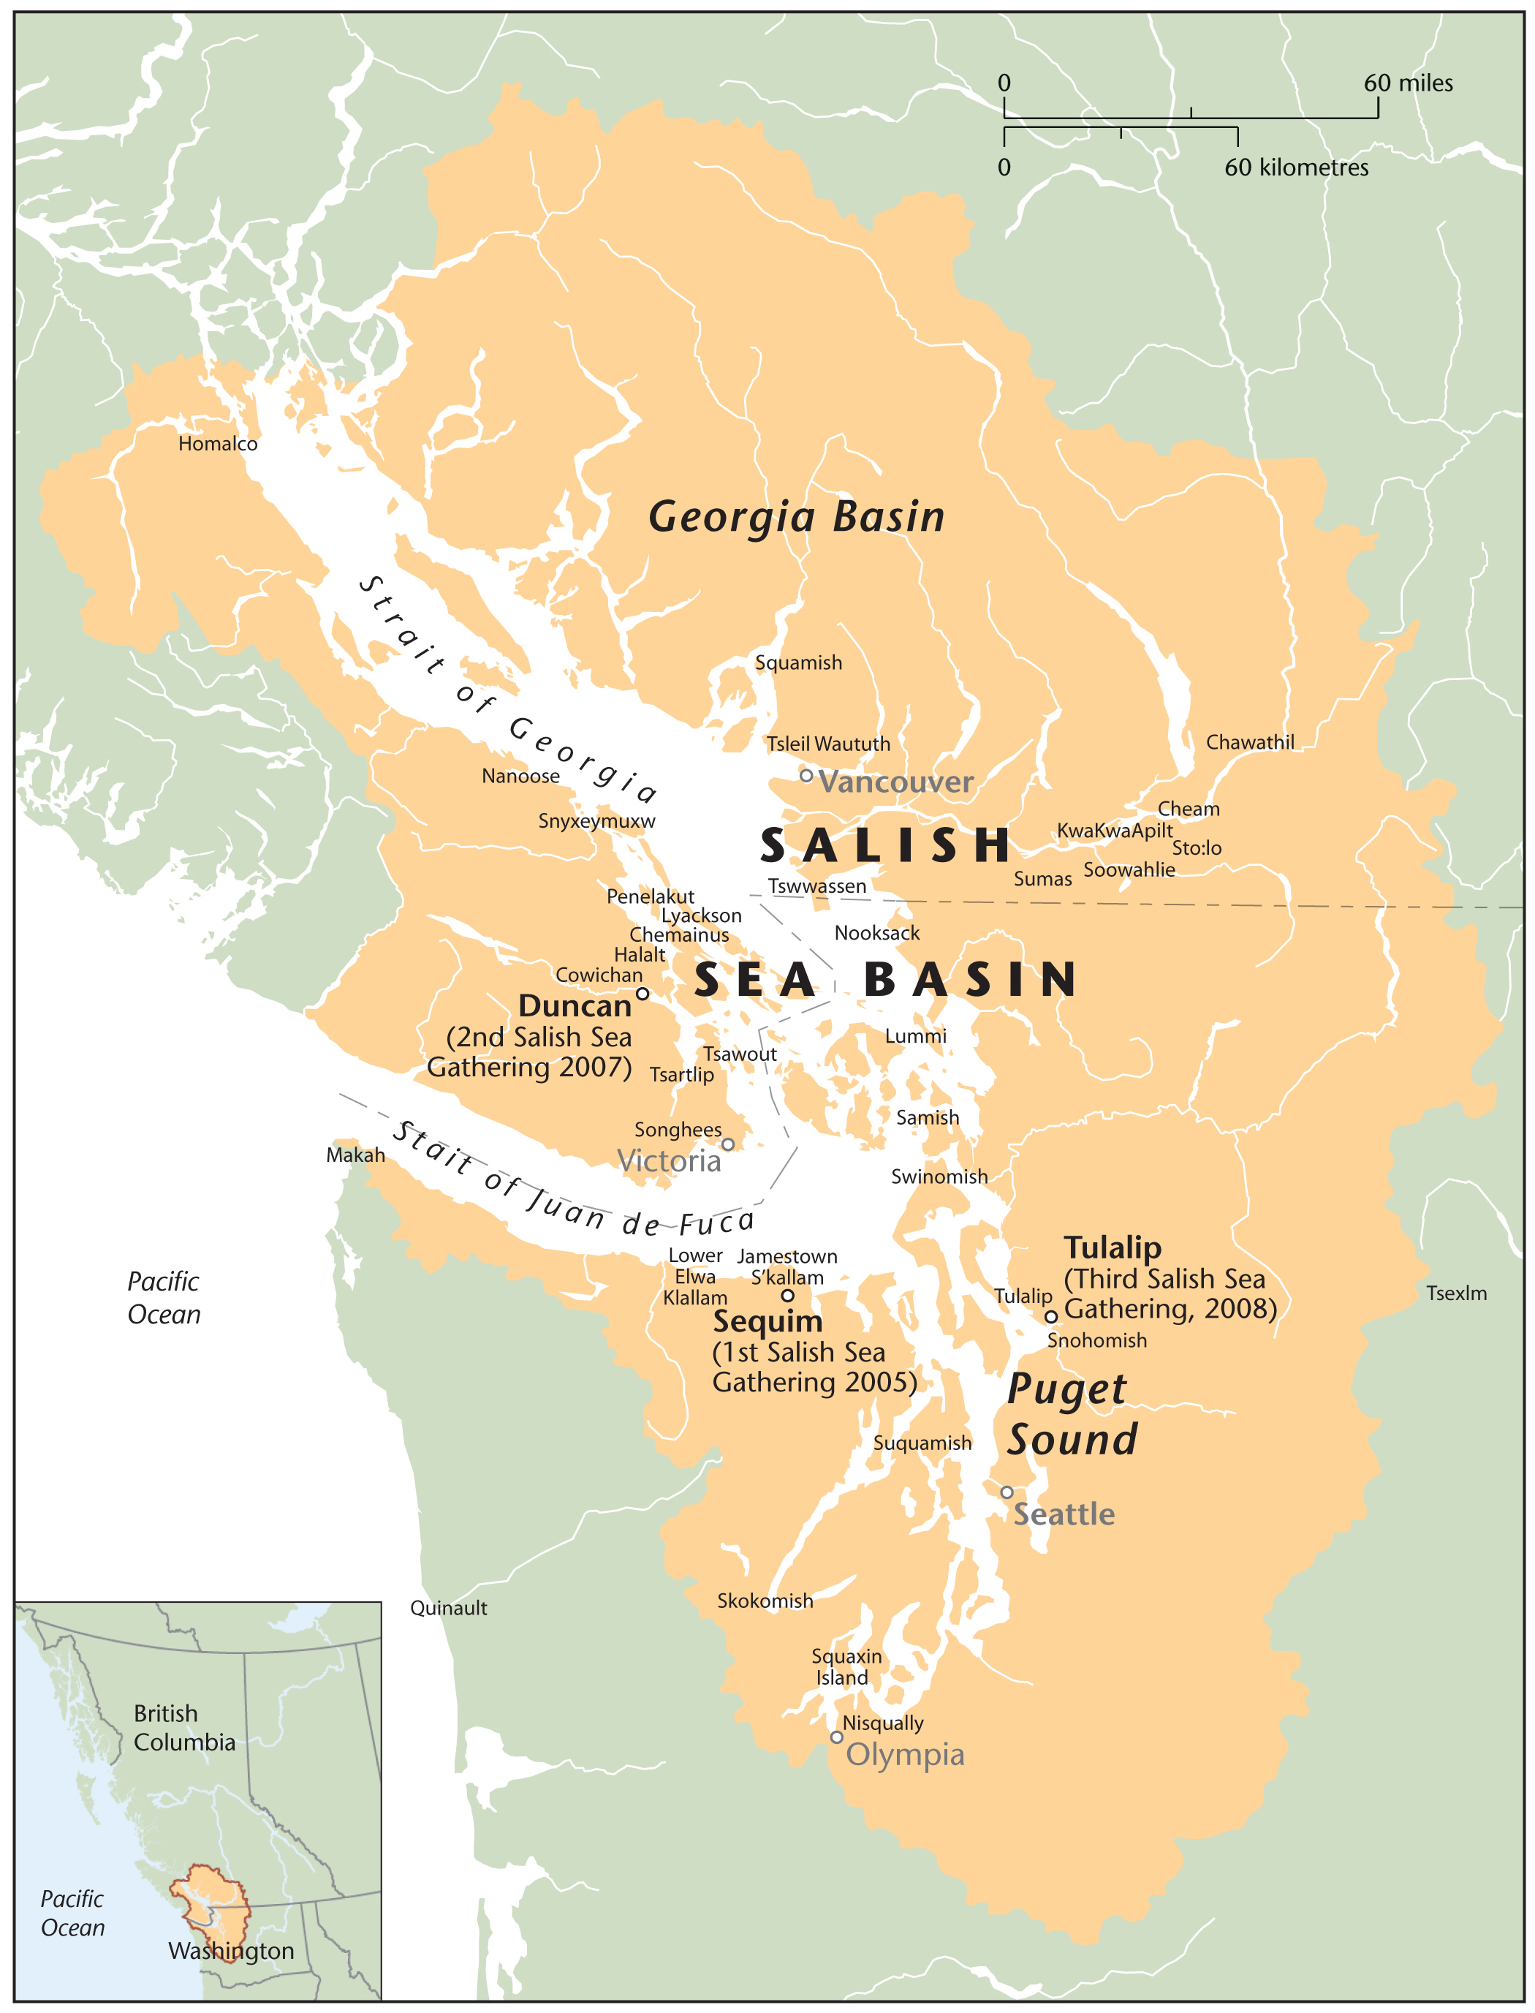
Source: Original Map. Cartographer Eric Leinberger, Department of Geography, UBC
Content based on maps produced by Environment Canada and the Environmental Protection Agency (EPA 2008) and the Coast Salish Aboriginal Council Participation List (2008)

The Gathering also marked a reaffirmation of the cultural continuity of the Coast Salish people. Since the demarcation of the 49th parallel and the implementation of the reserve [and reservation] system[s], the Coast Salish communities of British Columbia and Washington have been severed socio-politically. The divergent policies applied to Native rights to harvest marine resources in Canada and the United States have hindered coordination between the culturally connected Native communities. In a phone interview, one tribal natural resource employee reflected, “[T]he divergent policies complicate the tribe-to-tribe negotiations regarding shared natural resources.” Degraded ecosystems due to population pressures along the coast, over harvesting of marine resources, and industrial-agricultural pollution require immediate attention and increased coordination between tribes, local communities, and federal governments. This is important particularly for the Coast Salish communities, as the natural environment – particularly marine resources – provide important sustenance and cultural resources.
This governance model is unlike other co-management models, as it is based on a traditional Coast Salish governance model, yet it folds in "modern" governance styles. For example, at the Tulalip Gathering, the first day of the three-day meeting was set aside to prepare its members for the work ahead by welcoming the gathering, blessing the four corners, naming the witnesses, and celebrating through shared meals of traditional Coast Salish cuisine.
The meeting was also inclusive with members of the Environmental Protection Agency, Department of Ecology, Fisheries and Oceans Canada, the British Columbia Ministry of the Environment all attending and participating in the meetings. There role, however, was of invited guest. The meeting remained in the “hands of” the Coast Salish members throughout.
In conclusion, what will it take for the Salish communities to effectively address these diverse, numerous, and far-reaching environmental issues? What needs to be done to rebuild cultural connections and traditional governance structures? What will it take to bridge – or remove borders (both physical and cultural) – that have developed over the years? Answering these questions may help lay the foundation for a future, healthy Salish Sea ecoregion.

Appendix A:
Making Native Space: The Creation of the Semiahmoo and Nooksack Reserves

In 1855, representatives of several tribal communities north of Seattle met with the Oregon Territorial Governor to negotiate reserve boundaries. Neither the Nooksack nor the Semiahmoo communities participated in these initial treaty negotiations. Subsequently, they were expected to settle on the reserves of neighboring tribal communities, such as the Lummi reserve, whose reservation at the mouth of the Nooksack River represented only a small portion of their traditional territory.
The Nooksack Tribe resisted the move to the coast, as their linguistic and kinship ties were more closely related to the Fraser River Valley bands than the coastal Lummis. The Nooksacks remained in the upriver sites without federal recognition or reservation lands. In the mid-1930s they agreed to accept the provisions of the Indian Reorganization Act of 1934 (or Wheeler-Howard Act) to begin working on a tribal constitution. In 1971, they obtained full federal recognition and reservation status. The initial reserve consisted of one acre of land in Deming, Washington. Currently, they tribe has increased its landholdings to 2,500 acres.
For the Semiahmoo - whose Coast Salish language and cultural ties are closer to the Lummis - settlement with the Lummi community was more amenable. However, as the majority of the community members had settled north of the border by the 1860s, the community worked with the Canadian government to establish a reserve in 1887. The original reserve allocation was 328 acres; however several acres have been rescinded for various federal road expansion projects. Ironically, several acres of original Semiahmoo Reserve land were also taken back in 1921 to create the Peace Arch Park, which celebrates the creation of the Canada-U.S. border. The Semiahmoo remain without land in the U.S.

References
Almasri, M. N., & Jagath, J. K. (2004). Assessment and management of long-term nitrate pollution of ground water in agriculture-dominated watersheds. Journal of Hydrology, 295(1-4), 225-245.

Boxberger, D. (1989). To Fish in Common: The Ethnohistory of Lummi Indian Salmon Fishing. Seattle: University of Washington Press.

Boxberger, D. L. (1993). Lightning Boldts and Sparrow Wings: A Comparison of Native Fishing Rights in British Columbia and Washington State. Native Studies, 9(1).

Boxberger, D. L. (1994). Ethnicity and labor in the Puget Sound fishing industry, 1880-1935. Ethnology, 33(2), 179-191.

Combs, M. (1999). United States v. Washington: The Boldt Decision Reincarnated. Environmental Law, 29, 683-716.

Demeritt, D. (2001). Scientific forest conservation and the statistical picturing of nature's limits in the Progressive-era United States. Environment and Planning D: Society and Space, 19(4), 431-459.
DFO. (2009). “Management and Protection of Fisheries Resources”. Fisheries and Oceans Canada website. Available: <http://www.tbs-sct.gc.ca/rma/dpr/01-02/FO/FO0102dpr05_e.asp> Last Accessed: November 15, 2009

Donatuto, J. (2005). Rounding the Home Stretch: Learning Experiences from the Bioaccumulativetoxics in Native American Shellfish Project." Puget Sound Georgia Basin Research Conference. Paper presented at the Puget Sound Georgia Basin Research Conference.

EPA (2008). “Freshwater Indicators.” Environmental Protection Agency website Available:<http://www.epa.gov/region10/psgb/indicators/freshwater_quality/what/index.htm> Last Accessed August 15, 2008.

Hanna, K. S. (1999). Integrated resource management in the Fraser River Estuary: Stakeholder's perceptions of the state of the river and program influence. Journal of Soil and Water Conservation, 54(2), 490-498.

Harris, C. (2000). The Resettlement of British Columbia: Essays on Colonialism and Geographic Change. Vancouver: UBC Press.

Harris, C. (2002). Making Native Space: Colonialism, Resistance, and Reserves in British Columbia. Vancouver: UBC Press.

Harris, D. C. (2000). Territoriality, Aboriginal Rights and the Heiltuk Spawn-on-Kelp Fishery. UBC Law Review, 34, 195-238.

Harris, D. C. (2001). Fish, Law, and Colonialism: The Legal Capture of Salmon in British Columbia. Toronto: University of Toronto Press.

Harris, D. C. (2003). Historians and Courts: R. v. Marshall and Mi'kmaq Treaties on Trial. C.J.L.S., 18, 123-131.

Hii, B., Liebscher, H., & Mazalek, M. (1999). Ground Water Quality in the Abbotsford Aquifer, British Columbia. Vancouver, B.C.: Environment Canada, Pacific and Yukon Region.

Hoberg, G. (2000). How the Way We Make Policy Governs the Policy We Make. In D. J. Salazar & D. K. Alper (Eds.), Sustaining the Forests of the Pacific Coast (pp. 26-53). Vancouver: UBC Press.

Judd N.L., Drew C. H., Acharya C., Mitchell T.A., Donatuto J..L, Burns G.W., Burbacher T.M., Faustman E.M. . (2005). Marine Resources for Future Generations. Framing scientific analyses for risk management of environmental hazards by communities: Case studies with seafood safety issues. Environmental Health Perspectives 113(11), 1502-1508.

Mapes, L. V. (2007, July 6). Shellfish settlement ends years of rancor. Seattle Times, from http://seattletimes.nwsource.com/html/localnews/2003776926_shellfish06m.html

Mitchell, T. (1991). The Limits of the State: Beyond Statist Approaches and Their Critics. The American Political Science Review, 85, 77-96.

Miller, B. (1997). The "Really Real" Border and the Divided Salish Community. BC Studies: The British Columbian Quarterly, 112, 63-79. (CITE)

Miller, B. (2003). Invisible indigenes: The politics of nonrecognition. Lincoln: University of Nebraska Press. (CITE)

Miller, C., Chudck, P., & Babcock, S. (2003). A Comparison of Wellhead Protection Area Delineation Methods for Public Drinking Water Systems in Whatcom County, Washington. Journal of Environmental Health, 66(2), 17-24.

Mitchell, T. (1991). The Limits of the State: Beyond Statist Approaches and Their Critics. The American Political Science Review, 85, 77-96.

NWIFC. (2009). Shellfish. Northwest Indian Fisheries Commission website. Available:
<http://www.nwifc.org/about-us/shellfish/> Last Accessed November 15, 2009.

Singleton, S. (1998). Constructing cooperation: the evolution of institutions of comanagement. Ann Arbor: University of Michigan Press.

Singleton, S. (2000). Co-operation or capture? The paradox of co-management and community participation in natural resource management and environmental policy-making. Environmental Politics, 9(2), 1-21.

Sutherland. (2000). The Coexistence of Sustainable Development and Aboriginal Fishing Rights in Canada. Indigenous Law Bulliten.

Suttles, W. (1974). Coast Salish and western Washington Indians; the economic life of the Coast Salish of Haro and Rosario Straits. New York: Garland Pub. Inc.

Suttles, W. (1960). Affinal ties, subsistence, and prestige among the Coast Salish.
American Anthropologist, 62, 296–305.

Suttles, W. P. (1954). Post-Contact Culture among the Lummi Indians. British Columbia Historical Quarterly, XVII, 29 - 102.

Wei, M., Kohut, A. P., Kalyn, D., & Chwojka, F. (1993). Occurrence of nitrate in groundwater, Grand Forks, British Columbia. Quaternary-International, 20, 39-49.

Emma Norman is a member of the faculty at Northwest Indian College. This material is based upon work supported by the National Science Foundation under Grant No. 0817624.Any opinions, findings, and conclusions or recommendations expressed in this material are those of the author(s) and do not necessarily reflect the views of the National Science Foundation. The Canadian Consulate General – Seattle and the Weyerhaeuser Foundation provided funding to support the initial research for this project. The content is solely the responsibility of the writer. This case is part of the Enduring Legacies Native Case Initiative. Cases and teaching notes can be downloaded at http:.www.evergreen.edu/tribal/cases/ Please use appropriate attribution when using our cases.
Quoted in Coleman (2001)
Fecal coliform bacteria are found in the digestive tracts of warm-blooded animals and are used as an indicator of pathogens such as the virus hepatitis and the bacterium E.coli. If ingested, E. coli potentially could be a serious human health risk.
This quote is part of an opening address that Tom Sampson gave at the “Governing Transboundary Waters Workshop”, April 2006, Vancouver BC.
Fifty sites were tested.
Although several Native communities participated in shellfish harvesting in Boundary Bay, only the Semiahmoo and the Nooksack are currently active participants in the Shared Waters Alliance. Thus, this section will draw primarily from those two cultural groups.
Here, Boxberger is referring specifically to the Lummi, but the general premise is applicable to other communities within the Salish Native communities.
In British Columbia, the status of the shellfish beds are shared responsibilities between three governmental departments: Canadian Food Inspection Agency (CFIA), Environment Canada (EC) and the Department of Fisheries and Oceans Canada (DFO). Water quality monitoring and shoreline pollution surveys are conducted by EC and reported biannually to the Pacific Region Interdepartmental Shellfish Committee. Enforcement and public notification of the closures are DFO’s responsibilities, whereas CFIA is responsible for the commercial regulation (http://epa.gov/region10/psgb/indicators/shellfish/solutions/
In Washington State, the closure of shellfish beds is directed by Washington State Department of Health (DOH). The Office of Food Safety and Shellfish Programs monitors water quality and classifies shellfish areas based on growing area conditions. This work is administered under the National Shellfish Sanitation Program.
In the U.S., there are four classifications with shellfish harvesting areas: Prohibited, which means no harvest; Restricted, which means move to a clean area; Conditional, which means under certain conditions you can’t harvest; and Approved, which means you can harvest anything, anytime.
Fifteen western Washington tribes are covered by the ruling: Jamestown S’Klallam, Lower Elwha Klallam, Lummi, Makah, Muckleshoot, Nisqually, Nooksack, Port Gamble S’Klallam, Puyallup, Skokomish, Squaxin Island, Suquamish, Swinomish, Tulalip, and Upper Skagit (NWIFC 2009).
The treaty provision limiting the tribes' shellfish harvests is referred to as the Shellfish Proviso (Combs 1999).
This was the first of six treaties negotiated between Coastal Salish tribes and the first Governor Washington Territory, Isaac Stevens, between 1854 and 1856. The treaties became known as the Stevens Treaties. Variations of the aforementioned treaty provision are included in the subsequent treaties.
“The tribes conduct commercial, ceremonial and subsistence harvest for shellfish and finfish. Commercial harvests allow tribal members the opportunity to sell the shellfish products they harvest. Ceremonial harvests are intended for use in weddings, funerals and other traditional gatherings, while subsistence harvests are intended to provide tribal members with food.” (NWIFC 2009)
U.S. District Judge George Boldt, U.S. v. Washington, February 12, 1974.
In his text, he is specifically discussing land claims and co-management – however, his argument can be extended to multi-governance bureaucracies.
See also Foucault (1970) The Order of things were he explores the genealogy of knowledge, showing that ways of knowing cannot be separated from their cultural and historical roots.
Cole Harris’s book Making Native Space provides a comprehensive overview of the physical impacts of European impact on Native communities in British Columbia
An inherent right is considered to be one that is given the Creator and which is passed down by ones ancestors through culturally prescribed methods.
Boldt interpreted 'in common with' to mean “sharing equally the opportunity to take fish ... therefore, non-treaty fishermen shall have the opportunity to take up to 50% of the harvestable number of fish ... and treaty right fishermen shall have the opportunity to take up to the same percentage.” U.S. District Judge George Boldt, U.S. v. Washington, February 12, 1974. (http://www.propertyrightsresearch.org/caselaw/boldt_decision.htm)
Hanna draws on the experience of the U.S. censuses to explore the political implications of enumeration.
Salish Sea Council, Available: www. http://www.coastsalishgathering.com/ (Accessed January 15, 2008)
SSC 2008
The Salish Sea Council has not yet created its own map outlining their geographic region. In an email correspondence with one of the organizers of the SSC, I learned that the map is on hold while the Canadian bands are in treaty negotiation.
For a brief history of the creation of the Nooksack Reserve, see http://northregionems.com/native/Nooksack%20Tribe.htm.
Part of the lag time in creating the reserve was due to a disagreement between the provincial and federal governments: Ottawa maintained that at least 80 acres per family of five was required while the province set a maximum of 20 acres per family for future reserves, maintaining that coast tribes would not use that much land (Suttles 1974, Brown 2007).
Part of the reserve was taken back to make room for road expansion (King George Highway in 1939) and the Deas Island Highway 99 in 1962).

