# **TEACHING NOTES**

**Who has MMIP Task Forces? Analyzing Tribal, State, and Federal Actions taken for Missing and Murdered Indigenous People**

by Emily Washines, MPA

**Learning Objectives**

1. Learn about actions regarding Missing and Murdered Indigenous Women and People (MMIW/MMIP).
2. Understand federal & tribal partnership: Tribal Community Response Plans
3. Learn about the role of federal MMIP Coordinators
4. Learn about four tribes’ values and response regarding MMIW/MMIP
5. Analyze different tribes and state action for MMIW/MMIP
6. Understand there are various MMIW/MMIP databases
7. Utilize collaborative learning about MMIW/MMIP through discussion groups
8. Ability to discuss the intersectionality between tribal, federal and state actions regarding MMIW/MMIP

**Audience:** This case can be used for college students either at the undergraduate or graduate level. An introductory-level of familiarity with MMIW/MMIP is helpful. For example, students should be aware of the MMIW/MMIP movement and perhaps seen a video or read articles. In some instances, it could be used in high school or conference settings. Due to the nature of the content, there should be a trigger warning regarding violence against women and people. Adequate resources and options should be available for students that may not want to participate due to the nature of content.

The academic disciplines this case would be most useful for are the following: American Indian Law, American Indian Studies, Communications, History, Law and Justice, Political Science, Public Health Public Administration, and Social Work.

**Related Cases:** Washines, War Cry: Will Crossing Historical Boundaries in Indian Wars help Yakama Women?

**Implementation**: This case can be taught in numerous ways. Along with the case study there are 9 class activities. It is recommended to utilize the group discussion questions in the 1st activity. Option1. Teach in a single class session by assigning students to read it as homework and then discussing the questions in class, Option 2. Present the case in class and then have a discussion. 3. Follow this with additional activities which are the following: Research a State Task Force, Watch MMIP videos or read MMIP reports, Discuss Jurisdiction in Indian Country, and Vocabulary. Depending on time availability this lesson can be one day to a couple of weeks. For example, Monday, read the case, Tuesday, have a discussion, 3 days-2 weeks: select additional activities.

**Trigger Warning:** Instructor may provide a trigger warning as this subject can be sensitive. Additionally, there are the following support resources.

* If you need culturally-appropriate advocacy or support, please contact [StrongHearts Native Helpline*](https://strongheartshelpline.org/): 1-844-7NATIVE (762-8483) or chat online: strongheartshelpline.org *limited hours
* You can contact Crisis Text Line:   text 741741

# **ACTIVITY 1: GROUP DISCUSSION**

*Each group will have a set of discussion questions.*

Read or Present the Case Study prior to the discussion groups. To begin, the Instructor can re-cap a few highlighted points from the case then provide the instructions, and assign groups. When dividing into groups, there is an option to just use 4 tribal groups. If you have enough students, you can utilize all 7 groups. Each group should have at least 3 people. Recommendation for each group to select a spokesperson, recorder, and timekeeper. In the end, each group will share their storyboards by reading the caption and share their drawing. During the presentations, the timekeeper will let their group know when time is up. Drawings may be posted to the wall for classroom-wide observation. After group presentations, the instructor will reiterate the groups’ important points.

## **GROUP INSTRUCTIONS:**

1. Divide into Small Groups (20 min-25 min) ▪ Each Group gets the questions (printed)

* Decide Group Roles: Timekeeper, Recorder, spokesperson
* Each Group has a set of questions to discuss.
* Summarize key points from your group discussion: Using Posterboard or paper, record responses to questions
* Prepare to Present (5 min each group)
  + If possible, post the drawing on the wall (sticky post-it paper)
  + When Presenting: Share the name of your group and your responses. By the end, of all the group presentations, they will be displayed around the room.

2. Each group will present (5-7 min each group)

* Share a few key points from your group discussion with the class.

3. Exit Discussion – Class (5-10 min)

* Instructor highlights information based on group presentations. Additional class discussion can be: What are some themes we observed? What should happen next?

## **GROUP DISCUSSION QUESTIONS:**

## ***Group 1: Bay Mills Indian Community***

1. What is the tribe’s location and population size?
2. Discuss the tribe’s cultural values.
3. What actions has the tribe has taken for MMIP?
4. Does the tribe have a Tribal Community Response Plan (TCRP)? What are the components.
5. Does the tribe allow public access to their TCRP? Discuss why you think they do or don’t.
6. Discuss additional information from the tribe.

***Group 2: Confederated Salish & Kootenai Tribes***

1. What is the tribe’s location and population size?
2. Discuss the tribe’s cultural values
3. What actions has the tribe has taken for MMIP?
4. Councilwoman Bundy describes 6 MMIWG as a way to remember them. Discuss the personality traits she shared along with the status of their cases.
5. They were the first tribe in the nation to have a Tribal Community Response Plan. Discuss data sovereignty and why you think they don’t allow public access to their TCRP.
6. Discuss additional information from the tribe.

***Group 3: Tulalip Tribes***

1. What is the tribe’s location and population size?
2. Discuss the tribe’s cultural values
3. What actions has the tribe has taken for MMIP?
4. Review the circumstances surrounding one of the Tulalip tribal members disappearance. Discuss the reward for MMIP.
5. They were the first tribe in Washington to announce they have a Tribal Community Response Plan. Discuss data sovereignty and why you think they don’t allow public access to their TCRP.
6. Review the Missing Indigenous people map on p. 14, and discuss the numbers in Snohomish County. How does this compare to other numbers in Washington?
7. Discuss additional information from the tribe.

***Group 4: Confederated Tribes and Bands of the Yakama Nation***

1. What is the tribe’s location and population size?
2. Discuss the tribe’s cultural values
3. What actions has the tribe has taken for MMIP?
4. The tribe uses awareness events which includes RedGalia. Describe what RegGalia is and discuss awareness efforts for MMIP.
5. Review the tribe’s missing person form and discuss. Have you ever seen a tribal missing person form?
6. Review the Missing Indigenous people map on p. 14, and discuss the numbers in Yakima County. How does this compare to other numbers in Washington?
7. Discuss additional information from the tribe.

***Group 5: Federal Government***

1. List and discuss the Federal Acts and Executive Order for MMIP.
2. What is the difference between an issue-based task force and an activities-based task force?
3. Which states did the federal government provide MMIP Coordinators? (Hint: 11).
4. What is a TCRP and how to tribes create one?
5. What was the role of MMIP coordinators? (Hint: reference Bay Mills p. 7).
6. List and discuss the different MMIP websites the federal agencies have.
7. Though the process is not publicly available, discuss why you think the FBI offers rewards from some MMIP, but not others.

***Group 6: Montana***

1. How many federally recognized tribes are in the state? Compare and contrast this number with other states.
2. Discuss the state task force, dates active, and importance.
3. What is the problem or need outlined?
4. Montana has two reports, what are some of the recommendations?
5. Review and discuss the multi-jurisdictional issues.
6. Discuss the Resources: Do they have funding? What is the amount? Who is the funding from?
7. Montana utilizes a new online portal. Discuss the creation of this portal and the future goals they have for the portal.
8. Discus the chart comparing and contrasting the 11 states the DOJ Attorney General selected with the reported Top 10 States with highest number of MMIWG cases.

***Group 7: Washington***

1. How many federally recognized tribes are in the state? Compare and contrast this number with other states.
2. Discuss the state task force, dates active, and importance.
3. The Washington MMIWP report outlines the problem calling the “MMIWP crisis is the culmination of _______. Review what they stated and discuss.
4. What are some of the recommendations in the state’s MMIP report?
5. Review and discuss the multi-jurisdictional issues.
6. Discuss the Resources: Do they have funding? What is the amount? Who is the funding from?
7. Washington State organizes the missing Indigenous people through a Washington State Patrol database, discuss the missing list, and the geographically breakdown by county.
8. Discus the chart comparing and contrasting the 11 states the DOJ Attorney General selected with the reported Top 10 States with highest number of MMIWG cases.

# **ACTIVITY 2: RESEARCH A STATE TASK FORCE TO ADDRESS MMIW/P**

*Option A:*

Research tribal actions taken to address the MMIWP crisis. These may be done through task forces, committees, commissions, or boards. Have students research state actions taken to address MMIWP in a particular state through a series of 10 questions.

Here is a list of some states with an MMIWP Task Force: Alaska, California, Hawaii, Montana, Minnesota, New Mexico, New York, Utah, Washington, and Wyoming. Note: if selecting Washington or Montana, some of the information is available in the case study.

There are additional actions taken in other states to address MMIWP. These may be done through consultations, conduct a study, committees, commissions, or boards. Here are some states with MMIWP actions: Arizona, Colorado, Idaho, Nebraska, and South Dakota.

*Option B:*

Research a federal task force. For question 1: Name of Task Force, Committee, Commission, or Board. For question 3 they can include Federal Acts. Note, if selecting Savanna’s Act Task Force, some of that information is within the case study.

*Option C:*

Research a tribal task force. For question 1: Name of Task Force, Committee, or Board. For question 3. They can include Tribal Resolution(s). Note if selecting Salish & Kootenai, Yakama Nation, Bay Mills Community, some of that information is in the case study.

**RESEARCH QUESTIONS:**

1. Name of Task Force: _____________________________
2. From _______ [year] to : _______ [year]
3. The process (*Can also reference the State Bill(s),* *Creation of Task Force, selection of members, and types of meetings. Are there any public meetings?)*
4. Do they have a report?
5. The Primary Problem and/or Need:
6. The Recommendation(s):
7. The timeline: (*do any of the recommendations/goals have deadlines?)*
8. Do they discuss multi-jurisdictional issues?
9. The Resources (*Do they have funding? What is the amount? Who is the funding from?)*
10. References (include links and citations)

# **ACTIVITIES 3-7 (VIDEO AND/OR READING) :**

**3. Watch Confederated Salish Kootenai Tribe interview on War Cry Podcast:**

Time: 1 Hour 20 min

|  |  |
| --- | --- |
| Title: | Ellie Bundy - Salish Kootenai and Montana Tribal Task force for MMIP |
| Description: | Councilwoman Ellie Bundy shares her presentation on Montana MMIP cases. National and Montana State based legislation and how that ties into Montana Tribal task force processes and resources. This episode is a great way to get some real answers on how to contribute to the cause and movement of MMIW/MMIP in any community. As well as educating youth on the issue and how to keep aware and safe. |
| Class discussion: | What are does Councilwoman share about the task force process and resources? Discuss the MMIW/MMIP issues in Montana? |
| Link: | [Ellie Bundy - Salish Kootenai and Montana Tribal Task force for MMIP - YouTube](https://www.youtube.com/watch?v=U3evTApqX80&feature=youtu.be) |

1. **Read Montana MMIP Task Force report**

Time: 2 Hours

|  |  |
| --- | --- |
| Title: | Looping in Native Communities: Report to the State-Tribal Relations Interim Committee |
| Description: | A report on efforts to improve reporting and reduce missing Indigenous persons in Montana |
| Class discussion: | Discuss some of the key data shared. What are some of the recommendations for what should happen next for MMIP? |
| Link: | [Looping in Native Communities (dojmt.gov)](https://dojmt.gov/wp-content/uploads/LINC_Report_STRIC_FINAL_Aug.pdf) |

1. **Read Washington States’ MMIWP Task Force report**

Time: Approximately 2 hours

|  |  |
| --- | --- |
| Title: | 2022 Interim Report of the Washington State Missing and Murdered Indigenous Women and People (MMIWP) Task Force |
| Description: | This is the first report of the Washington State Missing and Murdered Indigenous Women and People (MMIWP) Task Force, and provides an interim update on the work of the Task Force |
| Class discussion: | Discuss the recommendation regarding the Cold Case Task Force and the numbers of MMIP shared by HITS. |
| Link: | [MMIWP Interim Report 2022.pdf (agportal-s3bucket.s3.amazonaws.com)](https://agportal-s3bucket.s3.amazonaws.com/uploadedfiles/Another/News/Press_Releases/MMIWP%20Interim%20Report%202022.pdf) |

1. **Watch Washington State Task Force meeting from December 2022**

Time: 6 hours 15 min.

|  |  |
| --- | --- |
| Title: | Missing and Murdered Indigenous Women and People Task Force on Dec. 15, 2022 - 9:00 am |
| Description: | The Washington State Missing and Murdered Indigenous Women and People Task Force hold an annual summit. Video courtesy of Emerald Queen Casino. |
| Summit Agenda:  *For shorter time blocks, you can reference the agenda to watch specific sections* | * Traditional Opening, Welcoming Remarks * MMIWP Families, Family and Survivor Panel Discussion * Keynote Speaker, Overview of MMIWP Task Force * Criminal Justice and Public Safety * Community Resources and Services * Program Spotlight: MMIWP and Families * Tribes |
| Class discussion: | Highlight and discuss some key points shared during the families and survivor panel discussion. Select other sections to highlight key points. |
| Link: | [Missing and Murdered Indigenous Women and People Task Force - TVW](https://tvw.org/video/missing-and-murdered-indigenous-women-and-people-task-force-2022121119/) |

1. **Read Guide for Families of MMIP adults**

Time: 1 Hour

|  |  |
| --- | --- |
| Title: | Guide for families and loved ones to respond when an AI/AN adult goes missing. |
| Description: | This guide provides information and practical resources to assist family members and friends with the search for a missing adult loved one. While not an exhaustive list of actions, this guide offers helpful steps to take while searching for a loved one, suggestions about how to cope with trauma, and a list of resources for navigating this difficult situation. |
| Class Discussion: | Highlight a few of the resources in the guide. What are helpful steps that families may not be aware of. Discuss the resources for navigating the situation. |
| Link: | [guide for families and loved ones to respond when an AI/AN adult goes missing](https://www.justice.gov/file/1562871/download). |

# **ACTIVITY 8: DISCUSS JURISDICTION IN INDIAN COUNTRY**

As a class or in groups discuss how multi-jurisdiction with tribes may impact MMIP cases. Discuss the examples of different courts based on the type of crime. Also, review the identity of the alleged defendant and identity of alleged victim in relation to the crime.

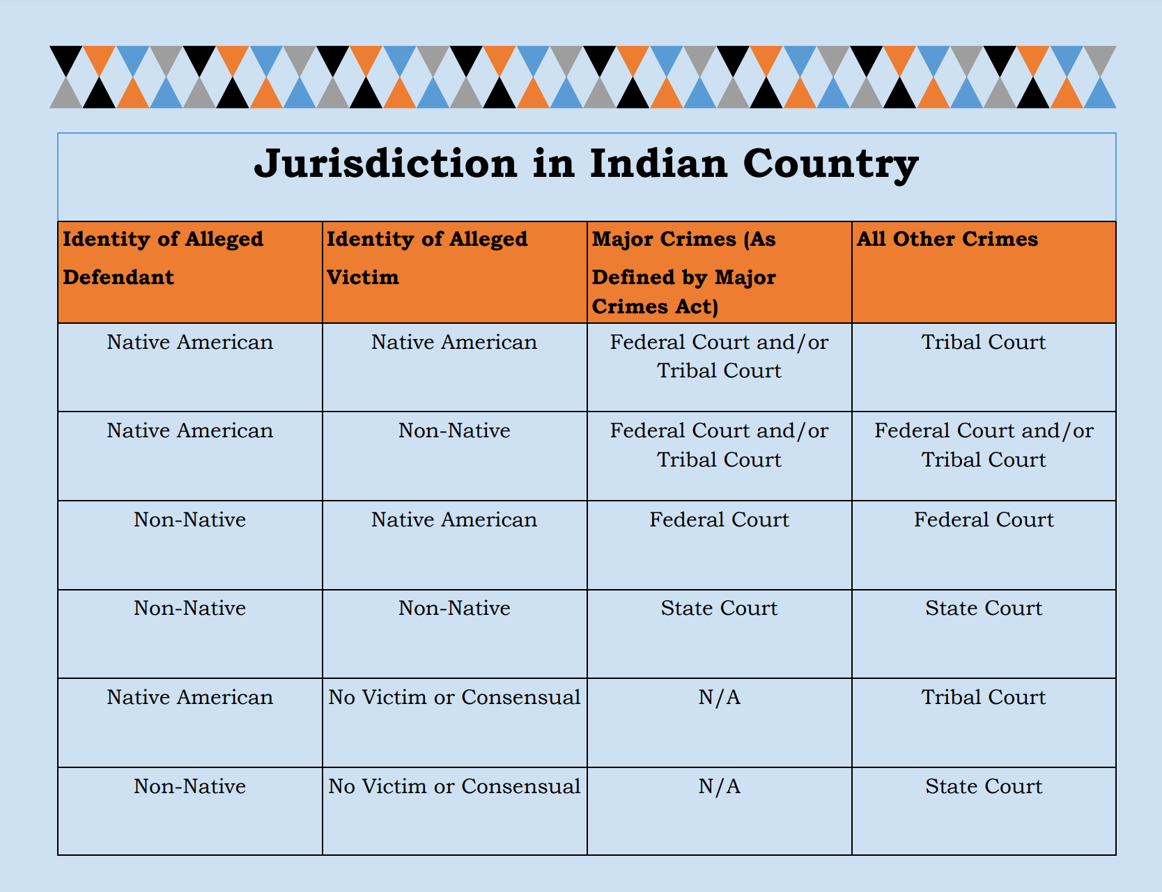

Source:

Bay Mills Indian Community. (2022, May 5). Tribal Community Response Plan Missing or Murdered Individuals. Michigan. Retrieved February 20, 2023, from <https://www.baymills.org/_files/ugd/869f65_c5e6b0971e2c45168b3fc4e0f1719d53.pdf>

# **ACTIVITY 9: VOCABULARY**

In the appendix section, Bay Mills Indian Community shares 12 definitions of the following terms. The Instructor can review the terms. You can create a quiz or give them an assignment. One example is to have them create a PowerPoint for the terms with a visual example.

1. Adult
2. Amber Alert
3. Ashanti Alert
4. At-Risk Missing Person
5. Endangered Runaway
6. Indian Country
7. Indian Tribe
8. Law Enforcement Agency
9. Missing Adult
10. Missing Child
11. Risk Factors
12. Silver Alert