**Teaching Notes**

**Should tribal access to electricity be a right or a privilege?**

by

Kathleen M. Saul, Ph.D.

**Learning Objectives:**

* Learn about the history of and current situation for tribes in Northeastern Oregon/Southwestern Washington.
* Discuss with the benefits of renewable electricity generation for tribes.
* Understand barriers to implementing renewable electricity generation projects.
* Recognize the connection between electricity generation and carbon dioxide emissions.
* Explore your own electricity usage and emissions generated as a result of that use.
* Discuss international programs for providing electricity access to rural areas of developing countries. Think about why those programs do not apply to the rural Native Americans.
* Demonstrate an understanding of the difference between a right and a privilege as it applies to this case.

**Audience:**

Suitable for high school and college students--undergraduate through graduate studies. This case is especially useful for study in environmental studies, energy, energy policy, American Indian studies, mathematics, and environmental justice.

**Implementation:**

This case can be taught in a single class session by assigning students to read it as homework and come prepared to consider a selection of the discussion questions.

**Discussion Questions:**

1. Picking up where the case left off, if you were Liza, which path would you choose?

List the most compelling arguments that support your choice.

2. Liza calculated that she used 7,428 kWh per year. How much electricity do you (and your family) consume on an annual basis?

How does that figure compare to the U.S. national average of 10,800 kWh per year?

You can estimate the amount by looking at your monthly electric bill and multiplying the monthly total kWh by 12.

Or, use the table below. (Source: Mason County Public Utility District (PUD) 3. (n.d.) Retrieved from https://www.pud3.org/uploads/pdf/appliancefactsheetenglish.pdf)

In what ways can you reduce your electricity consumption?

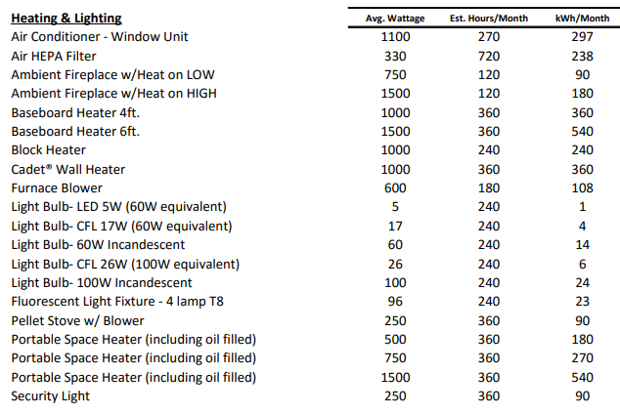

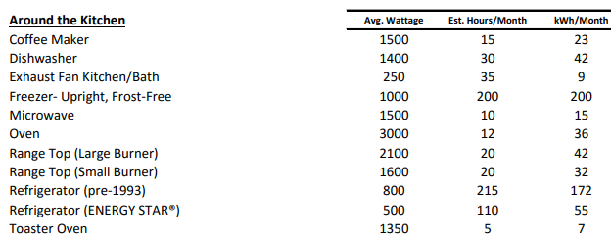

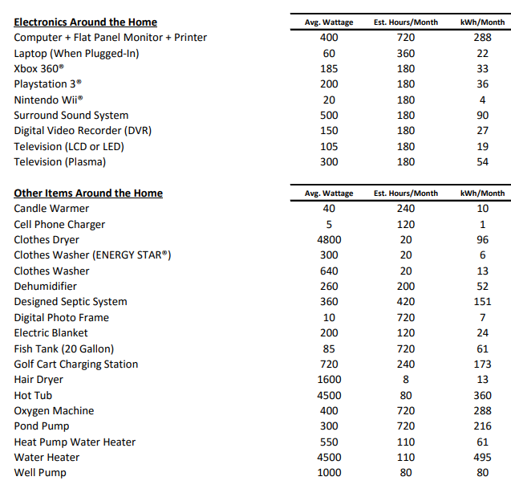

3. In Oregon, each kWh of grid-tied electricity generates, on average, 0.3 lbs. of carbon dioxide emissions (CO2) annually. Carbon dioxide is one of the major contributors to global warming.

If Liza were connected to the grid, her electricity use would result in just over (0.3 * 7428) = 2,228 lbs. of CO2 per year. That’s 2,228 lbs. of CO2 that would not be released into the atmosphere if she installed her solar PV system.

Use the table below to figure out how much CO2 your electrical use contributes to the atmosphere each year. (Multiply the number in the table by the kWh calculated in #2 above.)



(Source: U.S. Energy Information Administration (EIA). (25 January 2018) Electricity. State Electricity Profiles. Retrieved from https://www.eia.gov/electricity/state/)

How much CO2 might you save from being released into the atmosphere if you cut back on your electricity usage? (Multiple the lbs./kWh by the number of kWh saved.)

Note: States with the most renewable electricity production have the lowest value for the CO2 emitted into the atmosphere per kWh. Washington relies heavily on hydropower and Oregon has led the nation with programs in place to support wind and solar power.

3. Goal 7 of the United Nations Development Programme’s Sustainable Development Goals states that “Ensuring universal access to affordable electricity by 2030 means investing in clean energy sources such as solar, wind and thermal . . . Expanding infrastructure and upgrading technology to provide clean energy in all developing countries is a crucial goal that can both encourage growth and help the environment.”[1] Facts included alongside that goal include

* One in seven people [14.3%] still lacks access to electricity; most of them live in rural areas of the developing world; and
* Energy is the dominant contributor to climate change, accounting for around 60 percent of global greenhouse gas emissions.

The global non-profit Sustainable Energy for All (SEforall) program focuses on energy access and renewable energy programs for Sub-Saharan Africa and Asia.[2]

Why do you think such programs have not and do not target Native Americans living in rural area in the United States? As indicated in the case, 14% of households on tribal lands lack access to electricity.

4. Do you think access to electricity is a right (and should be free to all) or a privilege (that must be paid for)?

1. United Nations Development Programme. Goal 7: Affordable and Clean Energy. Retrieved from http://www.undp.org/content/undp/en/home/sustainable-development-goals/goal-7-affordable-and-clean-energy.html
2. Sustainable Energy for All (SEforAll). Retrieved from https://www.seforall.org/