# **The Salmon, They are My Brothers**

**A Story of the Lower Snake River Dams[1]**

**By Kathleen M. Saul**

**Abstract**

The era of federal dam building in the United States spanned the decades from the 1930s through the 1960s. The results were profound. Rocky rapids and side channels of rivers vanished below millions of acre-feet of slack water. Tribal villages and usual and accustomed fishing sites disappeared. Electricity coursed through wires to population centers like Seattle, WA, and Portland, OR, and towns throughout Washington, Oregon, and Idaho. Water pumped from the rivers opened up the dry lands of eastern Washington to farmers growing wheat, peas, apples, and grapes. The dams also affected the rivers’ inhabitants. Populations of the once abundant and culturally significant salmon and steelhead plummeted. In recent years, tribes in the Pacific Northwest have rallied behind the cry to remove many of those hydroelectric dams. This case examines the story of dams on the Lower Snake River. It ends by asking “What actions should be taken to restore a healthy salmon population to the Lower Snake?” Drawing on information about successful and ongoing dam removals on the Elwha, Klamath, and Skagit Rivers, and the case itself, readers learn about the challenges and advantages of dam removal and what removals could mean for salmon.

**Part I: The Backdrop**

I walked to the edge of the lake, tossed my sandals to the side, and dipped my big toe into the still, chilly waters. Concentric rings spread across the surface, the distance between them growing as they radiated outward. I peered deeply into the blue-green water and my ancestors gazed back at me, some in anguish, some with a vacant faraway look in their eyes, some with longing. I heard their stories and their songs. They reminded me of the importance of this place in our history and that even with the passage of time, we remained connected.[2] Their sorrows, their joys, their triumphs, their losses coursed through my veins.

But who I am? I am a Native woman who stands for the many Tribes of the Snake River and the Columbia River systems. This is my story. This is our story.

As I looked across the water, I thought of the irony of the name accorded the lake: Lake Herbert G. West. The lake exists today only because of the construction of dams along the Lower Snake River, dams whose reservoirs flooded the lands where my ancestors walked, camped, fished, gathered, and traded. Herbert G. West and the Inland Empire Waterways Association (IEWA) championed the idea of dams and locks along the Columbia and Snake Rivers to open the way for river transportation all the way from Portland, OR to Lewiston, ID. He cultivated friendships with key powerbrokers in Washington D.C. as well as within the Army Corps of Engineers, those responsible for federal hydroelectric and flood control projects, river navigation and irrigation. West’s tireless letter-writing, speech-giving, and hand-shaking in support of an “empire of industry, of commerce, of manufacture and agriculture”[3] helped make that dream a reality. But at what cost? For whose benefit?

Figure 1: The Columbia and Lower Snake River Systems in Washington State[4]

Dam construction began in the 1930s and continued through the 1970s

I recalled a Nimiipuu (Nez Perce) creation story I had heard as a child:

. . . Creator called all the large animal people together and said there was going to be a

great change and that he wanted all of the animals to qualify themselves for a new kind

of human being that would be coming as a result of this change. Creator wanted to know

who was going to be qualified to help these new human beings when then came because

those human beings were going to be naked, and they were going to have a hard time

making a living. The Creator said, “I want each of you to come forward and be qualified

to help these new humans when they come.” So all the animals had to come up and be

qualified . . .

Salmon and Steelhead came forward and said, “We can help the human beings with our

flesh.” Salmon said, “When we come up the river we will die, so the human beings will

have to catch us before that happens. I’ll come up only on certain times of the year, and

that’s when they’ll have to catch me.” Then Steelhead said, “I want to come in the winter-

time, but I’ll give them something special. That will be the glue from my skin. This glue

can be used to make bows and spears. I’ll be in the water all winter long.” So Creator let

Steelhead become qualified. Sockeye Salmon came forward and he said, “I don’t want to

be like Chinook Salmon and Steelhead, and my flesh will be red because I will eat different

foods.” Then Trout came forward and he said, “I am going to look like Steelhead, but I am

not going down to the ocean. I’ll just stay here in the waters even in winter, and if these

humans can find me they can have me for food.” Then Eel came out and said, “I don’t want

to look like the Steelhead or Salmon or Trout. I want to be long, and when I rest I want to

put my mouth on the rocks. But I’ll come up the river every year, and they can use my flesh

for food.” So this is how the fish became qualified.[5]

Deer, elk, moose, eagle, raven, bees, spiders, and fish all became qualified to help the humans that would soon inhabit the region.

Sadly, the creation stories of the Nimiipuu were not enough to convince those immersed in Western tradition of the long history of our people along the banks of the Snake River and its tributaries, or of the immeasurable value of the river and its resources to those people. It took archaeological excavations in the early 1960s to persuade others that our ancestors had lived in the area long before White men thought of “discovering” the New World—since time immemorial. Digs at the Marmes Rockshelter, Granite Point, and elsewhere uncovered Olivella shell beads, hackberry seeds, fish bones, mussel shells, antlers, human bone fragments, and stone and bone projectile points.[6] Modern radiocarbon dating technology confirmed that humans began using the site about 10,500 years ago.[7] Artifacts unearthed at Cooper’s Ferry suggest habitation goes back even further—to about 16,500 years ago.[8] Evidence also suggested our ancestors were not confined to the one area. They may have had encampments across the Columbia Plateau, where they could find deer, bison, duck, and a variety of plants.[9] Still, salmon fishing remained a large component of life.[10]

The radiating rings on the lake again captured my attention. My ancestors from long, long ago lay buried below the waters at my feet. I sang a song of gratitude for the wisdom they had shared with us all.

**Salmon and the Snake**

Historically, the Snake River basin produced about 45% of the spring/summer Chinook salmon of the entire Columbia River Basin.[11] Our ancestors could stand along the riverbanks and the mighty fish as they returned to spawn. They also caught coho, chum, and sockeye salmon; cutthroat, lake, and steelhead trout; and different varieties of whitefish, sturgeon, and lampreys.[12] Scholars have estimated fish consumption at 500 pounds per person per year.[13] At the time of contact with White settlers, the Nez Perce landed about 2,800 pounds of fish annually.[14] Even the members of the (in)famous Lewis and Clark expedition made note of the “emence” (sic)[15] numbers of fish in the rivers and lodges for drying fish. But catch had dropped to 1,600 pounds by the mid-1800s when treaties were signed. Current catch is one-tenth of that.

What has contributed to the steep decline in numbers of fish? First, a belief in the myth of endless supply of natural resources—water, enormous cedar and fir trees, and salmon. White immigrants adapted techniques used in their home countries to establish salmon gillnetting operations. Gillnets consist of large swaths of mesh, weighted at the bottom, and attached to buoys along the top. Fish that attempt to swim through the mesh get trapped at their gills. Not surprisingly, in those early years, the larger fish got caught while smaller fish escaped to spawn.[16]

Canneries followed the gillnetters. The first cannery opened on a barge in the Columbia River in 1866.

“Between 1866 and 1870, Columbia River canneries packed an average of 60,000 cases of salmon (48 pounds per case) per year, primarily Chinook . . . By 1883 there were 39 canneries and 1,700 commercial fishing boats on the Columbia. That year — 1883 — canneries shipped a total of 629,400 cases of salmon at 48 one-pound cans per case.”[17] As the number of returned Chinook declined, canneries turned to coho and chum. But those too began to decrease in number. Tastes of the American consumer also changed. Many moved their businesses to the waters of Alaska. In 1977, Columbia River canneries packed just over 2,500 cases of salmon.[18]

A large mallard splashed down on the water, disturbing my reveries and creating new rings on the surface of the water, rings that intersected with mine. Some stories from my ancestors treat ducks as silly creatures, outwitted by the cunning coyote. But, I wondered, what might that mallard have learned from his ancestors about the free-flowing waters of the river and their neighbors the salmon? Did he pine for the meandering side channels and flat riverbanks of old, or did he prefer the glassy surface of the deep lake created by the construction of dams?

I dried my feet off on my striped towel, slipped into my sandals, and looked across the water towards the Lower Monumental Dam. A friend worked as a day shift supervisor at the dam. They took me on a tour of the facility years before. I remember being impressed by its massive size, the thunderous roar of water through its equally massive pipes, how quickly the turbines rotated (90 rpm vs. 45 rpm for an old-fashioned record player), and the knowledge that wire coils spinning inside magnets could generate the electricity I took for granted. In one year, this dam could supply enough electricity to power about 254,000 homes![19] To produce that same amount of baseload electricity would require burning almost three billion pounds of coal and would result in the emission of over six billion pounds of carbon dioxide.[20] Carbon dioxide in the atmosphere works as a greenhouse gas, heating the planet. Burning coal also creates air pollution that has been linked to acid rain and increased asthma and lung diseases of nearby residents. The mercury released by burning coal can be deposited in local waterways, poisoning the fish and those who rely on those fish for food.

Dams or coal?

“There must be a better way!” I said to myself, shaking my head as I did so.

**On the Subject of Dams . . .**

Commercial fishing and canneries may have hastened the decline of the salmon populations, but the dams on the Columbia and Snake Rivers pushed them to the brink of extinction. The campaign for dams began in the late 1800s. Lewiston, Idaho had become a boomtown, supplying goldrush miners and farmers in the new Idaho Territory. Sternwheelers and steamboats ferried goods up and down the rivers, but only when the water ran high enough.

The U.S. Army Corps of Engineers, charged with overseeing and constructing coastal fortifications, lighthouses, jetties, and piers, and with assuring safe navigation of the nation’s inland waterways, built the first canal and locks on the Columbia River in 1896. Dignitaries celebrated the opening of a canal and five more locks at Celilo Falls in 1915, after 15 years of construction and an expenditure of $5,000,000.[21] The locks and canals cleared the way for year-round navigation on the river. Supporters dreamed of a rosy future:

The Inland Empire will be an empire in fact as well as in name—an empire of industry,

of commerce, of manufacture and agriculture; and the valleys of the Columbia and the

Snake will have become one vast garden, full of happy homes and contented and

industrious people.[22]

True to that vision, wheat consistently has been the primary commodity on Snake River barges. Another commodity that supports those happy homes and industrious people now fills the hulls of those barges--gasoline. Together wheat and gasoline have constituted an average of 77% of the total cargo since 2002 (see Figure 1).

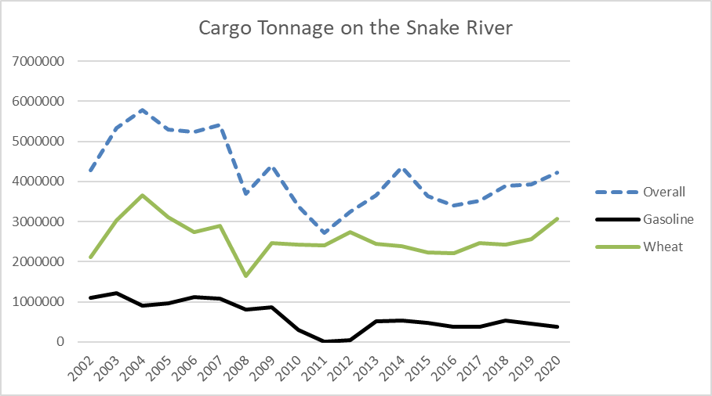

Figure 2: Cargo on the Snake River 2002 – 2020

Data Source: Waterborne Commerce Statistics Center, https://ndc.ops.usace.army.mil/wcsc/webpub/#/report-landing/year/2020/region/4/location/4520

Lake Herbert G. West does not provide irrigation water for the “vast garden” foreseen for eastern Washington, or for any farms in area. In contrast, almost 37,000 acres receive water pumped from Lake Sacajawea, created upon the completion of the Ice Harbor Dam.[23] Lake Sacajawea provides slack water from Ice Harbor Dam all the way to the Lower Monumental Dam, a distance of 32 miles. Lake West extends 28 miles beyond the Lower Monumental Dam, to the Little Goose Dam. Lake Bryan extends from the Little Goose Dam 37 miles to the Lower Granite Dam. The lake behind that dam stretches all the way to Lewiston, ID—about 40 miles. Because of the dams, the Lower Snake River has become a series of giant lakes that stretch almost 140 miles from Pasco, WA to Lewiston, ID.

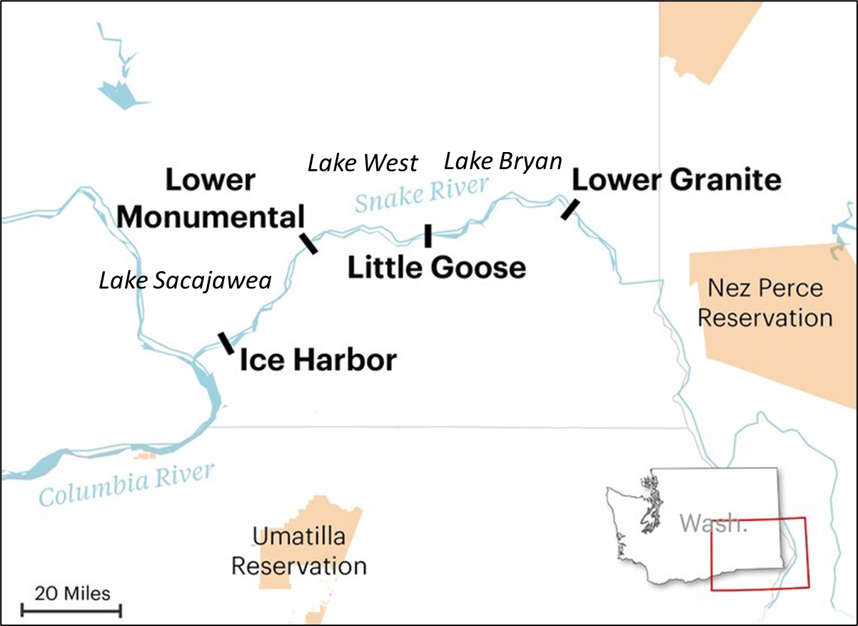

Figure 3: Dams and Reservoirs (Lakes) on the Lower Snake River[24]

Source: Oregon Public Broadcasting

The population of Lewiston, ID, also speaks to the impact of those dams on the region. After the U.S. Army Corps of Engineers completed construction of the four dams in the 1960s and early 1970s, Lewiston became a seaport. That drew industry to a region that had been predominantly agricultural. The population more than doubled between 1960 and 1970.

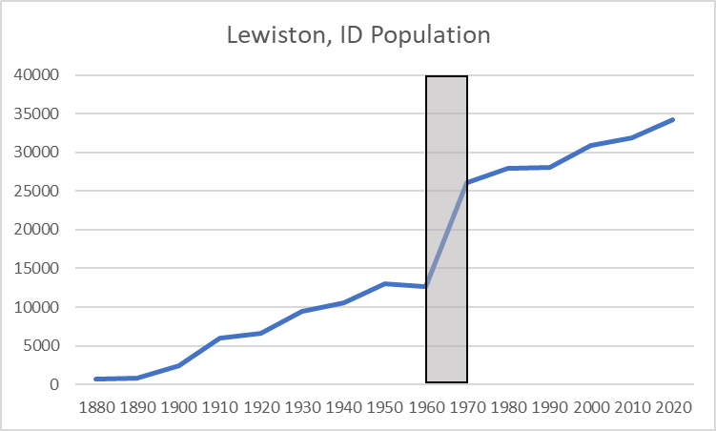

Figure 4: Population of Lewiston, Idaho

Data Source: United States Census Bureau

However, all these benefits came at the expense of the salmonids in the river and the people who have depended on them.

**Fish Ladders and More**

Concerns about the impact of dams on fish in the Columbia and Snake Rivers had surfaced before the construction of the Bonneville Dam in the 1930s.[25] While fish did successfully pass upstream using the fish ladders at Bonneville, and despite claims that the turbines were “absolutely incapable of hurting the

fish. If you could put a mule through there, and keep him from drowning he would go through without being hurt,”[26] studies indicated that downstream mortality reached as high as 15%.[27] No one knew the cumulative effects of the series of dams planned for the rivers.

Engineers built the four dams on the Lower Snake River with adult fish passage in mind: Fish ladders took fish away from the impassable face of the dams and into side channels consisting of a series of ascending pools. Fish would jump between pools, resting in them as needed, against the stream of rushing water. The Ice Harbor and Lower Monumental Lock and Dam projects included two fish ladders each; the Little Goose and Lower Granite Locks and Dams have one fish ladder with entrances on both shores and a fish passage through the dam.[28]

But those fish ladders have proven inadequate. Even with the ladders in place, salmon stocks plummeted.

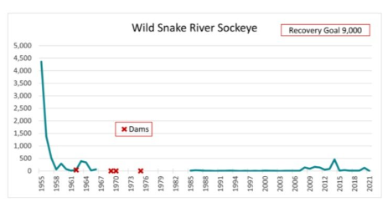

Figure 5: Historical Wild Chinook, Steelhead, and Sockeye Stocks on the Snake River[29]

Red X’s mark the years when dams on the Lower Snake River began producing power

Used with permission from Nic Nelson, Executive Director, Idaho Rivers United, https://www.idahorivers.org/lsrd

The engineers had overlooked the necessary migration of juvenile fish from their spawning grounds to the cold salt water where they spend years growing into adults before returning to their home streams to spawn and die. Passing through the massive hydroelectric turbines can masticate juvenile salmon. Others die due to the pressure differential between the water intake and the exit at the bottom of the dam. Those that do survive must expend energy to swim the length of the slack-water lakes formed by the dams rather than being carried along by a river current, and often fall prey to cormorants, terns, gulls, or pelicans.

Modifying the spillway weirs has improved conditions somewhat for juveniles. Still, the most successful approach to saving the juveniles has been to collect them and truck and barge them to below the Bonneville Dam on the Columbia River. The 10-year average collection of outgoing juvenile salmon and steelhead for 2011 to 2020 at Lower Monumental Dam on the Lower Snake River was approximately 2.2 million fish with approximately 1.7 million (77 %) of those transported to below Bonneville Dam.[30] Likewise, the 2011 through 2020 average collection of outgoing juvenile salmon and steelhead at Little Goose Lock and Dam was approximately 3.2 million fish with approximately 2.4 million (75 %) of those transported to below Bonneville Dam—about 254 miles.

I couldn’t help thinking that if I were a little fish, I might be quite disoriented after a detour into a pipe, a trip in a dark tank sloshing around with lots of other little fish to a river I had never visited. The Columbia beyond the Bonneville Dam has highways, cities and towns on either side, the freshwater additions from numerous rivers and streams, and a flow rate unlike any in the Lower Snake River. I would be one frightened little fish!

Another solution was introduced as the Lower Snake River Compensation Plan, authorized by Congress in 1976.[31] The plan involves the trapping of adult fish and collecting the roe, rearing of juveniles and release them into the Lower Snake and its tributaries. These activities should “compensate for the loss of 15 percent of the downstream-migrating juvenile salmon and steelhead at each of the dams. This amounts to a cumulative loss of 48 percent of the pre-dam runs.”[32] However, despite the addition of tens of millions of juvenile steelhead and salmon each year, the fish stocks have not rebounded. “In the Columbia/Snake basin, from 2008 to 2017, on average just 0.4 percent of the hatchery spring/summer chinook—about 60,000 fish out of 15 million—survived to make their way back up as adults past Lower Granite dam, the farthest upstream of the four lower Snake dams. Just 1.3 percent of hatchery summer steelhead returned from 2007 to 2016. In the most recent years the percentage has been even lower.”[33] Hatchery fish are not the answer either.

**Another Issue: Sedimentation behind the dams**

I had read that all dams are temporary.[34] Not because the materials of which they are made will degrade over time (the 20 million tons of concrete forming the Washington’s Grand Coulee Dam should last about 100 years!).[35] No, dams are temporary because of the sediment that accumulates behind them.[36] River systems transport sediment from fast-moving reaches to slower moving sections, bends, gravel bars, and estuaries.[37] Those processes reform and reshape rivers and the adjacent environments. Dams and their reservoirs interrupt the natural processes. Coarser and heavier rocks and gravel filter out of the water earlier in their river journey, leaving fine sediments to accumulate behind dams.

Erosion due to agricultural practices on the lands around Lake Herbert G. West and the Palouse River, which flows into that lake, contribute about 1.5 million tons of sediment per year.[38] The U.S. Army Corps of Engineers has estimated that more than 4 million cubic yards of sediment has accumulated within Lake Herbert G. West and behind Lower Monumental Dam.[39]

As the volume of sediment grows, the amount of water in the reservoir declines. In addition, that sediment may eventually block the pipes that feed water to the hydroelectric turbines or the spillways that allow floodwaters to bypass a dam.[40] Fine sediments that stay suspended in the water act as abrasives, wearing away the surfaces of the turbines, creating pits in the surfaces, increasing the need for maintenance and decreasing the electrical output of the dam.

Fine sediments also bring to Lake Herbert G. West another hazard: contaminants. Because of the large surface area, water soluble contaminants tend to adhere to the small particles.[41] The now banned but environmentally persistent pesticide DDT and similarly toxic DDE have been found in the fine-grained materials accumulating at the end of the lake, behind Lower Monumental Dam.[42] Studies have linked DDT to reproductive disorders, impaired immune system responses, liver damage and some cancers.[43] Exposure to DDE (a product of the degradation of DDT) mostly affects the nervous system. Dealing with those sediments adds another layer of complication to any projects involving the dam!

I muttered to myself, “It’s only a matter of time before that dam becomes a colossal concrete monument to the hubris of White settlers and their vision of an Inland Empire.”

**Broken Treaties**

As I stood beside the lake, I scanned the horizon as far as I could see. My ancestors once roamed the lands on both sides of the Snake River. They camped on its banks, fished in its waters, hunted deer and elk among the rolling hills, and gathered roots (like camas) and berries. They wanted for little.

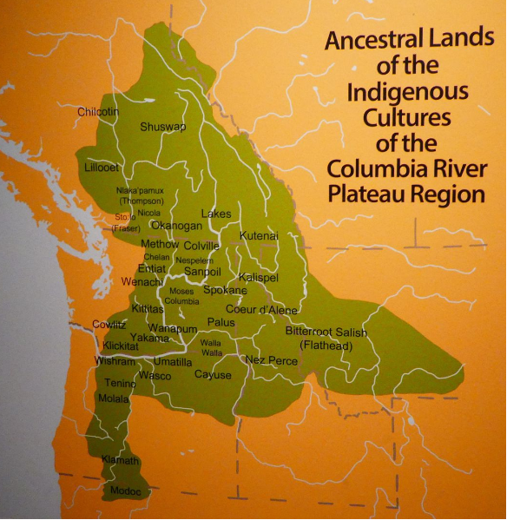

Figure 6: Ancestral Lands of Indigenous Peoples of the Columbia and Snake River Basins**[44]**

Source: nativeamericanneroots.net

Although some of the early White men described the lands bordering the Snake and Columbia Rivers as barren, with just “a few miserable tufts of grass,”[45] others saw promise in the wide-open tracts of land. The U.S. Army established forts to protect the growing numbers of colonists, and Christian churches sent missionaries to convert the region’s original inhabitants. Wars broke out. White men forced the Native Americans to cede much of their original territory and moved them to reservations, in treaties that reserved

[t]he right of taking fish in all the streams where running through or bordering said

reservation is further secured to said Indians; as also the right of taking fish at all usual

and accustomed places in common with citizens of the Territory; and of erecting

temporary buildings for curing, together with the privilege of hunting, gathering roots

and berries, and pasturing their horses and cattle upon open and unclaimed land.[46]

And yet time and time again the needs and wants and visions of the White man have taken priority over the words of those treaties. White men increasingly encroached on tribal lands, through laws like the Dawes Act of 1887, through redrawing of reservation boundaries, and other means. They dammed the rivers to increase their power—electric power, and power over water for navigation and irrigation of their agricultural lands and recreation.

Then a thought came to me. These dams were yet another form of power and control over the indigenous people of this land. The dams took away the lifeblood of many tribal people: the salmon.

The loss of the food and the salmon is monumental - and its all tied together. Food is

a really big part of the Yakama culture - as it is elsewhere. Anywhere you look in the

world, food carries culture. So if you lose your foods, you lose part of your culture . . .You

also lose the social interaction. When you fish, you spend time together - you share all

the things that impact your life - and you plan together for the next year. Salmon is more

important than just food.

Chris Walsh, Yakama Psycho-Social Nursing Specialist[47]

Salmon are the centerpiece of our culture, religion, spirit, and indeed, our very existence.

As Indians, we speak solely for the salmon.

Donald Sampson, Confederated Tribes of the Umatilla Indian Reservation[48]

The salmon lie at the center of the concentric rings I saw radiating across the surface of the lake, the rings that eventually encompass all of my ancestors and now me. I knew then I had to fight for the return of the salmon to the Lower Snake River.

**Review Questions for Part I:**

1. Based on your understanding of this case, list three of the primary reasons for constructing the dams on the Lower Snake River.
   1. Do the dams still provide the services promised at the outset?
   2. What factors might negate the usefulness of the dams in the future?
2. What have been the environmental impacts of the Lower Snake River dams?
   1. What actions have been taken to offset negative environmental impacts?
   2. How successful have those actions been?
3. What impact has the construction and operation of the dams had on the culture of tribes?

**Part II: Deciding on a Plan of Action**

Deciding to join the fight to save salmon runs on the Lower Snake River turned out to be easier than determining what action to support. Should I push for enhanced fish passage at the four dams, but leave them in place? What might that entail? Should I advocate for removal of any, or all, of the dams? Could that create other problems for the salmon? Would there even be any salmon returning to the river by the time we have navigated the bureaucracy to get necessary approvals for the removal of the large-scale hydropower dams? These and other questions swirled in my head.

I start my learning journey by reading the Columbia River Inter-Tribal Commission (CRITC)’s position on the Lower Snake River dams. In the 2022 *Energy Vision for the Columbia Basin*, the CRITC recognized the need for clean, reliable electric power for the region but also the need to restore “healthy and harvestable fish populations.”[49] The Vision includes a suite of near-term river restoration projects throughout the basin, improved fish passage, and expanded spills over the dams to coincide with fish migrations. In the longer term, the CRITC calls for breaching of the four dams on the Lower Snake River to create a “climate resilient, free-flowing river.”[50] This follows on resolutions passed in 2021 by both the Affiliated Tribes of Northwest Indians and the National Congress of American Indians that called for the same bold action.[51] I made a mental note: Take Bold Action—Remove the Dams!

That got me thinking about other hydroelectric dam projects in the Pacific Northwest—two dams on the Elwha River on the Olympic Peninsula in Washington (removed in 2011 and 2014), four on the Klamath River on the California/Oregon border (slated to be removed beginning in 2023), and another three dams on the Skagit River in northwestern Washington. How much influence did tribes have on the processes and decisions surrounding those projects? Was/Is dam removal the only action supported by tribes?

I decided to make a list of questions to guide my reading of the history and current status of those projects. I wanted to ensure I gathered comparable data about each of the projects and didn’t get sidetracked by some fascinating, but irrelevant, information.

1. What role do tribes play?
   1. Which tribes?
   2. How and at what points did tribes exert their influence?

(I did realize the answers to these questions might come later in my learning process, but I didn’t want to forget them!)

1. When were the dams constructed?
2. Did the dams have fish ladders or other structures to allow for fish passage when constructed? Or were they modified at some point in time to help preserve salmon runs?
   1. With salmon migration on the Lower Snake River at the forefront of my mind I wanted to understand how salmon had fared elsewhere in the Pacific Northwest. I expected older dams would not have fish ladders. As Hereditary Chief Ernest Alfred of the Namgis, Tlowit’sis and Mamalilikala Nation (Canda First Nations) recalled, the early dams arose during a time when salmon were plentiful: “My grandparents used to tell stories about how you could walk across the backs of the salmon—they were so plentiful that you could walk across the river on their backs.”[52] That had already changed by the time the Lower Snake River dams arose from the riverbed.
3. What spurred the controversy at each site? What event or change stirred people to call for action?
   1. I knew that for the Lower Snake River Dams, salmon, salmon migration, and preventing salmon extinction lay at the heart of calls to remove the dams. Was that true for all the other dams as well?
   2. And in some cases, the dams might need to be relicensed by the Federal Energy Regulatory Commission (FERC), opening a window of opportunity for a multitude of voices to be heard. Which dams up for relicensing?
4. What was the timeline for dam removal or dam retrofit projects?
   1. What agencies, community groups, or other stakeholders were and continue to be involved?
5. What options for action were or are being considered at each site?
   1. Which option had/has the best chance of being implemented and why?
   2. Which option did/do tribes prefer and why?
6. What might be lost or gained by the final choice of option?
   1. How might any losses be minimized or offset?

Questions, questions, questions! So many questions. Still, I felt excited. I felt empowered. Since time immemorial the salmon have given themselves unselfishly to sustain human beings on Turtle Island. It was now time for me to figure out what I could do to bring a thriving salmon population back to the Lower Snake River.

1. Copyright 2023 The Evergreen State College. Teaching notes for this case are available at http://nativecases.evergreen.edu. Kathleen M. Saul is a member of the faculty in the Graduate Program on the Environment at the Evergreen State College. Thank you to Barbara Smith and Linda Moon Stumpff for their many insightful comments on earlier drafts of this case.
2. Gregory Cajete. (1994). *Look to the Mountain: An Ecology of Indigenous Education*. Kivaki Press, Inc., 119 – 122.
3. Keith C. Peterson. (1995). *River of Life, Channel of Death: Fish and Dams on the Lower Snake*. Oregon State University Press, 87.
4. Linda Mapes and Hal Bernton. (9 June 2022). Removing Lower Snake River dams offers best chance for salmon recovery — at steep price, report says. *The Seattle Times*. Accessed 6 February 2023 from https://www.seattletimes.com/seattle-news/environment/new-state-federal-report-puts-10-27-billion-price-tag-on-lower-snake-river-dam-removal/
5. Dan Landeen and Allen Pinkham. (1999). *Salmon and His People: Fish and Fishing in Nez Perce Culture*. Confluence Press, 5 and 7.
6. Gary S. Breschini. (Fall 1979). The Marmes Burial Casts. *Northwest Anthropological Research Notes*, *13*(2), 111 – 158.
7. John C. Sheppard, Peter E. Wigand, Carl E. Gustafson, and Meyer Rubin. (January 1987). A Reevaluation of the Marmes Rockshelter Radiocarbon Chronology. *American Antiquity*, *52*(1), 123.
8. Wendy McDermott. (July 23, 2021). Snake River Vision: Tribal Rights. Accessed 6 February 2023 from https://www.americanrivers.org/2021/07/snake-river-vision-tribal-rights/
9. William Andrefsky, Jr. (2004). Materials and Contexts for a Culture History of the Columbia Plateau. Chapter 2 in in William C. Prentiss and Ian Kuijt, eds. *Complex Hunter-Gatherers: Evolution and Organization of Prehistoric Communities on the Plateau of Northwestern North America.* University of Utah Press, 27 - 28.
10. Randall F. Schalk, ed. (1983). *Project Report No. 8: Cultural Resource Investigations for the Lyons Ferry Fish Hatchery Project, Near Lyons Ferry, Washington*. Washington State University Laboratory for Archaeology and History, 26.
11. Michael Blumm, Laird J. Lucas, Don B. Miller, Daniel J. Rohlf, and Glen H. Spain. (1998). *Saving Snake River Water and Salmon Simultaneously: The Biological, Economic, and Legal Case for Breaching the Lower Snake River Dams, Lowering John Day Reservoir, and Restoring Natural River Flows*. Lewis and Clark Law School, Footnote 2, 999.
12. Benedict J. Colombi. (Autumn 2005). Dammed in Region Six: The Nez Perce Tribe, Agricultural Development, and the Inequality of Scale. *American Indian Quarterly* *29*(3/4) Special Issue: The National Museum of the American Indian, 565.
13. Ibid; Bendict J. Colombi. (Winter 2012). Salmon and the Adaptive Capacity of Nimiipuu (Nez Perce) Culture to Cope with Change. *American Indian Quarterly*, *36*(1), 81.
14. Meyers Resources, Inc. (October 1999). *Tribal Circumstances and Impacts from the Lower Snake River Project on the Nez Perce, Yakama, Umatilla, Warm Springs, and Shoshone Bannock Tribes*, xii.
15. Alvin M. Josephy, Jr., ed. (2006). *Lewis and Clark Through Indian Eyes*. Vintage Books, 100
16. Based on Neala W. Kendall, Jeffrey J. Hard and Thomas P. Quinn. (2009). Quantifying six decades of fishery selection for size and age at maturity in sockeye salmon. *Evolutionary Applications*, 523 – 536.
17. Northwest Power and Conservation Council. Canneries. (n.d.). https://www.nwcouncil.org/reports/columbia-river-history/canneries/
18. Ibid.
19. Calculations based on data contained in U.S. Army Corps of Engineers (n.d.) *Lower Monumental Lock and Dam Project Information*. Accessed 23 December 2022 from (https://www.nww.usace.army.mil/Locations/District-Locks-and-Dams/Lower-Monumental-Lock-and-Dam/; and U.S. Energy Information Administration (12 October 2022) “Frequently Asked Questions, How much electricity does an American home use?” Accessed 23 December 2022 from https://www.eia.gov/tools/faqs/faq.php?id=97&t=3#:~:text=In%202021%2C%20the%20average%20annual,about%20886%20kWh%20per%20month.
20. Baseload electricity comes from plants that can reliably provide the minimum level of customer demand at any given moment. Data for coal based on B.D. Hong and E. R. Slatick. (1994). Carbon Dioxide Emission Factors for Coal. Energy Information Administration, *Quarterly Coal Report*, January-April 1994, DOE/EIA-0121(94/Q1) (Washington, DC, August 1994). 1 – 8.
21. The Columbia River: A Photographic Journey. (February 2013). “April 28, 1915 . . .” Accessed 22 November 2022 from http://columbiariverimages.com/Regions/Places/the_dalles_celilo_canal.html
22. Joseph N. Teal, cited in Peterson. 74.
23. Reed Burkholder. (1993). Irrigation from 4 Lower Snake River Reservoirs by farms and agricultural users. Breaching Dams to Save Idaho's Salmon & Steelhead. Accessed 23 December 2022 from http://www.bluefish.org/iceharbr.htm; and U.S. Army Corps of Engineers Drawdown Regional Economic Workgroup (DREW). (1999). Water Supply Analysis. Accessed 23 December 2022 from https://www.nww.usace.army.mil/Library/2002-LSR-Study/DREW/
24. Toney Schick. (4 August 2022). How a federal agency is contributing to salmon’s decline in the Northwest. Oregon Public Broadcasting. Accessed 6 February 2023 from https://www.opb.org/article/2022/08/04/bonneville-power-administration-columbia-river-dams-salmon-recovery-spending-tribes/
25. Keith C. Petersen and Mary E. Reed. (1994). *Controversy, Conflict and Compromise: A History of the Lower Snake River Development*. Walla Walla District U.S. Army Corps of Engineers. 95.
26. Ibid, 96.
27. Ibid.
28. U.S. Army Corps of Engineers. (n.d.). Lower Snake River Dams. Accessed 21 January 2023 from https://www.nww.usace.army.mil/Missions/Lower-Snake-River-Dams/
29. Idaho Rivers United. (n.d.). The Lower Snake River Dams. Accessed 21 January 2023 from https://www.idahorivers.org/lsrd
30. U.S. Army Corps of Engineers. (n.d.). Lower Snake River Dams. Accessed 21 January 2023 from https://www.nww.usace.army.mil/Missions/Lower-Snake-River-Dams/
31. Northwest Power and Conservation Council. (2022). Lower Snake River Compensation Plan. Accessed 21 January 2023 from https://www.nwcouncil.org/reports/columbia-river-history/lowersnakecomp/
32. Ibid.
33. John McMillan. (1 July 2021). Hatcheries can't save Snake River salmon and steelhead. *Trout Unlimited*. Accessed 21 January 2023 from https://www.tu.org/magazine/conservation/barriers/hatcheries-cant-save-snake-river-salmon-and-steelhead/
34. Glen canyon Institute. (2018). All Dams are Temporary – Sedimentation. Accessed 13 March 2023 from https://www.glencanyon.org/all-dams-are-temporary-sedimentation/
35. U.S. Department of Interior, Bureau of Reclamation. (1 February 2008). Lake Roosevelt:

    The Grand Coulee Dam and the Columbia Basin Reclamation Project, Section II: Construction of the Grand Coulee Dam. Accessed 13 March 2023 from http://www.npshistory.com/publications/burec/grand_coulee_dam/sec2b.htm
36. Columbia River Inter-Tribal Fish Commission. (5 October 2015). Changing Ecosystem: Reservoir Sedimentation. Accessed 14 March 2023 from https://critfc.org/2015/10/05/changing-ecosystem-reservoir-sedimentation/
37. Southwest Biological Science Center. (6 October 2020). River Sediment Dynamics. Accessed 13 March at https://www.usgs.gov/centers/southwest-biological-science-center/science/river-sediment-dynamics#:~:text=Sediment%20controls%20the%20physical%20habitat,water%20column%20determines%20water%20clarity
38. Ibid, 2 – 1.
39. Ibid.
40. Dealing with Sediment: Effects on Dams and Hydropower Generation. (22 February 2017). Accessed 14 March 2023 from https://www.hydroreview.com/world-regions/dealing-with-sediment-effects-on-dams-and-hydropower-generation/#gref
41. U.S. Army Corps of Engineers, Portland District. (August 2020). *Sediment Quality Report, Lower Monumental Reservoir, Lake Herbert G. West, Columbia River Basin, Snake River, Washington,* 2 – 8.
42. Ibid, 2 – 10.
43. Sandip Chattopadhyay and Devamita Chattopadhyay. (2015). Remediation of DDT and Its Metabolites

    in Contaminated Sediment. *Curr Pollution Rep 1*, 251. DOI 10.1007/s40726-015-0023-z; Art Fisher, Mark Walker, and Pam Powell. (n.d.) DDT and DDE: Sources of Exposure and How to Avoid Them. University of Nevada, Reno, Cooperative Extension.
44. Plateau Indian Cradleboards (Photo Diary). (19 November 2019). Accessed 21 January 2023 from http://nativeamericannetroots.net/diary/Indians-101-Plateau-Indian-Cradleboards-Photo-Diary
45. Alfred Seton of John Jacob Astor’s Pacific Fur Company, as cited in Peterson. 57.
46. Colombi, 567 – 568.
47. Meyer Resources, Inc. (1999). Tribal Circumstances and Impacts from the Lower Snake River Project, vi.
48. Ibid, vii.
49. Columbia River Inter-Tribal Fish Commission. (2022). *Energy Vision for the Columbia River Basin*. 10. Accessed 14 March 2023 from https://critfc.org/wp-content/uploads/2022/09/CRITFC-Energy-Vision-Full-Report.pdf
50. Ibid, 56.
51. Ibid, 127, 132; Nez Perce Tribe. (2022). Affiliated Tribes of Northwest Indians Pass United Resolution Supporting Removal of Four Lower Snake River Dams. Accessed 14 March 2023 from https://nezperce.org/uncategorized/affiliated-tribes-of-northwest-indians-pass-united-resolution-supporting-removal-of-four-lower-snake-river-dams/
52. Ernest Alfred. (2021). Long ago, my ancestors could walk across the river on the backs of the salmon. Accessed 5 March 2023 from https://feralatlas.supdigital.org/poster/my-grandparents-used-to-tell-stories-where-you-could-walk-across-the-river