The Data May Be A Mess, But Can It Still Be Useful To Indian Country?

By

Mark Trahant?

ABSTRACT

This case explores the history of data collection in Indian Country ranging from the Bureau of Indian Affairs to the Census Bureau’s American Community Survey. It shows why American Indian and Alaska Native demographics matter and provides ideas about how to judge the value of numbers or reports that define who is an American Indian or Alaska Native.

NARRATIVE OF EXTINCTION

The problem of basic research involving American Indians and Alaska Natives is complicated because there are so many different kinds of data zooming across academic boundaries from anthropology to public health. Even after two-plus centuries of study, there are few shared definitions, and much of the information remains either irrelevant or only somewhat useful. The roots of that data irrelevancy stem from the idea that American Indians would be extinct by now.

“The assumption had come down from the earliest of times, not always voiced, but implicit, that the native inhabitants of the New World would become extinct,” wrote D’Arcy McNickle in his 1973 book, Native American Tribalism. “The notion grew stronger as the settlers waxed in numbers and the demand for living room accelerated. Reference to ‘the vanishing red man’ became a common theme in song and story. James E. Fraser’s equestrian statue, ’The End of the Trail,’ first shown at the San Francisco Exposition in 1915, captured the note of inevitable doom.” (McNickle, p.3)

Yet the idea of a vanishing people actually predates many of the stories told about Native America. Charles C. Mann writes in his book, 1491, that a major smallpox epidemic struck prior to contact. “The first whites to explore many parts of the Americas therefore would have encountered places that were already depopulated.” That notion alone would have made any sort of demographic information inaccurate. Indeed, Mann writes, “Historians have long wondered how many Indians lived in the Americas before contact. ‘Debated since Columbus attempted a partial census at Hispaniola in 1496,’ (William) Denevan, the Beni geographer has written, ‘it remains one of the great inquiries of history.’ Early researchers’ figures were, to put it mildly, informally ascertained. ‘Most of them weren’t even ballpark calculations,’ Denevan told me. ‘No ballpark was involved.’” (Mann, p. 93)

Denevan concludes that the population of pre-Columbian Americas was about 54 million people. Some scholars argue that even that figure is too low, possibly by half.
Mann says the first careful estimate of indigenous populations was made in 1928 by James Mooney, an ethnographer at the Smithsonian Institution. He estimated the native population at 1.15 million in North America. A few years later, Alfred Kroeber, a Berkeley anthropologist, cut back on that estimate to 900,000 -- a population density of less than one person for every six square miles or a total of 8.4 million people for the entire north and south continents. (Mann, p. 94)

However by the 1970s the indigenous population was found to be significantly higher. One study by Woodrow Borah, a Berkeley historian, reported the population in Central Mexico alone at 25.2 million people. “By contrast,” Mann wrote, “Spain and Portugal together had fewer than ten million inhabitants. Central Mexico ... was the most densely populated place on earth, with more than twice as many people per square mile than China or India.” (Mann, p. 94)

This debate shows why demographics matter. Historian Francis Jennings wrote: “Scholarly wisdom long held that Indians were so inferior in mind and works that they could not possibly have created or sustained large populations.” (Jennings, Founders, p. 83) Or, as Lenore Stiffarm, an ethnologist at the University of Saskatchewan, told Mann: You always hear white people trying to minimize the size of the aboriginal populations their ancestors personally displaced. Oh there used to be a few people there, and disease killed some of them, so by the time we got here they were almost all gone. It’s perfectly acceptable to move into unoccupied land. And land with only a few ‘savages’ is the next best thing. (Mann, 1491, p. 95)

If one believes that American Indians, at the time they encountered Columbus, were a handful of people, it is almost certain they were living in Stone Age conditions, they had very little in the way of culture, and the arrival of the Europeans might even have been a blessing for the tools and technology they brought with them,

wrote sociologist C. Matthew Snipp in an essay in the book, American Indian Nations (Snipp, American Indian Nations, p. 39)

But there is an accumulation of evidence to the contrary. One such place is the site of a once great city known as Cahokia. It is located across from St. Louis, Missouri, on the east side of the Mississippi River. At its peak, it was one of the largest cities in the world. In the 1100s and 1200s, it was significantly larger than the cities of Berlin and London, and virtually any of the cities in Europe at the time. It also may have been on par with several significant cities in the Middle East. (Snipp, American Indian Nations, p. 39)

Snipp points out that a clear understanding of the Cahokia site did not emerge until the 1920s. “Rendering an account of America was the inevitable settling of the unsettled frontier, taming the rivers, and conquering the wilderness,” Snipp writes. “This was made inevitable by what most believed was the irresistible engine of modern human progress. By the late nineteenth century, when American Indians were almost extinct, the notion of the vanishing American Indian became a fixture in nineteenth century culture.” (Snipp, American Indian Nations, p. 39)

DEMOGRAPHIC REVERSAL

Article I of the U.S. Constitution requires an “actual Enumeration” of citizens for representation in Congress every ten years. American Indians have a unique role in that process. “The House of Representatives shall be composed of Members chosen every second Year by the People of the several States, and the Electors in each State shall have the Qualifications requisite for Electors of the most numerous Branch of the State Legislature,” according to the Constitution.

Representatives and direct Taxes shall be apportioned among the several States which may be included within this Union, according to their respective Numbers, which shall be determined by adding to the whole Number of free Persons, including those bound to Service for a Term of Years, and excluding Indians not taxed, three fifths of all other Persons. (U.S. Constitution, Article 1, Section 2)
This language is similar to that in the Articles of Confederation which gives Congress the power to deal with Indian issues and “not member of any of the States.

But the counting -- or an inaccurate tally of Indians not taxed -- was and is a complicated undertaking.

McNickle had the idea that counting American Indians was full of “special problems” that started with the very idea of ultimate extinction. It did not matter how many people were originally on the continent if American Indians vanished. Indeed, by 1850, the total population was at 250,000, or possibly less. “... Within the first two decades of the present century it was possible to question the assumption of ultimate extinction,” McNickle wrote, but then after 1930 the American Indian population both in the U.S. and Canada began to reverse and exceed the rate of growth for the general population. (McNickle, p. 5)

But there were other special problems. Only American Indians that received federal services, in certain categories, were counted. McNickle wrote, “the government prefers to limit rather than to expand this number. Thus, many thousands of individuals are not counted, though they are as much Indian by inheritance and style of living as those who are officially enumerated.” (McNickle, p.5)

In 1977 the congressionally-sponsored American Indian Policy Review Commission also took a look at the policy of definitions. The commission asked:
Who exactly are American Indians? Where do they live? Are there Indians who do not live on reservations? Are there Indians in cities? Are there Indians that live outside the Western United States? How much do they earn, where do they work, what is there educational and health status? (AIPRC, Final Report, p. 87)

The commission said it was putting together its own demographic picture that even if incomplete would at least be a basis for action. The problem was, and is, that complete reliable statistics do not exist for reasons that are both simple and complex. The first issue is that there is no single generally-accepted definition of an Indian. “Without this basic definition, the development of further statistical descriptions is very difficult,” the Commission said. (AIPRC, Final Report, p. 87)

The question -- who is an Indian? -- is answered by the 564 tribal governments recognized by the United States Government. Every tribe has its own definition.

But the United States government has its legal requirements, too. The Office of Management and Budget’s Directive 15 defines an American Indian or Alaska Native as “a person having origins in any of the original peoples of North America, and who maintains cultural identification though tribal affiliation or community recognition.” However OMB’s Form 4432 is the document required to verify Indian preference for employment with either the Bureau of Indian Affairs or the Indian Health Service. The government identifies four categories: A, B, C and D. Category A is a member of a federally-recognized Indian tribe, band or community. It includes enrollment, or citizenship verification signed by a tribal official. Category B is a descendent of a member of a federally-recognized tribal member who were residing on an Indian reservation on or before June 1, 1934. That date is used because the Bureau of Indian Affairs collected records prior to the Indian Reorganization Act. Category C is persons who are at least one-half degree Indian blood from tribes indigenous to the United States. Category D is a member of an Alaska Native community or tribe.

But even these broad definitions miss many people who are considered American Indian by their community. For example, a Cree from Canada would be someone with indigenous origins in North America, but who would not qualify for either A, B, C or D designation for BIA or IHS employment. The Census reports that about 5 percent of American Indians are “foreign born.”

Of course the U.S. Census uses a broader definition of an American Indian, and that count includes indigenous people from Central and South America. The Census Bureau starting using self-identification in 1960 with a check off box for racial categories. That led to a significantly larger American Indian population. Then in 2000 the Census Bureau began allowing people to check more than one box and count multiracial backgrounds. Snipp said that boosted the number of American Indians to roughly 4.1 million when including another race and about 2.5 million alone. (Snipp,, p. 46)
Snipp said the Census approach “might leave one skeptical about who identifies as American Indian.” Many of those who have mixed-race background might not have other identifications with tribal communities such as membership or other markers of authenticity. “This remains one of the most contentious and controversial issues facing modern Indian communities today. Until this matter is resolved unambiguously, the ambiguity and uncertainty of the data reflected in the census are virtually certain to linger far into the future.” (Snipp, American Indian Nations, p. 48)

On an individual level, stricter definitions are already policy when it comes to how American Indians and Alaska Natives qualify for federal programs designed to improve economic conditions, housing or employment. But because each agency has its own qualification criteria, the data remains a mess. Or as the American Indian Policy Review Commission described the problem, “The task is made more difficult by the fragmentation of jurisdiction over the people classified as ‘Indians.’ Health services, agricultural and other developmental assistance, business loans, housing aid, land development, and other programs, though all directed to Indians, are handled by different federal agencies with widely dissimilar interpretations of eligibility criteria.” (AIPRC, Final Report, p. 87)

The result? A “diffusion, not only of effort, but of information.”

Stanford Sociologist Snipp says he has been looking at American Indian data for thirty years where he’s invited to talk about what a mess the data can be. “And it’s true,” he says. “But it’s not unique to the American Indian population. There are issues that arise when you begin to collect data about race for anyone.”

For example the Bureau of Indian Affairs (BIA) reports a lower number of American Indians enrolled by tribes than were reported by the Census 2000 (either alone or by including multiracial groups).(Data Symposium, Summary, p. 14)

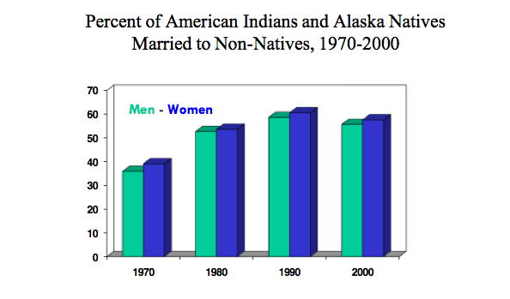Source: Data Symposium Summary, p. 11
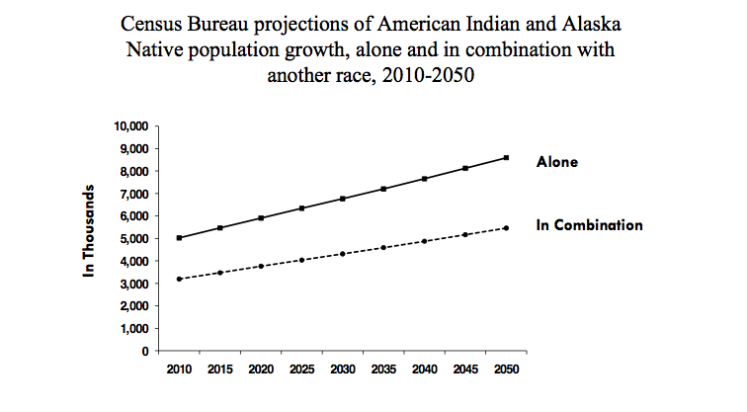

Source of graphic: (Data Symposium, Summary, p. 10)

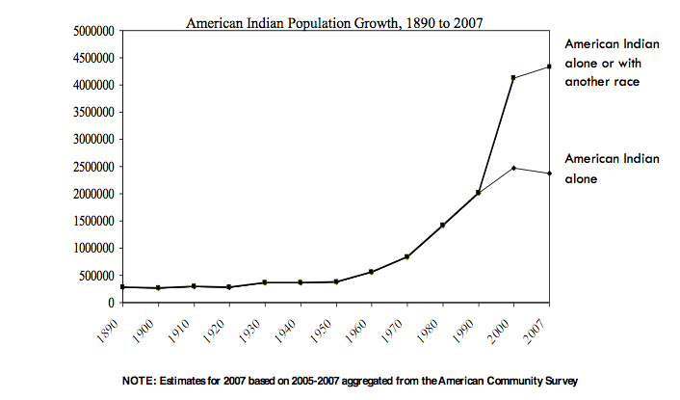

Source of graphic: (Data Symposium, Summary, p. 12)

“Reporting one’s tribal identification on the Census depends on how you label it,” Snipp said at a conference of demographers sponsored by the Centers for Medicare and Medicaid last year. Few members of federally-recognized tribes actually write-in the name of their tribal affiliation on the census form. And, if they do, there is the additional complication of a tribal name, such as Cherokee, and the actual tribal government that might have recognition from the United States. For example some 277,000 people listed Cherokee as their tribal affiliation in the 2000 Census, Snipp found. But in addition to that other census forms listed affiliation with Western Cherokee, Eastern Cherokee, and United Keetoowah Band, which could refer to membership in federally recognized tribes. But others cited membership in the Four Winds Cherokee, Echota, and the Cherokee of Alabama, which, Snipp said, are not the three federally recognized groups. Snipp, who is Cherokee and Choctaw, calls this the Cherokee Syndrome, but it is not a unique problem because the same issues surface with people who label themselves “Metis” (a French word meaning mixed-blood). (Data Symposium, Summary, p. 14)

What is clear in that data mix is that American Indians and Alaska Natives have the highest percentage of racial intermarriage. “In fact, there are more American Indians married to non-Indians than there are Indians married to other Indians,” Snipp said, “This is nothing new. It goes back to the very earliest settlement of the hemisphere and the story of Pocahontas and John Rolf.” (Data Symposium, Summary, p. 10)

MEASURING UNEMPLOYMENT

Consider the problem of measuring unemployment in Indian Country. “High unemployment is new to most Americans, but native people have felt it for decades, often those unemployment rates are four to five times the unemployment rate of the country as a whole,” said National Congress of American Indians President Jefferson Keel at his 2011 State of the Indian Nations speech in Washington, D.C.

But what number does that “four or five” times the national unemployment rate represent?

The Bureau of Indian Affairs (BIA) publishes the American Indian Population and Labor Force Report that measures what it considers the official unemployment rate based on data from 561 federally-recognized tribes. (The last available report was published in 2005.) That report shows unemployment at 49 percent nationally (showing South Dakota with the highest unemployment rate at 83 percent of the adult workforce). However the BIA’s methodology is different from any other employment report. Its numbers are based on reports from tribes only using the enrolled membership that lives on or near a reservation and is eligible for BIA services. This population total is about one-third of that reported by the Census Bureau. Also the Census Bureau’s Current Population Survey only counts people who are actively looking for work -- a restriction that is not part of the BIA screening of the data. There may also be a problem in determining employment. In the Pacific Northwest, fishing occurs at certain seasons, so a person might be employed at one time of the year, but depending on the time of the survey, might be “unemployed” though that person might be hard at work preparing for the next season.

Another way of looking at unemployment data comes from the Economic Policy Institute (EPI). A November 2010 study found American Indian and Alaska Native unemployment levels at 15.2 percent nationally (compared, at the time, to a white unemployment rate of 7.7 percent). But the impact of the recession was worse in Indian Country. “By the first half of 2010, the unemployment rate for Alaska Natives jumped 6.3 percentage points to 21.3%—the highest regional unemployment rate for American Indians,” EPI reported. (Austin, p. 1)

Moreover by using the same Census data as the general population, EPI was also able to uncover some important anomalies. For example: “The employment situation is the worst for American Indians in some of the same regions where it is best for whites: Alaska and the Northern Plains.” (Austin, p. 1)

Another important distinction is based on the age of American Indians and Alaska Natives. The EPI report said:

All else being equal a younger population should have a higher
employment-to-population ratio than an older population. Older adults are more likely to have disabilities that prevent them from working, and substantial numbers of adults over 54 years old retire out of the labor force. Thus, the younger Native American population should have a larger share of workers than the older white population. The ‘true’ American Indian/white employment rate disparity is likely greater than the observed gap. (Austin, p. 4)

Similar differences are reported between the BIA’s official poverty rate -- showing 29 percent nationally in 2005 -- and that from the Census Bureau’s reported 24 percent that same year.

HEALTH DISPARITY

The debate about American Indian health care is a good example of how the same data can be used to describe very different perspectives and is often driven by a particular political point of view.

The debate about U.S. health care reform is an example. One Harvard study, Debating Health: Election 2008, found that Americans are not certain where our health care system ranks globally. Forty-five percent believe the U.S. has the best system in the world; 39% believe other countries have better systems; and 15% don't know or don’t answer. But this question also reflects an ideological division because nearly seven-in-ten Republicans (or 68%) believe the U.S. health care system is the best in the world, compared to just three in ten (32%) Democrats and four in ten (40%) Independents who feel the same way.

Yet the data is clear. The U.S. is nowhere close to offering the best health care in the world. A 2010 report by the Organization of Economic Cooperation and Development (OECD) says the U.S. spends two-and-one-half times more than the average OECD country, but ranks near the bottom of all industrial countries in most health status categories, including life expectancy. (OECD health data)

Even though the “best care” narrative is not universal in the political debate about health care reform, the debate over Indian health care often relies on the opposite tack. Instead of “best care,” the story is about the lack of funding or the inadequacy of service. The Indian Health Service relies on direct appropriation for much of its operations and often runs out of money before the end of the fiscal year, so the oft-repeated line “don’t get sick after June,” becomes a storyline about a poorly-funded system that represents the worst in health care delivery.

But does the data match that story? The Centers for Disease Control’s (CDC) National Health Statistics Report, Health Characteristics of the American Indian or Alaska Native Adult Population: United States, 2004-2008 recently said the nation’s indigenous population faces significant challenges including higher mortality rates from tuberculosis, chronic liver disease and cirrhosis, accidents, diabetes, pneumonia, suicide, and homicide compared with other racial and ethnic groups.

The report’s bottom line: “The AIAN population has a life expectancy at birth that is 2.4 years less than that of all U.S. populations combined, and they have 1.2 times as many years of potential life lost at age 75 as that of all other populations combined.” (Barnes, et. al, p. 1)

These are bleak numbers when compared to the health statistics of other Americans.

But that’s just a single interpretation without historical context. Another view pulls back and looks at the arc of federal health care statistics over the last couple of decades or even fifty years. Then the story is one of remarkable success, not failure.

The transfer of Indian health services from the Bureau of Indian Affairs to the Indian Health Service (IHS) is a great example. In 1955 doctors were quitting because the bureaucracy was intolerable and there was no consideration of the needs of people. Indeed the new IHS started with a brilliant move: investing in sanitation and public health programs. (Something we now take for granted and complain about because it’s sometimes a slow process.) But over that first decade the IHS working with tribal governments built more than 400 water and waste disposal systems. The agency reported that “the people themselves have contributed more than one third of the total cost through donated labor, materials and funds.” (Rife, et. al, p. 35.) That single idea resulted in an 80 percent reduction in gastrointestinal disease among American Indian and Alaskan Natives since 1973. (Rife, et. al, p. 35)

Or jump ahead to the Indian Health Care Improvement Act signed into law on October 1, 1976 by President Gerald Ford. At the White House, Dr. Ted Marrs described the conditions of native people this way: “In 1974 the average age at death of Indians and Alaska Natives was 48.3. For white U.S. citizens the average age of death was 72.3. For others, the average age was 62.7.” ( (Marrs, in author’s files)

Again: Life expectancy in 1974 was a little over 48 years old -- compared to more than 72 for white Americans.

That changes the perspective of the CDC’s reported life expectancy disparity at birth of only 2.4 years less than that of all U.S. populations combined.

One huge source for health information comes from the Medical Statistical Information System, or MSIS, data that is collected by the Centers for Medicare and Medicaid. But this information begins at the state level and Indian Health Service often has different geographic boundaries as well as reporting systems.

Nonetheless, there is not a health care parity with the general population, not by a long shot, partly because of the chronic nature of so many diseases that afflict Indian Country.

The Indian Health Service reports that American Indians and Alaska Natives are two-and-one-half times more likely to have diabetes than non-Hispanic whites. More than 16 percent already have diabetes and nearly one-third show pre-diabetes. That compares with the general population where less than 9 percent have diabetes and about a quarter show signs of pre-diabetes. (Because diabetes is chronic and long-term it is the most expensive disease in America.)

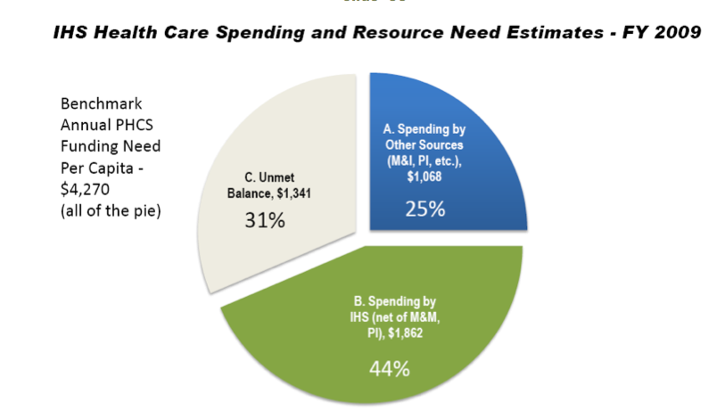

Source of graphic: (Data Symposium, Summary, p. 51)

And the federal funding gap is real (and potentially growing). But nonetheless by one important measure -- “closing the existing gap in age at death” -- has been improving steadily over the last four decades.

Health care reform -- or the Affordable Care Act of 2010 -- changes the requirements for data about American Indians and Alaska Natives in significant ways. The new business model for the Indian health system relies on third-party collections from either private insurance companies or from existing federal funding streams, primarily from Medicare and Medicaid (including the Children’s Health Insurance Program) where statistical definitions are complicated by multiple factors. Consider eligibility: more than 560 tribal communities with members living on or near reservations or spread out in urban areas. Each tribe defines its membership but that data is rarely collected for use in health statistics because it’s often privately held. The Indian Health Service has another definition that adds descendants of enrolled members to the mix. And it collects data through its area offices, not states. Many IHS boundaries and reservations cross state lines, further confusing the data. But Medicaid collects some American Indian/Alaska Native statistics when it’s identified as a single race, excluding those who are multiracial or also consider themselves Hispanic. And, coming soon, there will be new rules from the Internal Revenue Service as part of the Patient Protection and Affordable Care Act because of the American Indian exemption from insurance mandates (as well as a new definition for urban Indians).

In addition to those items on the grid, there are also 36 states with different administrative structures (remember that Medicaid is a state-federal partnership providing medical insurance for the poor and for long-term care) each with its own process for collecting data. One result: Eleven of the 36 states collect little data about Native Americans and seven collect none at all.

An additional problem is that few private health insurance plans collect the type of information that would be useful in this framework regarding American Indian and Alaska Natives. This is important because more American Indians and Alaska Natives live in urban areas than on reservations or rural areas.

But the data isn’t what’s really important here; instead, it’s how those numbers are used to drive policy and funding and that’s where Medicaid and Medicare are the biggest players in that game.

Edward Fox, Squaxin Island Tribe, a consultant with Kauffman and Associates, and author of the paper “Medicaid and Indian Health Programs,” said, “Medicaid expenditures exceed Indian Health Service expenditures in some areas.” He said in the Tucson area office, Medicaid is 156 percent of the IHS total; at Navajo, it’s 137 percent, Phoenix 94 percent and Alaska 91 percent. (Data Symposium, Summary, p. 47)

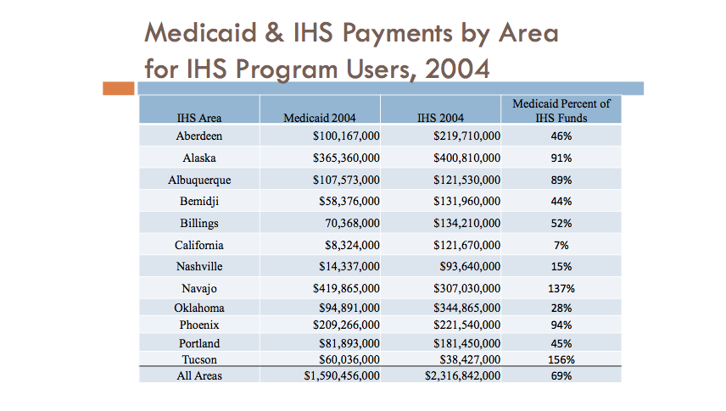
Source of graphic: (Data Symposium, Summary, p. 47)

Indeed, health care reform should boost financial support across the Indian health system because of the expansion of eligibility to include Medicaid to 133 percent of the federal poverty level and, for the first time, covering single adults.

But the data has another purpose: To help understand – and to correct – the remaining health disparities between American Indian and Alaska Native populations. What strategies, backed up by the data, work best to reduce diabetes? Or, better, are there clues to how to prevent the disease in the first place? And what do you compare those numbers against as a metric for success?

The Special Diabetes Program for Indians has used this sort of data feedback to tailor its efforts to reduce and control the disease for the past decade. One success has been improved blood sugar control. The Indian Health Service says the mean blood sugar measurement (called A1C) has decreased 13 percent in that decade. “Why is this important? Every one-unit decrease in A1C (such as 8% to 7%) translates into a 40% reduction in diabetes-related complications, such as blindness, kidney failure, and amputations,” according to the Indian Health Service. (Division of Diabetes Treatment and Prevention).

This is why the data matters. It’s why the country and the American Indian/Alaska Native community needs to make sense of what data is available -- even if a mess -- to shape discussion, policy and action. The Census Bureau’s American Community Survey, while far from perfect, collects a vast amount of general information about American Indian and Alaska Native people. It demonstrates how people work, move and where they live (remember, most Native Americans live in cities).

And, by the way, what is the definition of who is an American Indian? That’s an old debate, but soon the answer might generate a criminal inquiry because under the new health care reform law, IRS regulations will determine when a Native American is exempt from penalties for not buying mandatory insurance. There will likely be a penalty for claiming a tribal affiliation when one doesn’t exist or is not proved. Indeed, even that idea will be controversial and complicated. Most tribal enrollment records are private. Will tribes confirm to IRS investigators the enrollment status of members and descendants?

References

Austin, A. (2010). Different race, Different recession American Indian Unemployment in 2010 (Rep. No. 289). Retrieved Spring, 2011, from http://epi.3cdn.net/94a339472e6481485e_hgm6bxpz4.pdf
Barnes, P. M., Adams, P. F., & Powell-Griner, E. (n.d.). Health Characteristics of the American Indian or Alaska Native Adult Population: United States, 2004–2008 (United States, Department of Health and Human Services, Centers for Disease Control and Prevention).

Horse, C. G., Champagne, D., & Jackson, C. C. (2007). American Indian nations: yesterday, today, and tomorrow (pp. 38-48). Lanham, MD: AltaMira Press.
Jennings, F. (1994). The founders of America: from the earliest migration to the present (p. 83). New York: Norton.
Mann, C. C. (2005). 1491: new revelations of the Americas before Columbus (pp. 92-95). New York: Knopf.
McNickle, D. (1993). Native American tribalism: Indian survivals and renewals (pp. 3-5). New York, NY: Published for the Institute of Race Relations, London by Oxford University Press.
OECD Health Data Updates: Data, Sources and Methods, and Software Updates. (n.d.). Organisation for Economic Co-operation and Development. Retrieved May 27, 2011, from http://www.oecd.org/document/44/0,3746,en_2649_37407_2085228_1_1_1_37407,00.html
Rife, J. P., & Dellapenna, A. J. (2009). Caring & curing: a history of the Indian Health Service. [Landover, Md.]: PHS Commissioned Officers Foundation for the Advancement of Public Health.
Snipp, C. Matthews (2007), “ An Overview of Indian Populations” in Horse, C. G., Champagne, D., & Jackson, C. C. (2007). American Indian nations: yesterday, today, and tomorrow (pp. 38-48). Lanham, MD: AltaMira Press
United States, Centers for Medicare and Medicaid, Tribal Affairs. (n.d.). Developing Medicaid and Medicare Data.
United States, Department of the Interior, Bureau of Indian Affairs. (n.d.). 2005 American Indian Labor and Population Report (pp. Iv-9).
U.S.Cong., American Indian Policy Review Commission. (n.d.). American Indian Policy Review Commission Final Report (p. 87) [Cong. Rept. from 93rd Cong., 1st sess.].

This material is based upon work supported by the National Science Foundation under Grant No. 0817624.Any opinions, findings, and conclusions or recommendations expressed in this material are those of the author(s) and do not necessarily reflect the views of the National Science Foundation. Copyright (2011) held by The Evergreen State College. Please use appropriate attribution when using and quoting this case. Cases are available at the Enduring Legacies Native Cases website at http://www.evergreen.edu/tribal/cases/
? ² Mark Trahant is a writer, teacher and a “Twitter poet.” He was a 2009-2010 Kaiser Media Fellow, and former editor of the editorial page for the Seattle Post-Intelligencer. He has been chairman and CEO at the Robert C. Maynard Institute for Journalism Education. Mark is a member of Idaho’s Shoshone-Bannock Tribe and a former president of the Native American Journalists Association. He is the author of The Last Great Battle of the Indian Wars, about Henry Jackson, Forrest Gerard and the campaign for American Indian self-determination. He lives in Fort Hall, Idaho

