**War Cry: Will Crossing Historical Boundaries in Indian Wars help Yakama Women?**

By Emily Washines

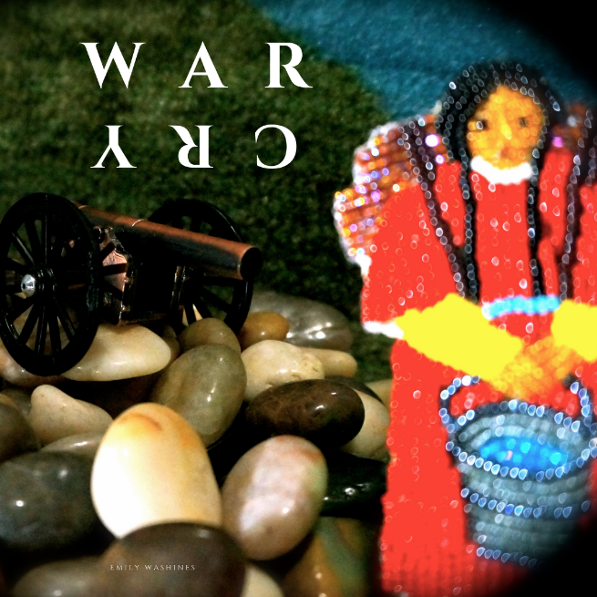

Figure 1 - Beadwork by Stella Washines, photo by Emily Washines

## Abstract

*Three months after one of the largest treaty councils held in the United States, there was a war that sent a shock through the Northwest. The Yakama War took place from 1855-1858. According to historical accounts, the war started because of violence against Yakama women and girls. History books often interpret the Yakama Warriors' response not as a defense of women, but as unhappiness with the treaty, resulting in decades of written erasure of violence against women. This case examines systems and patterns of Yakama historical and present-day Missing and Murdered Indigenous Women (MMIW). War Cry is a balance of strength and vulnerability to bring both history and justice forward. This path of post-war reconciliation also explores the question: How do you talk to someone when our great-grandparents were historic enemies? Examples are given of the meeting process between descendants of Yakama Nation tribal members and the U.S. military and militia. Sharing steps in crossing historical boundaries will help discussions about historical trauma and reconciliation action.*

DISCOVERING PATTERNS AND WHAT IS POSSIBLE FOR RECONCILIATION EVEN AS THE CYCLE OF VIOLENCE AGAINST INDIGENOUS WOMEN CONTINUES

Our Yakama people went to war in the mid-1800s to protect our women.[1] To this day, some may not understand and instead label our warriors hostile for defending our families. When I think of what my relatives went through, I also think about what they prayed for. The day when we would be strong enough to revisit this history together. This includes asking how a historic Northwest war connects to present-day Missing and Murdered Indigenous Women MMIW). Now is the time for Yakama people and our Non-Native neighbors to cross historical boundaries.

Sometimes I get puzzled looks from people that are uncertain about the Native woman talking about Indian Wars and asking questions. I find other non-Natives who stand by me as I revisit our history with curiosity. This is both a personal and community journey.

My methodology is my strength. My thinking on this topic is a cycle because when I think about the danger Native women went through, I also think of the present and the future. In this way, patterns become more apparent. There is an erasure of the violence of Native women in the historical record. This includes why the Yakama War started. Unfortunately, there is a pattern of erasure that continues.

If we think of the moments in our lives when we face danger, then compare it to historical tragedies of Native people what do we notice? Along this process of reconciliation, I revisit our teachings, including our Yakama historical accounts both in written and oral history. For Native people, we are a part of a legacy of connection to Native women before us who have sacrificed so we can be here.

When we tell the history of our people, we are on a parallel journey of healing. They are connected. Revisiting history is a process because we gain different lessons and insight at different points in our lives. I have chosen to do as my elders asked me when I was a teenager, to never forget the role of women in our tribe. That women fought in the war and that the war started to protect our women. Since 1855, Yakamas have been in an ongoing crisis of Missing and Murdered Indigenous Women.

I hope this case illuminates a pathway that will help Yakama women of past and present. Perhaps this case can be utilized as a model for others to research the history and patterns of violence in their tribes and communities. This case illustrates the strength and endurance of the people in the Northwest. Ultimately, the case centers on the question of what is possible in post-war reconciliations with Indian Wars?

**History in Schools and Reconciliation**

There are tribal historical accounts shared about the Yakama War. However, many historians reference available historical materials, which are rarely from tribes. For some tribal youth, history was whispered as if enemies were nearby. The following comment describes how history was taught at my middle school on the Yakama Nation reservation in the 1990s:

...My family would talk to me about our Yakama and other Native histories. I was frustrated. “Why didn’t the teacher or books have this history?” Other Natives were in the class including my cousin. He put his head down most of the time feigning boredom during the history lessons that erased Yakama history. I looked over at him willing myself not to care about my grade. Some days were silently painful...I wanted to escape those lessons that erased us...Some days I pretended to be him. Head down resisting the removal of our people from history. When the teacher yelled at him, he would write notes, his head still down on the desk. Refusing to get up to even sharpen his pencil, he wrote pressing hard on the paper so that you could not even see the lead anymore. When I walked by that class recently, I got a flashback. I remember that moment like it was yesterday because, on those days, that’s how big I felt. That tiny pencil stub. Painfully forced to record a history that was not accurate. (Washines, 2019)

A small number of states including Washington, Oregon, and Montana have passed laws requiring public schools to teach about Native history and sovereignty. Washington’s curriculum development and training of teachers has been going on since 2006 and is available at the Office of Superintendent website Since Time Immemorial. [2] This correcting and updating the curriculum on Native American history is long overdue. As Sarah Shear noted in her study of history standards in all of the US states the story being told is highly inaccurate. It stresses only pre-1900 history conveying the impression that “all Indians are dead” (Landry, 2014). Post-war reconciliation should include examining historical information along with more recent and more accurate accounts.

With truth and reconciliation, Professor of Ojibwe at Bemidji State University and author, Anton Treuer said:

We have to say what happened, how it happened, why it happened and acknowledging the way that systems of privilege were established and maintained and still maintained, even today, as part of the process to heal those ancient and contemporary wounds and make things better for the next 500 years (as cited, Martin, 2012).

This pathway of reconciliation includes reviewing agreements between the United States and Tribes.

The Yakama Nation is one of the 29 federally recognized tribes in present-day Washington State.

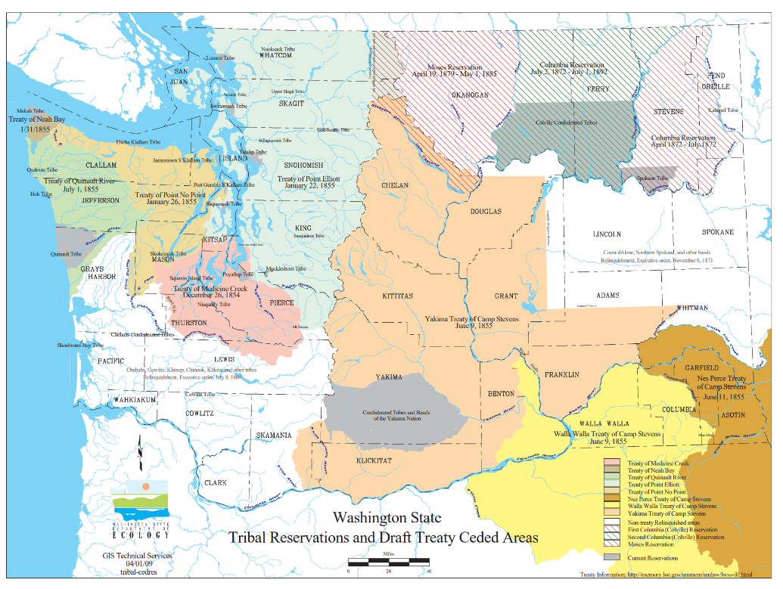

(Map of Reservations and Ceded Lands, 2009) [3]

**The 1855 Treaty Council**

In June 1855 one of the largest councils of multiple tribes gathered to discuss treaties with the United States in Walla Walla, Washington. The tribes signed their respective treaties. These tribes were located in Washington, Oregon, and Idaho. The 14 Confederated Tribes and Bands of the Yakama Nation became federally recognized under the Treaty of 1855 which had representatives from the following: Yakama, Palouse, Pisquouse, Wenatshapam, Klikatat, Klinquit, Kowwas-say-ee, Li-ay-was, Skin-pah, Wish-ham, Shyiks, Ochechotes, Kah-milt-pay, and Se-ap-cat and were to be known as Yakama. They agreed to an approximately 1.3 million acre reservation, approximately 11 million ceded area in Washington State, and a usual and accustomed area that spans numerous states (12 Stat 951, as cited Yakama Nation Treaty of 1855).

Growing up, Yakama elders explained to me that we signed the treaty to protect the resources for those not yet born.

*How did we get to the place where Natives are depicted as blood-thirsty in history books?*

Once gold was found, Governor Stevens refused to wait for the Treaty of 1855 to be ratified by Congress before opening the land to settlers. Simultaneous with opening the land, Stevens announced that Non-Natives had the option to file “Claims for Damages by Indians (Cutler 2016).” Stevens also refused to offer any protection and process for Native Americans, including Yakama people that would face violence by gold miners. Cutler further discusses this dynamic and deadly cost for Native people in the Washington Territory:

The first is the assertion that a “nation or tribe” is responsible for the actions of a member. The same did not apply to non-Native groups. Second, no process was set forth for the assessment of guilt or innocence of the targeted party.… When it came to alleged property damage or theft, Indians were assumed to be guilty unless proven otherwise. Third, no laws were established to allow Indians due process…Thus, George Wright, or any other commander, could draw from a wide range of punishments based on opinion, rather than law (2016, p. 73).

The extraction of resources is connected to tragedies for Native people in the Northwest. Yet, in over 165 years, there are not many who acknowledge the negative impact of seeking gold. When Elected officials enact protective laws and policy for Non-Natives, but failed to enact equal protection for Native Americans. History shows us that when crimes of violence happen to Native people, they had no process from territories, states, or the federal government to protect them. There are accounts of violence towards numerous tribes including those in settler states Washington and California.

**California Tragedies**

Throughout the Northwest there was change. “By the mid-1800s sweeping change was brought to California and the United States with the passage of the Treaty of Guadalupe Hidalgo in 1848 and the California Gold Rush of 1849,” (San Manuel Band of Mission Indians, 2019). Gold miners earned a notorious reputation among Natives in the Northwest. “In Shasta City, officials in 1851 offered a bounty of five dollars for every California Indian head turned in. Several unsuccessful miners suddenly found a more lucrative living in murdering Indians, bringing in horses laden with as many as a dozen Native people’s severed heads,” (Clarke, 2016)

These murders were a powerful warning of what could happen to tribes with the extraction of resources by non-Natives. Northwest tribes heard of the violence towards Natives in California. There was a violent reaction towards Natives, and this was a lesson that Natives in present-day California showed for other tribes in the Northwest.

The awareness of these events was heightened by an apology by one leader in California.

On June 18, 2019, California Governor Newsom apologized to tribes for the horrible history.

‘It’s called a genocide, that’s what it was, a genocide,’ Newsom said, citing the $1.3 million in state funding authorized in the 1850s to subsidize militia campaigns against Native Americans. ‘No other way to describe it, and that’s the way it needs to be described in the history books.’ (as cited, Dobuzinskis, 2019).

The acknowledgment of Native history by political leaders is powerful as it illuminates a history hidden from most school books. There are many steps in a reconciliation journey, but Governor Newsom’s validation of state history is an important one.

Are we able to face this historical violence against Natives in the Northwest?

**Problems and Systems**

Washington State history for tribes includes witnessing what happened in California, and Yakama leaders expressed concern; they did not want Yakama women hurt. In 1854, U.S. Indian Agent A.J. Bolan reported, “Any interference with their [Yakama] women will lead to bloodshed” (as cited in Miles 2017, p. 17).

Gold was found shortly after the Treaty of 1855 was signed. Unfortunately, Yakama women were hurt. “Because they did not want to give them their wives’ and there was fear for women and children because of unruly miners “might make them their toys,” (Father Charles Pandosy, 1855, as cited in Miles, 2017, p. 17). Since the treaty was not ratified, the Yakamas applied their laws regarding violence towards women which started a three-year war. From these accounts, and others discussed in detail later, we know there is a long-term pattern of underreporting of violence towards Yakama women. Even though these were reported by tribal members and government officials, the state and the federal government have yet to address these cases. The overall response of the government to historical cases of violence against Native women is unknown. As such, tribes have been in a silent crisis.

Violence has a process of reaction described by psychiatrist and Holocaust survivor Viktor E. Frankl, “An abnormal reaction to an abnormal situation is normal behavior (2006, p. 20). He then notes the shift of reactions. A person in “...the second stage of his psychological reactions did not avert his eyes anymore. By then his feelings were blunted, and he watched unmoved,” (2006, p. 21).

Many tribes carry historical trauma. Some may judge tribes as being too silent over the years. When Frankl explains the process of reaction, he is ultimately describing one of survival. This system was created to punish tribal people for defending their women. In looking at past and present-day cases of violence against women, we see a difference in the defense of our women and our calls-to-action. When western society depicts our Yakama Warriors as villains for defending our Yakama women, it has an impact of historical trauma that lasts generations. In the past, we called for hundreds of warriors throughout the Northwest to stand by our side to defend our women. But today, our calls are quieter.

Presently, our tribe does give an annual report on the women and girls missing and murdered. Though the Yakama Nation has a website and social media presence, neither has any flyer or announcement of any missing Yakama. This is painful to examine and write about. Yet, without acknowledging this system of my people’s fear of speaking up to defend our women, we will fail to change it.

Along with shame and silence, this structure depends on the exclusion of tribal quotes in media and books, especially Native women’s voices. Unfortunately, it seems most cannot yet face the extent of this violence and there is often a depiction of Natives in a certain way to try and shift blame to the families of those women raped or killed. When evidence of violence against women is a part of the historical account, some writers either deliberately omit these facts in their publications or are unaware of the rape and murder of Native women that led to Indian Wars.

Tribes throughout the Northwest were outraged about the violence towards Yakama women and we went to war from 1855-1858. Eventually, this shifted to quieter cries about violence against women. Therefore, a key post-war consideration is this system that erases Native women and girls.

Another issue to address is the multi-jurisdiction. At a Yakama MMIW event on May 5, 2019, I stood encircled by a crowd giving the keynote. I said, “We have had a problem with the safety of our women for 164 years. The missing and murdered women crisis cannot be fixed in the system we have. There has to be a new system across the local, tribal, state, and federal level” (Washines, as cited Ayer).

Public awareness about these outdated systems is increasing. The Yakama Nation holds numerous events to help bring awareness. In the past few years, I have seen the tribe along with others hold marches, give out information and t-shirts. When non-Natives look at the numbers of missing and murdered Indigenous women (MMIW) a common remark is *We didn’t know.*

Why are the victimization rates for Native women not viewed as a national crisis? Why has the government not acted to hold offenders accountable to stop the violence? The harsh reality that more than 4 in 5 American Indian women (84.3 percent) have experienced violence, more than half have experienced sexual violence (56.1 percent), and more than half (55.5 percent) have experienced physical violence by an intimate partner are a telling statement of social and governmental acceptance for these crimes. (Agtuca, 2020, p. 4).

The numbers of MMIW for tribes, including Yakama are unknown. The following are the numbers available for missing and murdered Yakama women or women enrolled in other tribes within Yakama homelands. What adds to the complexity of multi-jurisdictions is the data is often reported at different times or fragmented. Sometimes, information about the missing women, including their names are withheld from the public. This leads to partial information. A Washington State Patrol Report indicates there are 20 missing Native American women in Yakima County (Alexander, 2019). This is 20 out of 56, meaning that nearly half of the state’s missing population is in one rural county. Which happens to also be the one I and so many loved ones live. The State Patrol utilized information only accessible to law enforcement through a federal database ran by the Federal Bureau of Investigation.

One issue is accessing the names of our missing. I am unable to name or find any document or website that names the 20 missing Native women in Yakima County. If the point is to find these Native women, why is this information withheld from the communities and tribal members? I understand the case-sensitive information being only among law enforcement, but their names and general information is withheld.

Further, the State Patrol accessed the numbers for their report, however, the last public update by FBI on the overall numbers is their 2009-2011 news releases in which the FBI confirmed 16 cases of Yakama MMIW (Dietrich-Williams, 2011).

Other organizations still cite that 2011 news release including Sovereign Bodies Institute which references the 16 MMIW that are Yakama Nation (Jimenez, 2019). The Urban Indian Health Institute report included at least one Yakama MMIW in Seattle (Lucchesi and Echo-Hawk, 2018). The *Yakima-Herald Republic* lists approximately 36 MMIW, a majority of which are Yakama tribal members with cases in Yakama homelands (Ayer, 2019). With these examples of numbers for the Yakama tribe, one can see the vast differences in the reporting and numbers for MMIW.

When do organizations, the federal government, tribes, and the press give updates on their MMIW numbers?

The local newspaper in Yakima recently began giving updates quarterly on MMIW. The organizations, tribes, local, state, and federal governments seem to give updates regarding MMIW numbers that connected to meetings, bills, or legislation. Again, the multi-jurisdiction adds complexity to the MMIW reporting.

Currently, the numbers for historical cases of MMIW for Yakama are not listed in any of the above-mentioned reporting. There has been a long-held question and I was at a meeting when I inquired asked how historic 1800s cases. What if we have information about who hurt our women, even that far back? Yakima County Sheriff Udell said, “We don’t close them. Homicides they’re never closed.” He is the first person in law enforcement to confirm that our historical murder cases, while cold, are never completely closed if they are unsolved. (personal interview, March 11, 2020).

There needs to be awareness alongside additional measures. In organizing social movements one stage is to prove the failure of the institutions. “The movement’s goals in this stage are to document the problem, including the extent to which the powerholders and institutions are involved,“ (Moyer, 2001). There are several state and federal bills to assess this missing and murdered crisis in Indian Country. Moyer further states, “To survive this stage you must be stouthearted, determined, and persistent,” (2001, p. 51). The question of Native women's safety is one that stretches over a hundred years. As such, we need new systems to protect them.

**Native Women & Girls**

Helping build awareness and action for these issues is ongoing. There have been some discussions by U.S. elected officials. However, the fact that they have not passed bills is noticed by Native women and advocates throughout the United States.

In 2019, six bills were introduced in the House and Senate; the President issued a National Day of Awareness MMIW proclamation and created the “Operation Lady Justice” initiative, and the Senate passed the National Day of Awareness Proclamation. Yes, these actions all appear to be steps forward, but unfortunately Congress did not pass any of the proposed bills to increase the safety of Native women” (Agtuca, 2020, p. 4).

The longevity of these situations is written about and discussed by people. Professor of law and author Sarah Deer (Muscogee Creek Citizen) explains, “Now imagine living in a world in which four generations of women and their ancestors have been raped. Now imagine that not a single rapist has ever been prosecuted for these crimes” (2012, p. 12). While many Native women are uncertain about justice, they continue to be strong advocates within the missing and murdered Indigenous women movement.

Additionally, Native youth are vocal in powerful ways about MMIW. This youth from the Cowlitz Tribe found a way to amplify her message while running:

Moments after winning the WIAA 1B 800 Meter title at the WIAA Track and Field State Finals ... Muckleshoot Tribal School’s Rosalie Fish stood on the podium with “MMIW” painted on her right leg and a red hand painted across her mouth. “I have multiple women from my community who are impacted by violence and who are not here today because of violence against Indian Women,” said Fish. “Today I wanted to run for them,” (as cited, Caudell, 2019).

Her dedication to running is intertwined with her advocacy for Native women, a crisis that is shifting from silence.

**War Cry: Taking action to show the connections with patterns in history and the present through reconciliation**

This reconciliation is a process that shows a pathway to connect multi-generational voices. We are at a pivot point in our history regarding the safety of our Native women (Washines, as cited, Ayer 2019). Some skeptics may think “*this was so long ago, you should just move on*.” But history shows patterns that have allowed this injustice to continue. Understanding the past patterns of violence against women is necessary to proceed with reconciliation and awareness of continuing violence in the present. Here is an example of our proximity to this early period: a Yakama elder’s mother was born in the 1800s. As he is still living, for Yakamas, we are one generation removed from the 1800s.

When shifting into a phase where we speak about this era, there is pain and hope. For Native communities, there is neither a knight in shining armor nor a warrior on horseback with arrowheads that can just ride in to solve this crisis alone. This change will take many of us. The first time a non-Native man told me I should not have to face these statistics was in 2018. Comparatively, the first time a Native man told me I had to prepare for these statistics I was in elementary school. The warnings progressively increased as I got older. Native women and girls need direct action to increase our safety.

What all these calls-to-action are seeking is an increase in volume for advocacy. Our war cry is a balance of strength and vulnerability to bring both history and justice forward for Native women.

**My War Cry**

In 2013, my family and I had to get the information together because we were victims of a crime. I was emotional while trying to organize the paperwork to submit as a part of a victim’s impact statement. As I was shaking, I came across the historical account of the Yakama War I received as a teenager. As I read it again, I was able to connect with it in ways I never had before. From there, I applied for a grant through the Native Creative Development Program to make a short film about the Yakama War. When I feel scared, I think about how much our people survived.

**Women & War**

Since my perception of war shifted after I was a mother, I wanted to talk about *Ayat* and tell her story. *Ayat* means *woman* in Ichickiin (Yakama language). This is a dual sharing that

Yakama women fought in the war and the reason the Yakama War started was because of violence against women. Most history books exclude these facts. Also, while reading these books, the dehumanizing terms and continued erasure of Yakama women are painful. There are many parts of history to tell and they are fragmented like shrapnel and can be sharp to pick up and dangerous to revisit.

**Humor and History**

## Within my short film *Yakama War: Ayat*, I add humor. I used this approach to address the stereotype that exists that natives are *evil* and *hostile*. It was difficult to do this without coming across as defensive. Initially, I struggled to find a way to address this through film. The solution came when I thought of a time when I was *evil.* As seen in figure 2 I used my Maleficent picture from Halloween. For *hostile*, I used a picture of my husband as a zombie eating a candy eyeball. This is how I finally settled addressing this stereotype. There are numerous ways to address people’s bias. We should find one that gives us a sense of peace, which is important when revisiting war.

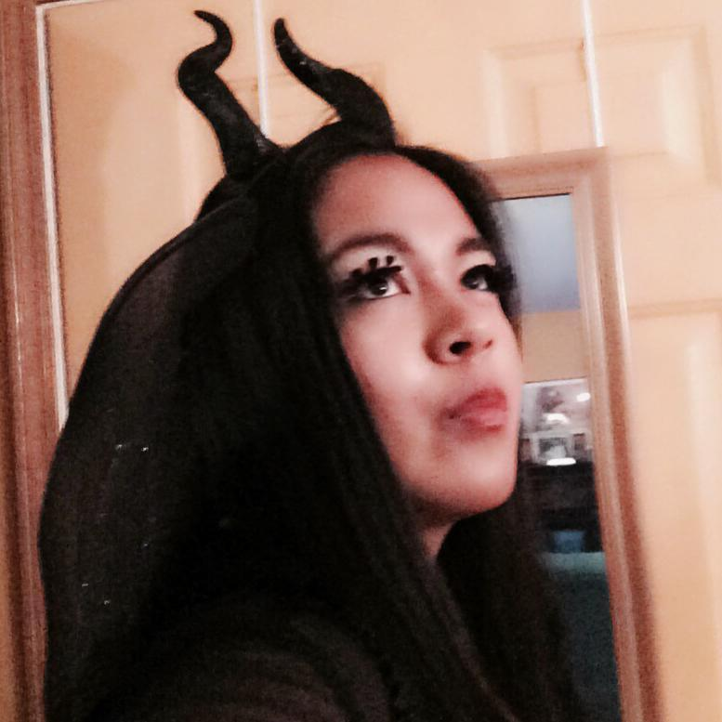

Figure 2 - Emily dressed as Maleficent to address bias in history

**Purpose: reconciliation begins with telling the story**

There can be various reasons for beginning a reconciliation project on Indian Wars. Starting the process, I began with the following purpose: *tell the story of the Yakama War*. Bestselling author, Scott Berkun, shares advice on starting a project:

Until you start working on something, you won’t truly start learning. The temptation is to have a grand sounding universal plan, don’t give in to it. That can come later…. There is always a way to start, just pick something small enough you can do yourself in an afternoon or with a friend and get to work (2016).

For this reason, I focused on the treaty and the first battle. After that, I focused on Yakama women and native language. It expanded since then and still reflects on the larger purpose that houses these themes.

**Community Involvement**

Researching the war, I became curious about the descendants of the Yakama War on the other side; *my historic enemies*. I asked many people if they knew anyone. They asked why I wanted to find them, which reinforces the need to identify the purpose.

This type of search needs community involvement. For that to occur, there is exposure which can surface vulnerability. There will be some waiting and possible rejection. It took almost a year to find a descendent of a soldier who fought against the Yakamas. I underestimated the magnitude of the search for finding such an individual. Some were skeptical and said that even if I did find one, they would not talk to me. I knew this would be a part of the story, but talking to someone about war especially when your ancestors fought against each other is somewhat awkward. Revealing the true cause of war from the Yakama view as violence against women is even more awkward. Email is a good way to correspond. However, when you have a historical connection, the conversation is easier than one may think.

**Meeting Descendants**

Months later I have been honored to meet numerous descendants. I will share a few of these times. In 2014, I visited Ft. Walla Walla Museum and asked if they might know any descendants. I left my number on a scrap of paper. I had little hope of meeting someone at this point. A couple of days later, I was taking my kids to class when I got the call from Steve Plucker. His great-grandfather was Private Charles Plucker, 9th U.S. Army Infantry, Fort Simcoe 1857-1859 (personal interview, December 3, 2014). He sent me some of his research that he later published about the War. Figure 3 shows us meeting in person. He attended my talk about the Yakama War at Fort Walla Walla Museum. Because he was the first descendent of a U.S. soldier I met, I describe it as finding a needle in the haystack.

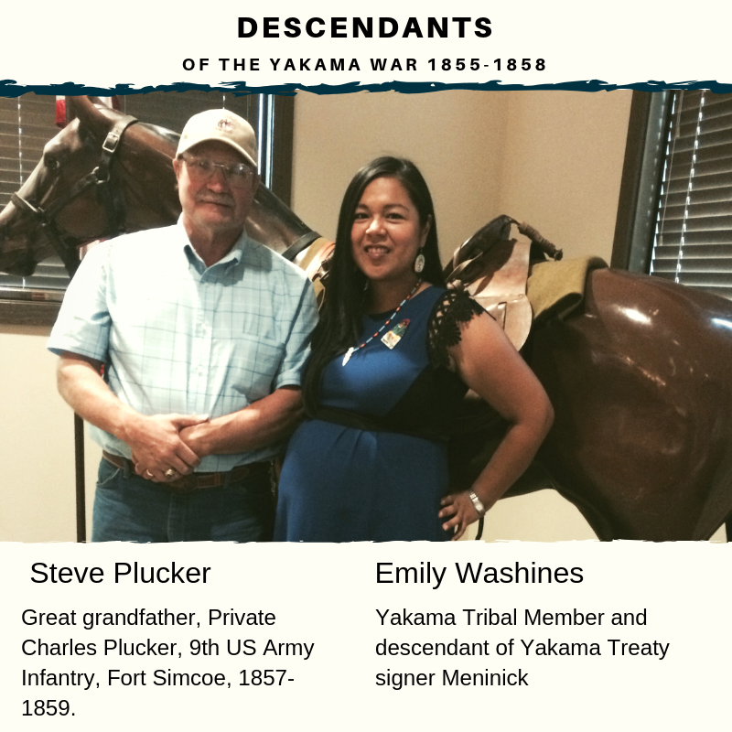

## Figure 3 - Steve Plucker and Emily Washines meet in person for the first time.

**U.S. Indian Agent Olney**

In 2014, I read an Indian War record. As I read through the names, I paused. It was my husband’s relative. Initially, I had not thought to include descendants of Indian Agents in my search. Now my search includes them. Jon Shellenberger, Yakama Nation Archeologist and descendent of Agent Olney talks about his relative.

He had children with two Yakama women and there are many from his lineage that are enrolled Yakamas. Nathan Olney began life in the Northwest as a businessman in the Dalles, Oregon. Because of his strong relationships with Native Americans, he was asked to serve as U.S. Indian Agent. At some point, Agent Olney was struck with an arrowhead during a battle with Natives. In 1866, after the wars were over, he was on the Yakama Reservation. He fell from his horse and the arrowhead finished the job. We work with a lot of arrowheads and advise others not to pick them up, because of the intent of the weapon. You don’t want to have a person carry that (personal interview, April 16, 2018).

This has made me mindful of the lineage connections in history. Agent Olney and the next descendent were at the same places at the same time. They likely met.

**Glen and Emily**

When I was interviewed by NW News Network, my search was shared on the radio across the Northwest (Banse, 2017). Glen contacted me about his relative Pvt. Supplina Hamilton's time in the 1st Oregon Mounted Volunteers in Company H from Linn County, OT commanded by Capt. Davis Layton. He was 23 in Oct of 1855 when the Governor's call for volunteers went out. One story he shared was when his relative received ten yards of red ribbon from Natives celebrating a newborn (personal interview, August 24, 2017). This surprised me, because this was right after the war and that Native family had lost their patriarch in the war. We were email pen pals for over a year when I asked if he would meet on camera for the first time. This was a part of the local spotlight for the PBS series *NATIVE AMERICA* (Germain, 2018). Glen and his family agreed. We talked about the opportunity for people to revisit this history through film.

Figure 4 is a photo of our families together. Figure 5 is when we finished filming and we asked each other: *What should we do next?*

|  |  |
| --- | --- |
| Figure 4 - Glen Hamilton’s & Emily Washines’ families. Photo by Lay Conn | Figure 5 - Emily Washines and Glen Hamilton. Photo by Lay Conn |

I have found that people listen more when you ask descendants of the military and militia to stand by your side as you share the Native American historical accounts of Indian Wars. I continue to reach out to descendants of the Yakama War because there are still post-war stories to tell.

**Native History & Language**

I narrated our history in *Ichiskiin* (Yakama language) for my short film, Yakama War: Ayat. I utilized information from *A Historical Account of the Yakama War*, by Alex Saluskin states:

Pa’iyatnanaya ayat ku ayatmiyanash ku iksiks púwani miyanásh Mushiilnan. They have killed the wife and his daughter and the baby in a board of Mushiil. Ku kúuk, Mushiil ku ná́pu x̱áyin pa’iyatnana kumanák Pashtenmaaman. And then Mushiil and two of his friends, they killed those White people [murderers] (as cited, Washines, 2017).

After Agent Bolan threatened the Yakamas with military retaliation, they killed him as an accomplice after the fact. The 1855 violence against Yakama females was followed by 1856 murders of Klickitat men, women, and children. The latter tragedy was written in two reports by two different government officials. One report went to Governor Stevens (Fields, 1856). The other report went to the U.S. House of Representatives and President Franklin Pierce (Sheridan, 1888). The 1856 report includes Spencer and Umtuch families (Miles, 2016, p. 160). The Yakama people have yet to get a response from any Washington Governor, President, and U.S. Congress about these reports.

When I decided to include the language, I realized that this would be following a pathway of those Yakamas before me, who told the accounts in hopes it would bring forward the history. I believe that including Native language in our telling of our history includes healing. Some publications will not accept any material written in *another language*. Yet, translation may sometimes change the meaning. When possible, the Native American language(s) should be included with historical accounts.

We need Natives to share their history and language. Equally, we need historians and news to reference the Native Americans as sources.

**Reconciling Media Coverage**

In elevating Native voices within Indian War history, it is necessary to assess media coverage. In 1855, after defending attacks on Yakama women and children, the newspaper *Olympia Pioneer and Democrat* said, "We trust they will be rubbed out - blotted from existence as a tribe - and that all confederates, aiders, and abettors will be summarily punished, by being forever quieted," (as cited, Cutler, 2016, p. 76). This is a statement of genocide towards Yakamas. An earlier example was given about California Governor Newsom addressing the genocide that took place in present-day California. Therefore, by reading this we are revisiting the history of violence towards tribes.

Can you think of schools, elected officials, or news that have addressed historical accounts of violence towards tribes?

Part of the process in revisiting is asking people where they get information about history with tribes. I was taught in a way that western society may never value the history Natives hold. That perhaps, it might be even safer to whisper these accounts only amongst tribal members. I understand there might be accessibility and trust issues with regards to acquiring historical accounts from tribes. Once this information is in hand, what role does each of us have?

From a representative sample spanning 1855 to January 8, 2019, there were limited local, regional, and national articles with Yakama quotes. “The Yakima Herald-Republic, which traces its roots to the late 19th century….is Washington State's seventh-largest daily newspaper,” (2019). Since 1889, this sample showed the Yakima-Herald Republic, quoted the Yakama historical account of the war five times. Those articles were all within five months. Those quotes appeared in the Yakima-Herald Republic on September 2018, October 2018, November 2018 (twice), and January 2019.

The *Yakima-Herald Republic* reporter Tammy Ayer began her September 2018 article with quotes from Alex Saluskin and connects it with missing and murdered women of past and present. This number of references from Natives keeps increasing in both local and regional articles. Reconciling media coverage about war includes increasing the inclusion of quotes from respective tribes.

On May 4, 2019, the *Yakima-Herald Republic* published a letter to the editor which called for a correction to a 1904 article they printed. Co-authored by Indian War Descendants, Glen Hamilton and I, we explain:

...For over 100 years, militia shared stories and were quoted. The origins of the conflict were so unknown to the white population at the turn of the last century that newspapers across the nation reprinted some over-the-top boasting as fact. This includes the Yakima-Herald. In 1902, three sons in the Crabtree family applied for war pensions. They claimed their father John Jay Crabtree, started the Yakama War because of a land dispute in the Yakima Valley. In 1904, this was printed as fact. However, according to the census records, the Crabtree family did not live in the Yakima Valley during the first tragic event that led to the start of the Yakama War (Washines and Hamilton, 2019).

**Targeting of Yakama Women Continues**

Native women were targeted after the allotment period. “Thomas Priestly, who was the federal Indian agent for the Yakama Agency in Washington State in the 1880s, noted the white men who married Indian women for such purposes were, “not of the better class,” (as cited, Deer 2015, p.66).

In 1910 several newspapers across the country printed an article entitled, “Dusky Maidens in Demand,” which details how much Yakama women are worth, to help men target them (Deer 2015, p. 66). “They just wanted to cash in on the land revenue & used the women to get it. A lot of the girls and women were sent to Oklahoma Indian School when they were young, our grandmother attended there. “She was 7 years old and it was 1916. She was sent along with her 2 sisters,” said Joycelyn Azure, sharing about her Yakama grandmothers (personal interview March 11, 2019). “Luckily she made it back here to Yakama Rez [reservation].”

“Many Europeans were alarmed by the powerful role played by Native women within their nations, and efforts were made to reduce the status of Native women through numerous means,” (Deer 2015, p. 20). Since time immemorial, Native women are the life-givers on this land now called the United State of America. The Yakama people are a matriarchal society. Native women need solutions that include our past and present.

**Art as Reconciliation: Promise to the elders**

For me, there is an artistic response that goes along with this reconciliation process. Figure 1 shows a beadwork depiction of a Yakama woman. Sometimes, I sew, bead, or write to process the heaviness of this topic. In October 1999, I was a teenager in Palm Springs, California during the National Congress of American Indians (NCAI). I was just crowned Miss NCAI and the elders and Yakama Nation Tribal Council made me promise to never forget the role of women in our tribe. This poem is entitled: They Sang a Warrior Song for Her:

This teenage girl stands with a new crown/Side-by-side her elders

Step on stage with hopes and dreams/Hundreds of tribes watch

They sang a warrior song for her/Her heart goes Boom! Boom!

Her breath slows/As she wonders what it means

When the elders sing you a warrior song/Questions ring through her head

They joke - we heard pageants are tough/Like battlefields of our people

She smiles and releases the question/They lean closer

There is another reason to be told/Never forget the role of women in this tribe

She braces herself for cooking lessons/For how to find a good ám

They say - Yakama women were in the wars/She blinks

They continue on/We want you to remember this message

She carries this with her crowns/How should she talk about war?

Is this why pageant girls say world peace?/Years have passed

These elders have too/Even though she has more to learn

She uses her voice/They sang a warrior song for her

And women who lack ancient acknowledgment

(Washines, 2017).

**Multi-generational Reconciliation from Past to Present--Our Women’s Lives Mean Something**

By embarking on this process there is a commitment to reconcile the history of Indian Wars. This multigenerational approach is one that honors our connected path. Together with our allies, we are who the Native ancestors prayed for to bring this history forward. May many that join on this journey of crossing historical boundaries. We each have our pathway in this. Research sessions will range from exciting to exhausting. The shame and silence in systems within the tribal, local, state and federal governments may further perpetuate lack of answers and justice. Maybe this will cause confusion, sadness, or anger.

When this point is reached, I share four words that were given to me when I considered pausing this work. In June 2018, I had just met Tara Gatewood (Isleta Pueblo), of Native American Calling, she hosting a powerful panel of Native women at the Women are Sacred Conference. During the Q&A, I had the opportunity to share my research with the Indian Wars. My voice shook because I feel accountable to the women. Yet, I was not sure if I could continue. The panel was supportive (Hughs, 2018). Afterward, Tara shook my hand and said: *I wish you strength*. I have reflected on those four words so many times. Now, I share this with you, so that you can carry these words of encouragement.

The War Cry here includes pain, strength, and action.

Will crossing historical boundaries in Indian Wars help Yakama Women? Revisiting our history is bringing resilience and truth-telling to my family, my tribe, and the community. Perhaps this method will be utilized by other people searching for answers about how to help address our history alongside the crisis of missing and murdered Native women. I still hear the war cry of the Yakama people rising to protect our women. This is a mission we are born into.

Ultimately, it is up to each of us to determine what is possible in post-war multi-generational reconciliations from the Indian Wars.

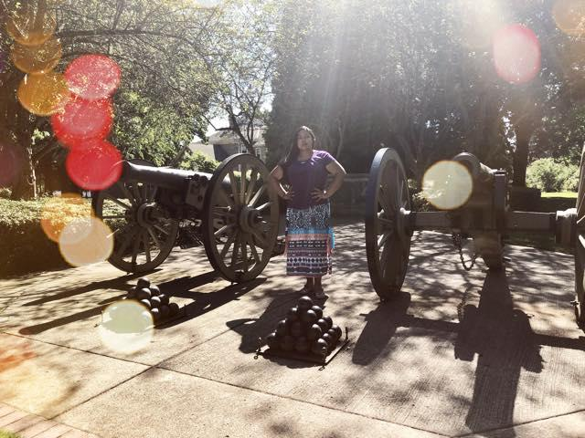

## Figure 6 - Replicas of howitzers used during the Yakama War. Photo by Emily Washines

**References**

Agtuca, J. (Ed.). (2020, February). Editor's Note. *Restoration of Native Sovereignty and Safety for Native Women*, *17*(1), 4–5. doi: <https://rm.niwrc.org/wp-content/uploads/2020/01/Restoration_V17.1.pdf>

Alexander, Monica (2019, June 1). *Washington State Patrol: Missing and Murdered Native American Women Report.* Volume 1*.* Washington State Patrol. Retrieved from: <http://www.wsp.wa.gov/wp-content/uploads/2019/06/WSP_2951-SHB-Report.pdf>

Ayer, T. (2019, May 5). *Hundreds Gather in Support Of Missing and Murdered Indigenous Women and Girls on the Yakama Reservation and Beyond*. Yakima Herald-Republic*.* Retrieved from: <https://www.yakimaherald.com/special_projects/vanished/hundreds-gather-in-support-of-missing-and-murdered-indigenous-women/article_b4b9a361-ae59-542c-b9e9-0568545f790a.html>

Ayer T. (2019, January 29). *“We all matter”; memorial service honors The Vanished.* Yakima Herald-Republic. Retrieved from: <https://www.yakimaherald.com/special_projects/vanished/missing/stories/we-all-matter-memorial-service-honors-the-vanished/article_8c3cd11c-2458-11e9-9378-2762af5da774.html>

Banse, T (2017, August 9). *Yakama War History Project Seeks Descendants Of U.S. Army Combatants.* NW News Network. Retrieved from: <https://www.nwnewsnetwork.org/post/yakama-war-history-project-seeks-descendants-us-army-combatants>

Berkun, S. (2016, May 11). *The Simple Plan for People that Want to Solve Big Problems. Excerpt from Ch. 12, The Myths of Innovation.* Retrieved from: <https://scottberkun.com/2016/the-simple-plan-for-people-that-want-to-solve-big-problems/>

Caudell, J (2019 May 25). *WIAA 1B 800 Meter title at the WIAA Track and Field State Finals.* Tribal Tribune Nespelem, WA. Retrieved from: <http://www.tribaltribune.com/>

Clarke, Chris (2016, September 26). *Untold History: The Survival of California Indians*. KCET Public Media Group of Southern California. Retrieved from <https://www.kcet.org/shows/tending-the-wild/untold-history-the-survival-of-californias-indians>

Cutler, D. L. (2016) *Hang Them All: George Wright and the Plateau Indian War*. Norman, OK: University of Oklahoma Press.

Deer, S. (2015). *The beginning and end of rape: Confronting sexual violence in Native America*. Minneapolis, MN: University of Minnesota Press.

Dietrich-Williams, A. (2011, June 29). *Results of FBI Analysis of Reservation Deaths Announced*. Federal Bureau of Investigation. Retrieved from <https://archives.fbi.gov/archives/seattle/press-releases/2009/se050609-1.htm>

Dobuzinskis, A. (2019, June 19). *California governor apologizes to Native Americans, cites 'genocide'*. Retrieved from https://www.reuters.com/article/us-california-native-americans/california-governor-apologizes-to-native-americans-cites-genocide-idUSKCN1TK03P

Hughes, A. (2018, June 27). *Live from the Women are Sacred Conference: VAWA five years later.* Native American Calling. Koahnic Broadcast Corporation. Albuquerque, NM. Retrieved from: <https://www.nativeamericacalling.com/?s=women+are+sacred+conference>

Jimenez, E. (2019, March 22). *‘No Family Deserves To Have To Go Through This’: Missing And Murdered On The Yakama Nation.* Northwest Public Broadcasting. Retrieved from https://www.nwpb.org/2019/03/22/no-family-deserves-to-have-to-go-through-this-missing-and-murdered-on-the-yakama-nation/

Field, H. (1856, May 12). *Letters from employees assigned to the Columbia River or southern district and Yakima Agency 1854-1861.* National Archives microfilm M5 Roll 17.

Frankl, V. E. (2006). *Man's search for meaning*. Boston, MA: Beacon Press.

Germain, J (2018 November 12). *NATIVE AMERICA: The Yakama War*. PBS and KCTS 9. Retrieved from: <https://kcts9.org/programs/native-america/yakama-war>

G. Hamilton (August 24, 2017). Personal interview.

J.Shellenberger ( April 16, 2018). Personal interview.

Landry, A. (2014, November 17). ‘All Indians Are Dead?’ At Least That’s What Most Schools Teach Children. *Indian Country Today*. Retrieved from https://indiancountrytoday.com/archive/all-indians-are-dead-at-least-that-s-what-most-schools-teach-children-6Hk8Ahnr0EG0dsV4MssWcg

Lucchesi, A., & Echo-Hawk, A. (2018, November 14). *Missing and Murdered Women and Girls: A snapshot of data from 71 urban cities in the United States.* Urban Indian Health Institute, a division of the Seattle Indian Health Board. Retrieved from https://www.uihi.org/wp-content/uploads/2018/11/Missing-and-Murdered-Indigenous-Women-and-Girls-Report.pdf

Map of Reservations and Ceded Land. (2009, April 1). Washington State Department of Ecology. Retrieved February 1, 2020, from <https://goia.wa.gov/sites/default/files/public/tribal-gov/Tribal_Cedres.pdf>

Martin, M. (2012, October, 8). Everything You Wanted To Know About 'Indians'. National Public Radio, Inc. Retrieved from: <https://www.npr.org/2012/10/08/162392326/everything-you-wanted-to-knowabout-indians>

Miles, J. (2017). Chasing “Thunder:” The Yakama Warrior Qualchan, 1855-1858. Journal of the West. Vol 56. No. 3 15-24

Miles, J. (2016). Kamiakin Country: Washington Territory in Turmoil 1855-1858. Caldwell, ID: Caxton Press

Moyer, B. (2001). *Doing democracy: The MAP model for organizing social movements*. Gabriola Island, B.C.: New Society Publishers.

R. Udell (March 11, 2020). Personal Interview.

S. Plucker (December 3, 2014). Personal Interview.

San Manuel Band of Mission Indians (2019). *History*. Highland, CA. Retrieved from: <https://www.sanmanuel-nsn.gov/Culture/History>

Sheridan, P.H. (1887) *Indian Fighting in the Fifties in Oregon and Washington Territories.*

Fairfield, WA: YE Galleon Press.

Sheridan, P. H. (1888). *Personal memoirs of P.H. Sheridan, General U.S. Army*. New York, NY: Jenkins & McCowan.

Washines, E. (2019, March, 15). *1909 Yakama Songs: Louis Mann as recorded by Edward S. Curtis*. Native Friends, Toppenish, WA. Retrieved from: <https://nativefriends.com/blogs/news/1909-yakama-songs-louis-mann-as-recorded-by-edward-s-curtis>

Washines, E., & Hamilton, G. (2019, May 4). *Time to correct the record on the Yakama War.* Yakima-Herald Republic. Retrieved from:<https://www.yakimaherald.com/opinion/saturday-soapbox-time-to-correct-the-record-on-yakama-war/article_10655901-9850-5b99-9c17-ae7422d7ae32.html>

Washines, E (2017, August 3) *They Sang a Warrior Song for Her*. Native Friends. Toppenish, WA Retrieved from: <https://nativefriends.com/blogs/news/they-sang-a-warrior-song-for-her>

Washines, E (2017, September 2). *Who Started the Yakama War.* Native Friends. Toppenish, WA. Retrieved from:

<https://nativefriends.com/blogs/news/who-started-the-yakama-war>

Yakama Nation Treaty of 1855 (n.d). *Yakama Nation*. Toppenish, WA. Retrieved from: <http://www.yakamanation-nsn.gov/treaty.php>

Yakima-Herald Republic (2019). *About Us.* Retrieved from: <https://www.yakimaherald.com/site/about.html>

**Table of Figures**

Figure 1 - Beadwork by Stella Washines, photo by Emily Washines………………………..p. 1

Figure 2 -Emily dressed as Maleficent to address bias in history……………………………..p. 7 Figure 3 - Steve Plucker and Emily Washines meet in person for the first time……………...p. 8

Figure 4 -Glen Hamilton’s & Emily Washines’ families. Photo by Lay Conn…………….....p. 9

Figure 5 - Emily Washines and Glen Hamilton. Photo by Lay Conn………………….….....p. 9

Figure 6 - Replicas of howitzers used during the Yakama War. Photo by Emily Washines…p. 12

1. Due to the nature of the content, there are emotional triggers regarding war and violence against Native women.
2. <https://www.k12.wa.us/student-success/resources-subject-area/time-immemorial-tribal-sovereignty-washington-state>

   Smith, B. L., Brown, S., & Costantino, M. (2011). Since Time Immemorial: Developing Tribal Sovereignty Curriculum for Washington’s Schools. Retrieved February 1, 2020, from <http://nativecases.evergreen.edu/collection/cases/since-time-immemorial>
3. Map for visual purposes only, as might be additional details from tribes. For example, the Yakama Nation Ceded lands have maps with different boundaries.