**Darkness to Dawn: Columbia River Native Tribes’ Science and Salmon Restoration Success [1]**

By

Brian Footen[2]

*Roll on Columbia*

Woody Guthrie

Recorded 1941

Published by Smithsonian Folkways

*Green Douglas firs where the waters cut through.  
Down her wild mountains and canyons she flew.  
Canadian Northwest to the ocean so blue…*

*Roll on, Columbia, roll On!*

*These mighty men labored by day and by night,  
Matching their strength 'gainst the river's wild flight,  
Through rapids and falls they won the hard fight,  
Roll on, Columbia, roll on.*

*Roll on Columbia Roll On.*

*Your Power is turning our Darkness to Dawn,*

*So Roll on Columbia, Roll On*

**Abstract:** *From the start of its 1243 mile journey in the Canadian Rockies all the way to the Pacific Ocean, the Columbia River drains the heart, soul and bounty of the Pacific Northwest. In this water is a history of a river and people that goes back 15,000 years. The bountiful water has supplied the world with food and energy. The development of the river for hydro-power and irrigation has played a critical role in modern history. This development, however, has come at great cost to the original inhabitants of the area and the primary resource that they thrived on: the salmon. The Nez Perce,* NiMiiPuu*, lived in the Columbia River basin for thousands of years. This existence was altered by the arrival of European settlers, and in 1855, the Nez Perce signed a treaty that defined an area over which they had jurisdiction and rights to the resources, including salmon, vital to their culture and survival. Since then salmon populations have declined. Dams and the resulting habitat degradation have had negative impacts on salmon survival. Some populations have been listed as endangered, and policies regarding how these fish are treated have complicated the recovery process. Recent efforts by the Nez Perce tribe, however, have shown that in spite of a mechanized river and political resistance, the river still has enough bounty to bring back a salmon run that was nearly extinct.*

**Introduction**

In the Woody Guthrie song “Roll on Columbia,” he describes the taming of a river and people, which creates a path to a brighter future. Nonetheless, the history of the Columbia River and its development has not led to a bright future for the original inhabitants. Salmon has been an important cultural resource for the Native people of the basin, but habitat degradation from the building of dams and irrigation has caused salmon populations to decline.

The Columbia has played a significant role in the development of the modern Western U.S. It has also played an important role in shaping the landscape of modern Europe by providing energy to help build weapons for World War II. This case provides background about the development of the Columbia River and the complexities encountered when trying to balance the protection and restoration of natural resources, in this case the salmon important to the Nez Perce Tribe, and the use of the river as a machine to build a modern society.

**The River without Salmon**

Floyd Dominy, 84, former commissioner of the Bureau of Reclamation during the explosion of dam building in the 1950s and 1960s, provided insight into Columbia River history and the plight of the salmon in a 1995 interview: “Now, I’m sure people can survive without salmon, but I don’t think they can survive without beans and potatoes and lettuce. . . .I think the dams were worth it. I think there’s substitutions for salmon. You can eat cake” (www.nwcouncil.org)

**The River**

The Columbia River begins at Rocky Mt. Lake in southeastern British Columbia. It is the fourth-largest river by volume in North America, with an annual average flow of 192 million acre-feet. Because of its proximity to the ocean and the elevation at which it originates, the river is one of the most unique in the world in terms of its combination of runoff volume, velocity, and diverse habitat. The river declines in elevation at about two feet per mile, running through rock walled canyons that confine its route. The combination of confined high flows and steep elevation drop make the river ideal for hydropower. Today there are 14 dams on the mainstem Columbia, and more than 450 dams throughout the basin. Dams on the Columbia and its major tributaries, primarily the Snake River, produce half of the electricity consumed in the Pacific Northwest.

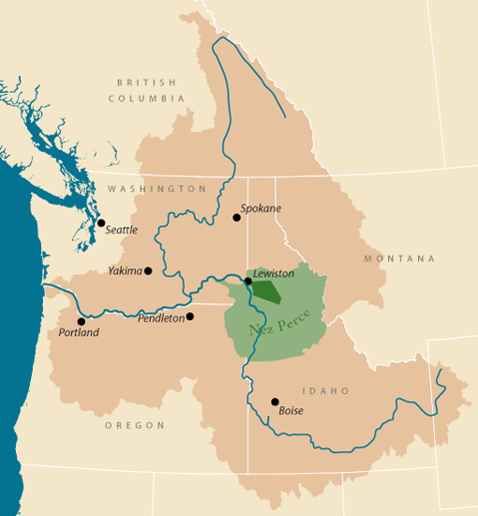

*Figure 1. Columbia River Basin and Nez Perce (Source: Columbia Inter-Tribal Fish Commission)*

Native oral stories of the region tell the tale of the Columbia’s creation. The Coyote created the Columbia. He wanted to bring salmon to the people. Coyote pushed beaver back through the mountains towards the ocean. The beaver’s tail created the Columbia River Gorge, opening a channel to the sea. This made salmon available to the people.

**The River, the Salmon**

The Columbia River Basin (Figure. 1) was once home to one of the largest salmon runs in the world, with an estimated annual return between 17 and 30 million fish returning every year. Overfishing, dams, and irrigation degraded habitat in the Snake and Columbia rivers, reducing the number of returning salmon to the basin to around 1.5 million fish. The majority of the fish returning are produced by hatcheries.

Starting in the 1860’s and lasting for over 80 years, canneries in the lower Columbia River accounted for most of the salmon decline, primarily Chinook salmon. By 1883, there were 39 canneries and 1,700 commercial fishing boats on the Columbia. Between 1889 and 1920, the average annual harvest of Chinook salmon from the lower Columbia River was 25 million pounds.

Other impacts were at work against the salmon. Water diversions for irrigation, and siltation and pollution of spawning streams caused by mining, grazing and timber harvest, rapidly degraded the quality of spring Chinook spawning habitat. Facing this decline, salmon harvest managers in Washington and Oregon promoted increased hatchery production, believing that hatchery production of fish would overcome declines caused by overfishing and habitat destruction (Smith, 1979).

**The River, the People**

Tribes Historic

Perhaps as long as 15,000 years ago, nomadic hunter gatherers dominated the Columbia River landscape. Based on salmon bones found in The Dalles, Oregon and at Marmes Rock Shelter, fishing began to be important as long as 10,000 years ago. Additional evidence suggests that preserving fish played an important role in the culture by about 3,000 years ago. The preservation process allowed for the storing of food supplies, reducing the time and energy required by the nomadic existence needed to find food. A more sedentary existence allowed for population growth and cultural development.

By the time the first Euro-American explorers arrived in the Columbia River Basin in the early 19th century, they encountered a complex community of Native Americans living in 32 distinct groups speaking over six different major languages (CRITFC, 2014).

Lewis and Clark

In 1804 Meriwether Lewis and William Clark were ordered by Thomas Jefferson to create a new path for commerce by setting out to find the headwaters of the Missouri and a route to the Pacific Ocean. On this two-year journey they would go beyond the Missouri headwaters to encounter the Columbia River at its confluence with the Snake River in the heart of Nez Perce territory. The explorers gathered new information about the West, its people, animals, geography, vegetation, rivers and lakes. The explorers described in detail the Missouri and Columbia Rivers, the people who lived along their shores, and, in the Columbia drainage, abundant salmon.

Upon descending the Columbia, the explorers noted the abundance of salmon, an organized fishery at Celilo Falls, where fish were caught in nets at the end of long poles. Clark noted that the Indians would dry the fish, pound it flat, and pack it into baskets that he estimated weighed 90 to 100 pounds apiece. In one of his journal entries shortly after arriving in the area, Lewis observed that the Columbia River valley was a fertile environment for development: “I have no doubt but that this tract of country if cultivated would produce in great abundance every article essentially necessary to the comfort and subsistence of civilized man”(University of Nebraska Press, 2005).

Treaties

By the 1840’s, westward expansion was a national policy goal. The Native people of the Columbia River Basin were simply in the way. As a result, conflicts with local tribes often led to violence. The United States government began to remove tribes from their homes and transfer them onto reservations that were created by treaties in the 1850’s. Historically what was Native land became non-Indian settlements. The configuration of Treaty Tribes in the Pacific Northwest today is the product of treaty-making with the United States in 1855.

These treaties contained common language that gave the Native people rights to fish, hunt, and gather in their usual and accustomed places (U and A’s) a promise as recorded in the Walla Walla Treaty Negations to be kept by the Americans for “as long as the sun shines, as long as the mountains stand, and as long as the rivers run.” 1 (Northwest Council, 2014)

These rights have been tested in court many times and have always prevailed. In 1974 the Federal courts granted tribes the right to manage their fisheries in their “usual and accustomed” fishing areas on and off reservation through US v Washington (commonly referred to as the Boldt decision after the judge presiding over the case). The State and treaty tribes were prescribed to work together to create and maintain harvest equity, conservation of the resource, and the production of knowledge for management.

**The River, the Machine**

Dams

The legacy of the Columbia River is primarily defined by the dams. Dams can provide flood control, hydropower, water for irrigation, and locks for navigation of boats and barges. Dams create more than half of the electricity consumed in Pacific Northwest, encompassing Idaho, Washington and Oregon. Most of the region’s hydropower is generated on the Columbia River and its tributaries. In addition, nearly 50% of the power for the greater Los Angeles area is supplied by the Columbia River.

In a 1926 report to Congress, the Secretary of War proposed a plan for building eight dams on the Columbia. The Army Corps of engineers expanded the plan to ten dams. All of these dams were to be built for the purpose of “improving the Columbia River and minor tributaries for the purposes of navigation and efficient development of water-power, the control of floods and the needs of irrigation” (US Congress, 1926).

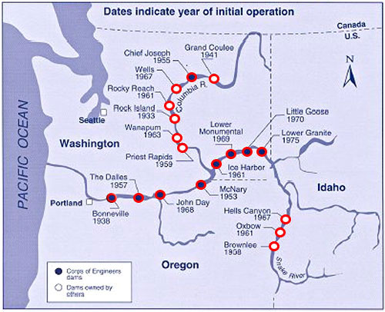

*Major Columbia River Dams (Source: nwhistorycourse.org)*

See Brown and Footen case: “Pacific Northwest Salmon Habitat: The Culvert Case and the Power of Treaties.”

Dams impact salmon and steelhead in a number of ways. Dams block adult fish and juvenile fish passage. Nearly 60% of the historic habitat available to salmon in the Columbia River basin is no longer accessible. Dam operations can inundate spawning areas or strand salmon nests and juveniles from dewatering rearing and spawning grounds. Slack or slow moving water created by water impoundments raise water temperatures to lethal levels for salmon in some cases.

World War II

The energy produced by the Columbia River played an important role in helping win WWII. Boeing, which was building warplanes in Seattle, was a primary customer for aluminum being produced by smelters using inexpensive energy from the Columbia rather than the more expensive fossil fuels. It is estimated that the energy from the Grand Coulee Dam helped create over 1/3 of the aluminum used for Allied planes during the war.

In addition to aluminum production, the Columbia River supplied power to the Hanford Nuclear Facility which was part of the Manhattan Project. The Manhattan Project was a research and development project that produced the first atomic bombs. The project was very expensive, requiring massive amounts of energy for generating nuclear material needed to make the bombs. The hydropower supplied by the Columbia River was integral. One of the two bombs dropped on Japan that ended World War II was built at Hanford.

Navigation

Every year, through a series of eight locks created by Columbia River dams, nearly 20 million tons of cargo navigate the 465 mile long waterway. To maintain channel depth necessary for navigation, water elevations are determined to meet the needs of electrical generation, flood control, and the release of water to help fish passage. Historically flood control and hydropower determined river levels. Most recently, impacts on salmon have resulted in the National Marine Fisheries Services prioritizing water use for recovery over all river uses except flood control.

Flood Control

In 1948, the importance of flood control became a priority after flooding in Vanport, Oregon displaced thousands of people. The Army Corps of Engineers responded by developing a multiple-use reservoir storage plan for the Columbia River Basin.

The Columbia River Treaty with Canada and the evolution of sophisticated planning and interagency cooperation have resulted in up to 39.7 million acre-feet of storage space being available for flood control. That is enough water to cover the Northwest four inches deep in water. For the Columbia River Basin, the need for reservoir space to help reduce the risk of flooding is most important during two seasons of the year: in winter, when there are rain-induced floods, and in the spring and early summer, when there are floods from snowmelt and rain. In 1996, record rains on snowmelt resulted in flooding, causing millions of dollars in property damage. The impacts of flooding were greatly reduced by the capacity of the reservoirs created by the dams to store the runoff. The Army Corps of Engineers estimated that flood control measures saved 3.2 billion dollars in potential damage.

Irrigation and Flood control have had impacts on the Nez Perce as well. The destruction of the historic fishing site at Celilo falls is one such example. In March of 1957, when the gates of The Dalles Dam closed, six hours later and eight miles upstream, an age-old Indian salmon fishery was under water.

Food

Irrigation of crops with water from the Columbia River, an economic activity that today consumes millions of acre-feet each year, began with the first permanent settlements along the river. One of the earliest, if not the first of these irrigation systems, was the one constructed in 1818 by Donald McKenzie of the North West Company at Fort Nez Perces, the trading post he built near the confluence of the Walla Walla (the name means “many waters” in the Nez Perce language) and Columbia rivers.

Irrigation is a big business. Today, about 8 million acres are irrigated with water from the Columbia River and its tributaries. Nearly all the potatoes, sugar beets, hops, fruit, vegetables and mint grown in the Columbia River Basin are irrigated, as are large crops of hay and grain.

Irrigation affects fish, particularly migratory fish like salmon and steelhead, not only by reducing stream flows: this can lead to increased water temperatures and the deterioration of shoreline habitat for fish.

**The Nez Perce**

The *Niimiipuu* or the Nez Perce are known as The People.

The Nez Perce tribe were nomadic, traveling with the seasons, buffalo hunting in the Great Plains and salmon fishing at Celilo Falls on the Columbia River. Today, the Nez Perce Indian Reservation consists of 750,000 acres. The Nez Perce are responsible for the management of the land and the surrounding natural resources. A fisheries department run by the tribe employs 50 full-time and part-time workers. Tribal members fish for salmon on the Reservation and surrounding rivers.

The Nez Perce treaty rights and subsequent court cases that upheld the treaty put the Tribe in a fisheries management position. In 1977, four Indian tribes with treaty fishing rights on the Columbia River formed the Portland-based Columbia River Inter-Tribal Fish Commission (CRITFC) to coordinate fish management policies and objectives. The participants are the Nez Perce Tribe, Confederated Tribes of the Umatilla Reservation, Confederated Tribes of the Warm Springs Reservation, and Confederated Tribes and Bands of the Yakama Indian Nation.

On behalf of the tribes, CRITFC works on restoring Columbia River Basin salmon runs. The agency conducts fisheries research, functions as a salmon advocacy group, conducts planning for salmon fisheries in the Native-only fishing zone of the Columbia between Bonneville and McNary dams, and conducts law enforcement on tribal fisheries.

**The River, the Science**

Salmon runs have been on the decline in the Columbia River so much so that many of the species in the Basin are listed under the Endangered Species Act. Hatcheries in the Columbia River Basin began production in the late 1800s to provide salmon for harvest and to supplement the fish production losses as a result of the loss of fish habitat and extreme harvest for canneries.

Early hatchery practices assumed all fish salmon species were equal, and eggs and fry were transported from one river system to another. This homogenization of the genetic diversity of the fish stocks had detrimental impacts on the ability of natural and hatchery fish to survive.

As early as the 1920s, scientists began to question the methods of hatchery production practices. By the middle of the 20th century, fishery scientists were beginning to apply production methods that were guided more by fish science. Transportation of genetic material was decreased and more scrutiny was applied to the methods by which the fish were raised and released.

Still hatcheries produced fish for harvest in an artificial environment which had no natural corollary. By the early 1980’s there was a growing consensus that salmon reared in a hatchery that came back to spawn with wild adults was decreasing the survival of the wild stock.

Although recent research has shown that fitness loss is not the same for all species, this belief in the negative impacts of hatchery and wild fish spawning together began to make its way into policy. A formal recommendation for hatchery reforms was developed in 2009 by the Hatchery Scientific Review Group (HSRG). This group of scientists, private councils and policy makers put together the following series of guidelines based on consultation with state and tribal hatchery managers to provide a foundation for future hatchery practices (HSRG, 2005).

**Principle 1:** Develop clear, specific, quantifiable harvest and conservation goals for natural and hatchery populations within an “all H” (hydropower, hatcheries, harvest, habitat) context

**Principle 2:** Design and operate hatchery programs in a scientifically defensible manner

**Principle 3:** Monitor, evaluate and adaptively manage hatchery programs

Many current hatchery programs have been operated in a manner that disrupts the natural selection for population characteristics that are tailored to local conditions in the natural environment. One of the most significant problems associated with hatcheries is the unknown genetic effects of interbreeding between hatchery and natural-origin fish, particularly in the natural environment. In fact, there is mounting evidence of the negative effects and reduced level of productivity that results from domesticated hatchery fish breeding with wild fish in the natural environment. Some negative effects include poor spawning success of adults and a lack of predator avoidance behavior in juveniles.

Harvest is a primary goal of most hatchery programs, but genetic management is becoming a priority even for harvest-dominated programs. The HSRG believes that there are two primary modes of hatchery operations that need to be employed to reduce the impacts of genetic exchange between hatchery and wild stocks: 1) Sufficiently isolate hatchery fish from wild fish, and 2) Assure that the hatchery fish are as similar to wild fish as possible. To this end, hatchery programs should be managed as either genetically integrated with, or segregated from, the natural populations they most directly affect, according to the HSRG. The intent in either case should be to not allow hatchery fish on the spawning grounds with wild fish, as the hatchery-origin fish pose a risk to wild fish.

The HSRG also recommended that hatchery fish from harvest programs and from most conservation programs should have an external mark, such as a clipped adipose fin, so that hatchery-origin and natural-origin fish can be effectively identified and managed to meet standards for composition and abundance of natural-spawning escapement and hatchery broodstock.

These guidelines, however, are not one size fits all and go against some programs that are being employed that actively place fish that return to the hatchery back onto the spawning grounds to spawn with wild fish. This is the very type of supplemental work the Nez Perce were conducting. The work is done to insure the genetic similarity between the stocks in the hope that the additional production on the spawning grounds will give the fish naturally spawning population a boost. These programs are controversial and have been challenged by the National Marine Fisheries Serivice (NMFS) under the Endangered Species Act. However in the face of these challenges, some tribes including the Nez Perce have proven the method successful.

In 1999, the CRITFC began work with the University of Idaho to develop a collaborative research program to study the genetics of salmon in relation to potential supplementation projects. The partnership resulted in the Hagerman Fish Culture Experiment Station, which was built to explore fish genetics and pathology. The Hagerman laboratory has been instrumental in helping the CRITFC develop recovery programs based on a better understanding of conservation and population biology, and genetics. The Hagerman genetics program includes three primary focus areas of research to support the type of supplementation program the Nez Perce were conducting:

1. **Genetic tagging and monitoring of fisheries**As adult salmon and steelhead migrate through the Columbia River, there is a need to understand stock specific abundance and run-timing to assist fisheries management. Through genetic tagging methods known as parentage-based tagging (PBT) and genetic stock identification (GSI), CRITFC has ongoing programs to estimate which stocks are present in the river and those that are harvested by commercial, sport, and tribal fisheries.
2. **Genetic effects of hatchery practices**Hatcheries are expected to be used as a recovery and supplementation tool for salmon and steelhead as long as dams and other habitat limitations remain in the Columbia River Basin. Our goal is to better understand how hatchery reform can be implemented to reduce genetic impacts on wild populations.
3. **Genetic adaptation to local environments**Salmon and steelhead have the ability to adapt to local environments, and understanding the genetic basis for these adaptations is expected to be useful for reintroduction programs, recovery of stocks, and response to climate change. Studies are underway to investigate the genetic basis for a variety of traits, including thermal adaptation, migratory run-timing, smoltification, disease resistance, and age-at-maturity.

In addition to these general areas of research, specific projects are underway to assist with tribal needs such as evaluating genetic diversity of lamprey and sturgeon in the Columbia River Basin.

The Nez Perce have been employing the knowledge gained from research done at the Hagerman Lab to create one of the most successful fish restoration programs in the Columbia River to date by using hatchery fish to supplement wild stocks on the spawning grounds. Supplementing wild spawning fish with hatchery fish on the spawning grounds is in direct violation of HSRG recommendation, but last year a record 56,000 Snake River fall Chinook passed Lower Granite Dam. 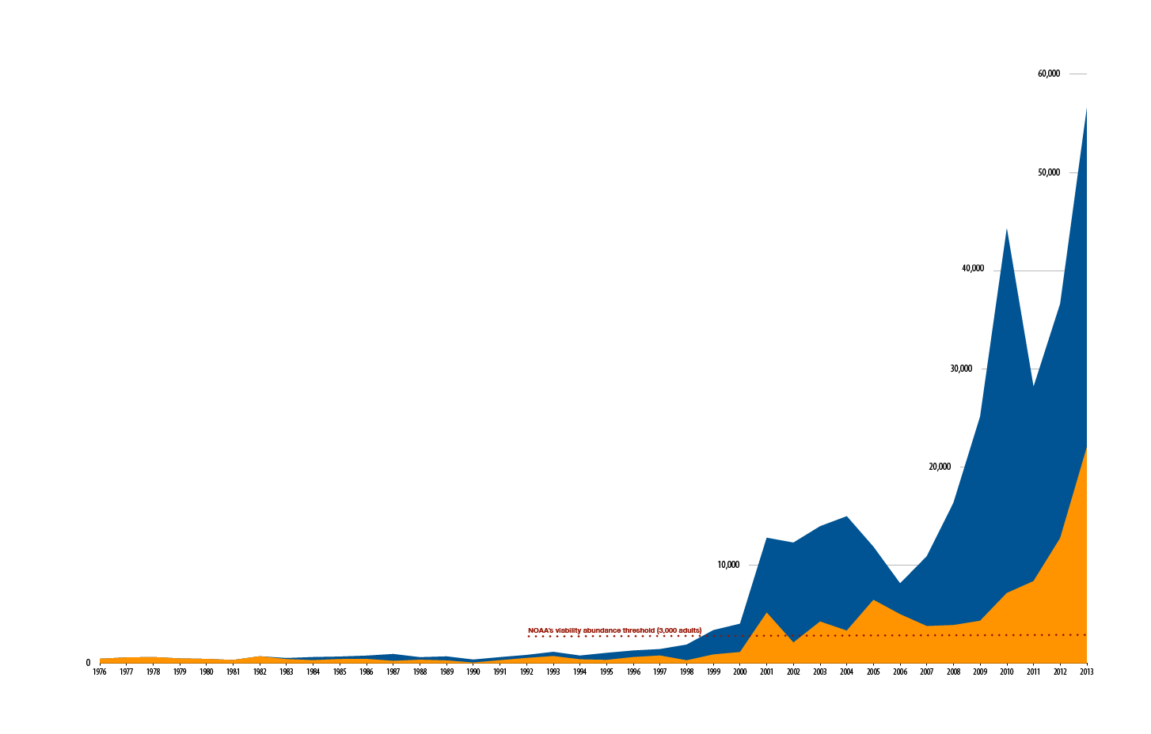

*Figure 2. Chinook Recovery from Nez Perce Supplementation Program (Source: nptf.org)*

Total hatchery (shown in blue) and wild (shown in orange) Snake River fall Chinook salmon counts at Lower Granite Dam. The Snake River Fall Chinook Recovery Program began in 1996.

In 1995, the Nez Perce set out to recover Chinook using their hatchery facility. They had some success but they knew they needed a better facility to succeed. It took until 2005 to get approval from NMFS to build a cutting-edge hatchery to supplement natural Chinook populations with hatchery-reared fish of the same stock.

After the Nez Perce supplementation program began with the new hatchery, the success of the program began to be apparent. As is the goal of the supplementation program, both hatchery and wild stocks are increasing in numbers. Most of the fish taken from the hatchery and released on the spawning grounds spawn naturally, producing wild offspring. An estimated 21,000 (38%) of last year’s run were wild fish, setting a new record since the construction of Lower Granite Dam in 1975. Fishing has returned to the river as a result of the high returns. Getting approval to implement the program was difficult because of the ubiquitous application of the HSRG recommendations with regard to mixing hatchery and wild fish. Washington Department of Fish and Wildlife, Idaho Fish and Game, U.S. Fish and Wildlife Service, NOAA Fisheries, and Oregon Fish and Wildlife all strongly opposed and fought the implementation of the Nez Perce recovery program. Today in the face of positive results management and regulatory agencies are cooperating with tribal restoration efforts.

**The River with Salmon**

In 1995, Dan Beard, Commissioner of the Bureau of Reclamation, was quoted in the *Oregonian* newspaper as saying that the problem of dams and salmon in the Columbia River, and the difficulty of rebuilding salmon runs there, was “the most complex natural resources problem in America today. Nothing else approaches it” (www.nwcouncil.org).

The restoration of salmon runs in the Columbia can succeed, but it will take acceptance of new ideas, breaking through barriers. One option might be a powwow where everyone gets together to celebrate all salmon. Breaking through these barriers is fully imagined by Sherman Alexie, as he describes in his poem that which is critical for the restoration of Nez Perce culture:

*The PowWow at the End of the World*

Sherman Alexie

*I am told by many of you that I must forgive and so I shall*

*after an Indian woman puts her shoulder to the Grand Coulee Dam*

*and topples it.*

*I am told by many of you that I must forgive*

*and so I shall after the floodwaters burst each successive dam*

*downriver from the Grand Coulee.*

*I am told by many of you*

*that I must forgive and so I shall after the floodwaters find*

*their way to the mouth of the Columbia River as it enters the Pacific*

*and causes all of it to rise.*

*I am told by many of you that I must forgive*

*and so I shall after the first drop of floodwater is swallowed by that salmon*

*waiting in the Pacific.*

*I am told by many of you that I must forgive and so I shall*

*after that salmon swims upstream, through the mouth of the Columbia*

*and then past the flooded cities, broken dams and abandoned reactors*

*of Hanford.*

*I am told by many of you that I must forgive and so I shall*

*after that salmon swims through the mouth of the Spokane River*

*as it meets the Columbia, then upstream, until it arrives*

*in the shallows of a secret bay on the reservation where I wait alone.*

*I am told by many of you that I must forgive and so I shall after*

*that salmon leaps into the night air above the water, throws*

*a lightning bolt at the brush near my feet, and starts the fire*

*which will lead all of the lost Indians home.*

*I am told  by many of you that I must forgive and so I shall*

*after we Indians have gathered around the fire with that salmon*

*who has three stories it must tell before sunrise: one story will teach us*

*how to pray; another story will make us laugh for hours;*

*the third story will give us reason to dance.*

*I am told by many  of you that I must forgive and so I shall when I am dancing*

*with my tribe during the powwow at the end of the world.*

References

Columbia River Inter-Tribal Fish Commission, 2014. <http://www.critfc.org/>

Hatchery Scientific Review Group (HSRG) – Lars Mobrand (chair), John Barr, H. Lee Blankenship, Donald Campton, Trevor Evelyn, Tom Flagg, Conrad Mahnken, Paul Seidel, Lisa Seeb and Bill Smoker. April 2005.

Nortwest Power and Conservation Council, 2008. https://www.nwcouncil.org/

Smith, Courtland L. 1979. *Salmon fishers of the Columbia*. Oregon State University Press, Corvallis, Oregon. 117 pp.

University of Nebraska Press / University of Nebraska-Lincoln Libraries-Electronic Text Center. (2005, March). *The Journals of the Lewis and Clark Expedition*. Retrieved October 5, 2005, from <http://lewisandclarkjournals.unl.edu/>

US Congressional Report, 1926. Committee of the Columbia River, Report #308. United States Congress.

1. The writing of this case was supported by a generous grant from the Nisqually Tribe. All opinions expressed in the case are solely the responsibility of the author. Teaching notes for this case and other cases can be found at [www.nativecases.evergreen.edu](http://www.nativecases.evergreen.edu). Copyright held by The Evergreen State College 2014
2. Brian Footen has worked with tribal, federal and state fishery departments in Washington State for more than 15 years.