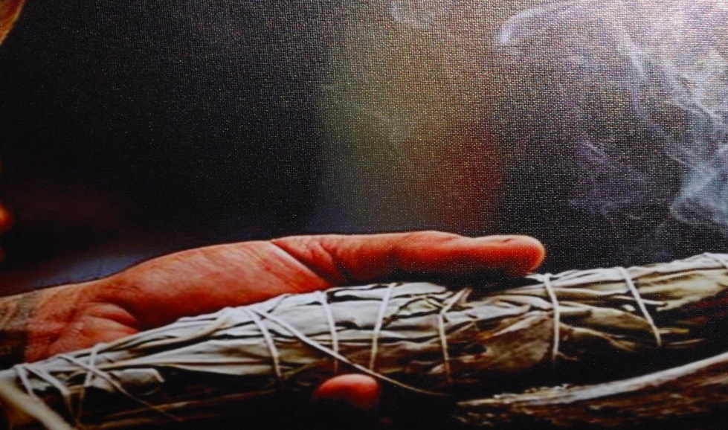

**Does smudging belong in the workplace?**

By Toby Sawyer[1]

Recently, a highly confrontational event had taken place at work. A Native American client stormed into an urban tribal office that meets the needs of tribal clients and their families and threatened harm to his ex-wife, who was onsite attending a day long client orientation meeting. He also threatened harm to staff and other clients. He was arrested and booked into jail. After his departure, the ex-wife and a few other clients and staff engaged in emotionally heated discussions surrounding the event.

The next morning, an employee and member of a Northwest tribe, used a smudging ritual to purify and cleanse the office of the recent event and the residual negativity left behind[2]. Another employee immediately complained that the smoke from the smudge aggravated her allergies and interfered with her ability to take care of the clients assigned to her. Two clients protested to management that the smoke smelled like marijuana (which is illegal) and hampered their ability to remain clean and sober.

Altogether, this office has nine employees. Three employees felt very strongly that traditional Native rituals help maintain Native identity, values, and culture, and they favored the use of smudging in this situation. Three of the employees are against using smudge in the workplace because of adverse physiological responses or value judgments as to how it should be done. Three others choose to remain silent on the issues for fear of losing their job and/or loyalty issues. The supervisor holds steadfast to her own traditional ways and Native culture while also maintaining that her highest priority is the clients the agency is mandated to serve. Ninety percent of the staff are enrolled American Indian although they come from diverse cultural backgrounds and rituals.

The supervisor, Anna, was very sensitive about injecting her own beliefs into this dispute, and tried to carefully evaluate the various strong, persuasive, and competing interpretations of this situation. The objection to the smoke itself was thus: the physiological effects from particulate matter, like smudge or cigarettes, have been scientifically linked to upper respiratory conditions (asthma), heart attacks, and strokes (Collins, C. 2010). Most affected are the elderly, infants and children. Infants, in particular, are more impacted because their lungs are still developing, and they are breathing at faster rates and taking in more air contaminants (Collins, C. Ch. 2, 2010). Anna was aware that more than a few clients and their children had chronic breathing issues, allergies, and compromised immune systems that could be impacted by the particulate matter of smoke from smudging. On the other hand, there are indigenous healers worldwide that use and advocate the burning and inhalation of smoke from specific plants (ie; mullein and yerba santa) to heal upper respiratory conditions (Renee, 2010). Western science does not currently acknowledge this form of healing as valid or beneficial.

Anna thought he objections from some clients, who inferred that marijuana, not smudge, was being used in the office, could potentially be resolved through education about the legal and cultural issues that differentiate smudge from marijuana. She was also aware of staff conversations indicating that competing belief systems around smudging were part of this dispute. Some staff were asking questions such as: does the employee have the right to perform such ritual?, who taught them?, did they receive permission from their tribe?, have they done it the “right way”?, if the office is not on tribal land, is it ethical to use ritual?, and if a non-Native was performing the smudging, how different would the objections be?

Anna could only surmise that the three individuals who remained silent in the debate were unsure of their ‘place’ within the office organizational structure. Two of the employees had been recently hired and still remained on probation, which meant that job termination could be applied more liberally. The remaining silent employee was a relative and fellow tribal member of the one performing the smudging. Anna assumed that loyalty to family and tribe was the overwhelming motivation for his non-participation on the discussion of smudging.

Anna observed that both employees and clients were clear that the agency existed to assist needy families of tribal affiliation. Differences of opinion surrounded the variety of valid traditional spiritual practices such as Smokehouse, Sundance, Native American Church, and Seven Drums ceremonies, and how the smudging ritual may be similar or different within each of these spiritual practices (McGaa, 1990).

Most felt that smudging could be done at work, but felt it was far better for someone to practice their cultural rituals in their non-work environment, at home, or on their tribal lands. A few noted that prayer was still observed regularly before every meal served to clients on site and contended that, because smudging and prayer are synonymous, it should be allowed.

One employee, the person who performed the smudging, argued that cultural identity is the tie that binds employee and client, and it is everyone’s right to benefit from any and all rituals that encourage cultural connection. Urban Natives, she pointed out, may have the greatest need for cultural identity and healing.

Anna also thought about the larger context. The agency that oversees operations of this urban Indian office provides temporary assistance to needy families through a federal/tribal partnership grant. Services are focused on strengthening families through promoting work as a path to independence. The federal program strives to move families to self-sufficiency while encouraging and supporting flexibility, innovation, and creativity in local tribal programs. Another complementary program, also under the umbrella of this agency, frequently sponsors events combining education, spiritual, and cultural activities that are traditional and non-traditional to encourage individuals’ view of self and what it means to be healthy (O’Brien, Chp.7, 2008). At these events, the smudging ritual was incorporated into some event itineraries.

In 1978, President Jimmy Carter, noting how Native traditional religions and practices are the fabric of Native American cultures, signed the American Religious Freedom Act (Bubar, 2006). This Act created hope among Native people since the right to worship as one pleases is a critical component of social unity (Bubar, 2006). Washington State Initiative 901, passed in 2006, banned smoking in all public places but did not prohibit or restrict the use of incense, smudge sticks, smudge bowls, ceremonial pipes, or similar equipment used as part of a bona fide religious ceremony in a place which otherwise meets the definition of public place (Initiative Measure 901, 2006). The city where the building is located is not on tribal lands and prohibits smoking in or near the building.

The supervisor see herself as an objective fair individual who understands that any decision she makes will have potential consequences. She thinks she is going to have to create a process that will allow all parties to share their opinions. But she also recognizes that her personal opinion, albeit valid, must be set aside to facilitate the process and bring about an equitable solution with integrity.

**References**

Bubar, R. W. & Vernon, I. S. (2006). *Contemporary Native issues: Social life and issues.*

Chelsea House.

Collins, C. (2010). *Toxic Loopholes: Failures and future prospects for environmental law*. New

York, Cambridge University Press.

O’Brien, C. (2008). *Religion and Healing in Native America: Pathways for renewal.*

Westport, Connecticut: Praeger.

McGaa, E. (1990). *Mother Earth Spirituality: Native American paths to healing ourselves and orld.* San Francisco, Harper-Collins publishing*.*

McKenna, R. (2006*). Interpretation and Implementation:* Initiative Measure 901. Retrieved from: www.indiancountrytodaymedianetwork.com wa.org/sites/default/files/attachments/AG%20opinion%206%208%2006.pdf

Renee, J. (2010). Sacred Smoke: Smudging (An ancient art for modern times). Retrieved from:

[http://www.lumhttp://www.luminearth.com/2010/02/15/sacred-smoke-smudging-an-](http://www.lumhttp:/www.luminearth.com/2010/02/15/sacred-smoke-smudging-an-) ancient-art-for-modern-times/inearth.com/2010/02/15/sacred-smoke-smudging-an-ancient-art-for-modern-times/

Warry, W. (1998). *Unfinished Dreams: Community healing and the reality of aboriginal self-*

*government*. Toronto, Canada: University of Toronto Press.

**Discussion Questions**

1. Is it appropriate for an employee of an urban tribal office to perform a traditional smudging ritual and impose her spiritual and cultural beliefs on others? Why or why not?
2. Could cultural revitalization of an urban Indian population be cultivated and maintained by incorporating smudging and other Native rituals and values in the workplace?
3. Do urban Indians have a right to be Indian? What does this mean?
4. Does the supervisor have the authority to tell this employee what personal traditions they can or cannot do in this environment?
5. How are conflicts like this best resolved?
6. What could be the possible ramifications for her decision in this situation, one way or another?
7. What do you think Anna should do and why?
8. Role Play: Anna has called a meeting with all the staff to discuss this issue. Assign members of the class to play each role.

1. Toby Sawyer is a student in The Evergreen State College MPA program.
2. Smudging, a long standing American Indian ritual of purification and cleansing, is an important practice of cultural identification within many tribes. Smudge materials may be different for each tribe; barks, fungus, grass, plant, or needles. Smudging is currently a common daily ritual in many Native schools and health and wellness facilities but there is concern that rituals practiced without proper expertise or traditional knowledge compromise the very tradition they are emulating (Warry, 2007).