Making the High School Diploma Mean Something

Adapted by Barbara Leigh Smith from a MPA Tribal Administration capstone project by
Sean Dence & Terry Thacker, The Evergreen State College

Abstract: In 1997 Washington, like many states across the nation, established a new framework for assessing student performance in K-12 education believing this was key to making the high school diploma mean something. The new standards, implemented through the WASL (the Washington Assessment of Student Learning), were gradually phased in but will eventually become graduation requirements. While student performance has improved, students of color continue to have lower achievement scores than other students. This case looks at a reservation community struggling with the question of how to improve student performance on the WASL and the various factors that might explain poor performance.

When Joan took the tribal position of Indian Education director she knew that Washington state’s evolving assessment program would be something she needed to learn about. She’d heard that the WASL (Washington Assessment of Student Learning) was part of a landmark education reform in 1997 inspired by Governor Booth Gardner. Political leaders said it was designed to catapult the educational system toward “world class standards.”

Currently all fourth, seventh and tenth grade students take the WASL test in science, writing, reading, and mathematics. After a long phase-in period starting in 1997, the WASL test would soon become a high school graduation requirement. Since it was tied to graduation, it was called a “high stakes” test. Deadlines for both state and federal education reforms were fast approaching.

The Federal government was also moving towards testing and higher standards. It passed the No Child Left Behind Act which set rigorous standards for schools in terms of student performance. Requiring more teachers to have “appropriate” educational backgrounds in the subjects they taught was also part of No Child Left Behind. This, too, was difficult in Indian country where it wasn’t always easy to find highly qualified teachers. There was special concern also because many Tribes were attempting to revive Native languages and the elders were usually the only speakers who could lead these efforts but they weren’t credentialed educators.

Some tribal members initially believed that the WASL only applied to Native students attending public schools and living off the reservations, but it turned out that this line of thinking was inaccurate. Children in tribal schools also had to take the WASL as part of an agreement the schools and tribes made to get funding under the Johnson O’Malley Act. The tribe needed the Johnson O’Malley funding which had become an important part of the budget. Johnson-O’Malley funds were established to meet the special educational needs of Indian children.

Now, there was more and more talk about needing to do something so no “Indian child was left behind.” The high school drop out rate for Native Americans was twice that of other students, and the pressure was on. The tribal council was increasingly anxious about student performance and asked Joan to develop a plan to prepare students to pass the WASL, but they also wanted her to work on making the curriculum culturally relevant. They said the high school diploma should mean something in terms of the tribe’s long-term sustainability.

“Somehow, I need to better understand the overall situation before developing and presenting my plan to the tribal council and the school district leaders,” Joan thought. She started by doing some research and talking with education directors at other tribes to find out what they’re doing.

Student Performance on the WASL
Joan quickly learned that the WASL test was controversial both on and off the rez. Some tribes seemed to be further ahead than others. In some school districts, parent groups had protested against it, claiming that it promoted unreasonable expectations for students. There was also concern about the impact of the WASL on minority students. One concerned parent filed a lawsuit against the state of Washington because he believed public schools fail to adequately prepare minority and poor students to take the test. “My child is behind being African American, he is further behind, undereducated, as compared to a suburban wealthy community," he said in a recent article discussing the controversies surrounding the WASL.
Student pass rates and the so-called ‘achievement gap” between groups on the WASL had improved since testing began in 1997 as indicated in recent data from the Office of the Superintendent o Public Instruction, but there were still disparities between schools districts and between different ethnic groups (OSPI, 2006). Mathematics remained a big problem.

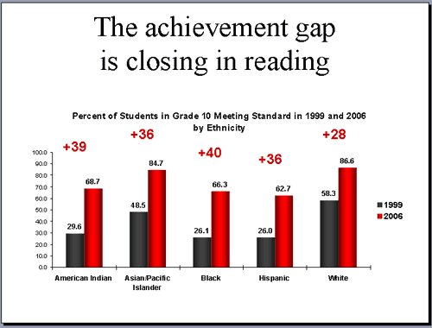

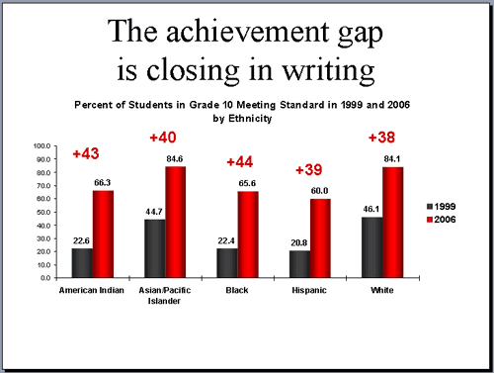

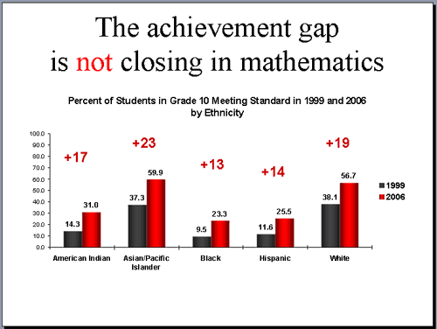

When she looked at the profile of the state and individual schools on the OSPI website, Joan saw many differences between schools near reservations and surburban schools in terms of WASL scores and the students and teachers (see Appendix 1). So what really made a difference in pass rates on the WASL and what could the tribe do about the number of certified teachers or the number of students from low-income families? Should she suggest ways the tribe could respond to these issues or should she just focus on the WASL?

Why aren’t Native American Children passing the WASL ?

There were lots of opinions about why pass rates varied. When she talked with community members, Joan quickly learned that many concerned parents and educators believed that Native children and other students of color do poorly on the WASL because it is written in a way that is culturally biased. “The WASL, as well as other standardized tests have always had a cultural bias,” one of the teachers said “ And, not only a ‘cultural bias’ but an ‘elitist’ bias as well,” he elaborated. “Students from more affluent school districts have different access to equipment, experiences, field trips, etc. So, of course, those students would do better.”

Joan knew that many scholars argued that Western education is culturally biased and that it is designed to benefit white students who are born into a system set up to meet their needs. In an essay she read in college by Robert Westley, he argued that

“the pervasiveness of white supremacist structures…inhabit our literature and the canons of literary interpretation; they inhabit our speech; they inhabit popular culture, from films and television, to music, dance, and fashion, they determine classroom curricula throughout the educational system; they influence the friends we make, the restaurants we choose to eat in, the places we shop; they establish national priorities and the means employed to resolve social problems; often, they define what it means to be a problem. (Winbush pg. 116).

Another scholar she read in school,Linda Tuhiwal Smith, said that Westernization can make indigenous people in society feel inferior:

The nexus between cultural ways of knowing, scientific discoveries, economic impulses and imperial power enabled the West to make ideological claims to having a superior civilization. The ‘idea’ of the West became a reality when it was re-presented back to indigenous nations through colonialism. By the nineteenth century colonialism not only meant the imposition of Western authority over indigenous lands, indigenous modes of production and indigenous law and government, but the imposition of Western authority over all aspects of indigenous knowledges, languages and cultures (Smith, 1999, pg. 64).

And in a recent publication even the Office of the Superintendent of Public Instruction (OSPI), which was a state agency, acknowledged that schooling is often culturally biased:

White middle-class school teachers may be oblivious of the degree to which some of the routines and rules reflect their own culture and assumes that the culture of schools is more universal than it is. Unwittingly, teachers may perpetuate the difficulties experienced by minority and poor students as they expect children to behave according to norms of the majority culture without making these norms explicit. Teachers generally expect students to change to fit into the molds of the school rather than adapt the school structures to the children (Delpit, 1995; Greenfield, Raeff, & Quiroz in Williams, 1996; Lipman, 1998; Howard, 1999). Students who do not conform have been described as deficit, disadvantaged, culturally deprived, and at-risk of failure (OSPI, 2002. Pg. 23).

On the other hand, a recent study by graduate students from The Evergreen State College found that a majority of the men and women in the field of education, and the men and women they interviewed in the state legislature, did not believe that the WASL was culturally biased. “This is probably the most unbiased test, but it is tough, and it does require good teaching and motivation to do well,” one of the teachers stated. “The WASL …was developed by a wide variety of people from a variety of occupations and ethnic backgrounds,” she explains. When another was asked if he thought the WASL test was culturally biased, he said “Nonsense! “The 3 ‘R’s are not cultural, but literate.”

But as Joan observed, American Indian children were not the only children with poor WASL test results. The WASL had a gap between the white students and the students of color taking the test, as well as a gap between the poor and the economically privileged students.

In a commentary in the “Pacific Northwest Inlander” Donald C. Orlich, a professor at Washington State University, said that “discussions about high-stakes tests must address the issue of student poverty. He argued that policy makers who have legalized high-stakes testing need to ask about the “the impact of student poverty and ethnicity on test scores as a mechanism for sorting and classifying children’ ”

He went on to say that
High-stakes test scores are very highly correlated with family income. School leaders and politicians in Washington state are touting WASL scores as if they were precise educational measures of student learning and overall achievement: The scores are not…. Poverty and ethnicity appear to be inextricably related. One example tells it all. The WASL test score pass rates of one of Washington state's highest-family-income school districts, Mercer Island, were compared with all children from low-income homes in the state. Extraordinary achievement differences of 40 percent to 60 percent favored Mercer Island children at every grade level and for every subject tested …http://www.inlander.com/commentary/300985148093014.php).
He concluded his commentary by stating:

…high-stakes tests, the WASL in particular, have created a new American dilemma. The poor, disfranchised, minority and disabled children have fallen into education's "achievement gap." Poverty is a powerful force in creating educational deficits. But you will not find advocates of the WASL discussing that social issue, including the Partnership for Learning, the Business Roundtable, the Superintendent of Public Instruction or our the state legislators. One simply has to ask, "Why the silence?" The social consequence of labeling a generation of adolescents as being flat-out failures from one questionable test needs serious psychological, psychiatric and legal evaluation” (http://www.inlander.com/commentary/300985148093014.php).
At a recent conference Terry Bergeson, the Superintendent of Public Instruction, presented information about the relationship between income and the WASL which seemed to support what Orlich was saying, but the Superintendent wasn’t budging on her demands that all students succeed on the WASL. Intergenerational poverty was a real problem in many Indian communities. It wasn’t just the individual’s fate but a spiraling downward over generations.
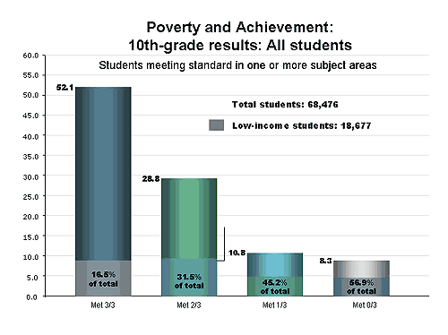
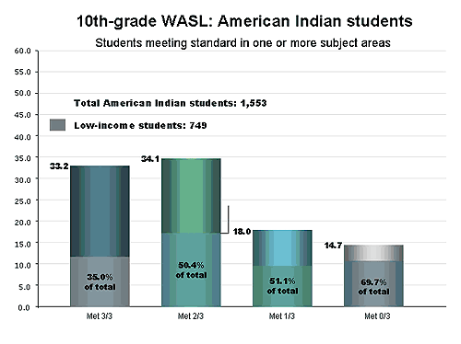
Raising the Stakes
The way the WASL is being implemented was another point of contention. Because it is tied to graduation requirements, unlike tests in some other states, the WASL is considered to be a “high-stakes” test. Opponents of the WASL also argue that an all inclusive “one size fits all” test is not an appropriate measure of how much a student has learned.
“I like the accountability for students and staff,” one of the teachers said, “but I don’t like the ‘one size fits all’ approach.”
“There are many better, more spread-out ways to assess achievement,” a high school teacher argued. “I think” he elaborates, “the entirety of a student’s achievement should be taken into consideration: portfolios, projects, community service, all sorts of school achievements. Daily work in a classroom is a much better gauge of achievement than one test. And when taken in May of a school year…we are forgetting the last two months of the school year!”
Even state representatives critiqued this aspect of the WASL. “I have never believed that one test should be used to judge a student’s academic achievement,” she stated. “I also believe that the WASL should be multi-cultural, and that we must find alternate methods for testing some of these students. I fear that the WASL as given now will set Native American children back in learning, military children moving into the state in a WASL year, and other ethnicities will not do as well.”
On the other side, many supporters believe the WASL will make the high school diploma finally “mean something.”
“It is about time we had a diploma mean something,” one of them stated. It will show “that this person who graduates has the skills needed to be a functioning and productive member of society. It has a basic standard, and then a higher standard with the 4th level. Those that do not pass have other options and that is good and well. It gives people who see that this student passed the WASL has skills- it gives us a common basis that the diploma from one school is the equivalent at another.”
Jan Maxson, a Special Education teacher and a guest columnist at the Seattle PI, discussed the WASL in the Opinions section of the online edition of the paper in October of 2005. She said,
I understand these concerns; I have felt them myself. That is why I spent the first part of July, in Auburn scoring the fourth-grade reading WASL with other teachers from all over the state. Last year, I scored the writing WASL. And I came away from both experiences with the strong conviction that the WASL is a fair test of what we should be teaching students, and of what we hope they are learning in our classes.
While I don't agree with federally mandated pressure for schools to do well in tests, I do agree with wanting my students and my own kids (I have three who took the WASL this year) to be able to communicate well. They will need this, whatever job they have in the future. I would compare the ability to read and write effectively with being able to drive a car. We want our kids to be able to do more than just pull out of the driveway. We want them to be able to drive proficiently (and safely) for the situations they are going to face on the road. Similarly, we want our kids to be able to read and write, not just to scrape by, but well enough to get where they want to go. I think the WASL helps measure our efficacy in teaching them those important skills (http://seattlepi.nwsource.com/opinion/237701_waslop24.html).
Maxon went on to add:
I had the chance to hear Dr. Mel Levine, child-learning expert, at the Seattle Center. He had interviewed Fortune 500 CEOs for his most recent book, "Ready Or Not, Here Life Comes." Levine asked them what they felt the graduates of today were missing that was interfering with job success. Across the board, they articulated that young graduates have great difficulty with written communication. I think preparing for the WASL can help kids work on that. Eighty thousand students in the state took the fourth-grade WASL last year. Sparing them a high-stakes testing experience is not really doing them a favor. Testing, whether we like it or not, is the way of the world. As for the WASL anxiety and WASL mystique -- we need to work on getting information out there about what it is and how we can succeed at it. But I don't think we should run from testing if the skills to be learned have value, with or without the WASL. Let's keep what's good and useful and build on it. I want my students and my own children to be able to write coherently, and read for comprehension, even if that means their feet (or ours) are being held to the fire. Really, whether I or anyone else disagrees with the WASL is a moot point. The WASL is not going to go away because I or any other single individual wants it to
(http://seattlepi.nwsource.com/opinion/237701_waslop24.html).
Katy Armagost, a retired teacher, had this to say about the WASL:
I heartily endorse the WASL. Like many others, I think it does need some tinkering, but the idea is sound and from what I can see, it’s being implemented with care and intelligence. Kids have not had to take it seriously until now, so they haven’t. They WILL be able to meet the standards set by the WASL, but as long as they think a knight on a white horse will arrive at the 11th hour to save them, they won’t give it the effort they need to succeed. I have seen this over and over again in the classroom. (http://www.internationaledwa.org/involved/testimony/ed_bills.htm).
Another said “I believe, with all my heart, and forty years of teaching and learning, that were we to abandon (or even delay) the ‘high stakes graduation requirements’, we’d be abandoning the very students that I’ve devoted my life to serving. Going back to teachers being independent contractors not responsible for every single child’s educational success is not an option in my mind. Every child is living in the twenty-first century. Every child deserves an opportunity to succeed in the twenty-first century. Limited to a lifetime job at a casino doesn’t fit the vision of opportunity I see for children living in Washington.”

Another state representative said : “The WASL is a critical part of the overall educational improvement plan, neither because it allows students to demonstrate their ability, nor because it holds teachers accountable. The WASL is a mechanism designed to validate that the school is performing as a system. For the test to be valid, it must be taken seriously by adolescents who, experience shows, don’t take the WASL seriously unless there is a consequence.”

New Directions for the WASL and Tribal Involvement

Many WASL supporters are also in favor of the alternative assessment methods for students who are unable to pass the WASL. As a result of a new bill, Senate Bill 6475, high school students will soon have the following three alternative methods to passing the WASL if they fail the WASL twice:
- A collection of Evidence. This option “will require students to compile a collection of work samples based on specified guidelines.
- WASL/Grades Comparison: This option, available fall 2006, compares the student’s grades with the grades of other students in the same high school who took the same mathematics or English courses and who met the standard on the WASL.
- PSAT, ACT and SAT Mathematics Scores: This option allows a student's ACT, PSAT or SAT scores to be used as an alternative to the WASL in mathematics.

In addition to enacting legislation to provide alternatives to the WASL, the State Legislature recently passed House Bill 1495 which encouraged the development of curriculum that included Washington's tribal history, culture, and government. One of the arguments in favor of this bill was that it would combat the perceived cultural bias in the curriculum by including Native perspectives. The hope was that tribal children would be more interested in engaging in westernized “high stakes” assessment tests if they feel their viewpoint is included and they are not being culturally assimilated.

So one thing Joan could recommend was how the tribe should respond to the invitation in House Bill 1495 for tribes and schools to work together to revise the curriculum, but that probably wasn’t enough of a response. She needed, above all, a plan that held the promise of making the high school diploma mean something--- but not cultural assimilation and the destruction of her community.

Additional Resources and References

Bergeson, T. Student Success for the 21st Century, 2006, Washington. Office of Superintendent of Public Instruction (OSPI.) www.k12.wa.us/Communications/presentations/PTA200610.ppt

Davies, Gordon. Setting a Public Agenda for Higher Education in the States. December 2006. National Collaborative for Higher Education Policy- Education Commission of the States, National Center for Public Policy and Higher Education and the National Center for Higher Education Management Systems.

Demmert, Jr. William 2001. Improving Academic Performance among Native American Students: A Review of the Research Literature ERIC Clearinghouse on Rural Education and Small Schools. Charleston: WV.

Kristin, S. (2005) Redesigning High Schools: No Child Left Behind Act and High School Reform. National Conference State Legislatures Washington D.C.

OSPI , “The High Schools We Need: Improving an American Institution” (May 2006), www.k12.wa.us/research/default.aspx

Smith, Linda Tuhiwai. Decolonizing Methodologies: Research and Indigenous Peoples. London. Zed Books Ltd. 1999. 210 pps.

Washington Office of Superintendent of Public Instruction. 2002. Addressing the Achievement Gap: A Challenge for Washington Educators.

Wheatley, R. in Winbush Should America Pay? Slavery and the raging debate on Reparations.

Discussion Questions

Tier One Questions

- Why was the WASL enacted? Why do you think these subject areas were chosen? What has happened over the last seven year in terms of pass rates? Why is it now becoming a requirement for graduation?
2. What are the arguments for and against the WASL?
- What are the rates of passing the WASL among the different ethnic groups? How has this changed over time? How do pass rates vary in the different subject areas ?
- Research question. What is the Johnson O’Malley Act? What does it fund? How important is it in schools’ overall budget?
- Research Question. What are the major provisions of the No Child Left Behind Act?
- Who are the different stakeholders in the WASL debate? What are their issues? Where is the common ground for compromise?
- What choices do tribes have in terms of the WASL?
- Do the alternatives recently develop to passing the WASL address tribal issues? What are the tribal issues at play here?
- Why is the debate about the WASL and schooling in general significant for Native Americans?

Tier Two Questions

- What do you conclude from examining the tables that look at ethnicity, income, and pass rates on the WASL ? What questions would you propose to further explore the differences between the different school districts in Appendix 1 in terms of the factors that might influence how students did on the WASL?
- Research Question: Look at the data in Appendix 1 comparing several school districts. For further research to explain differential student success, look at William Demmert, Jr’s “Improving Academic Performance among Native American Students: A Review of the Research Literature” which is available online.
- What additional information does Joan need to decide how she can best do her job of supporting tribal educational needs, especially with respect to the WASL?
- What are the major points you think Joan should include in her plan?
- Research question: Have some schools with large Native student enrollment been more successful than others in terms of student performance on the WASL? How do you explain any differences?
- What is the difference between tribal schools, charter schools, and public schools? Who sits on school boards and what decisions do they make that might have a bearing on the issues in this case? In what ways does schooling involve intergovernmental relations?
- Generalizing from this case, how can education reform be best accomplished? What are the important considerations ?
- Does culture influence test-taking itself? How might this concern be addressed if it is a genuine issue?
- What issues about validity are raised by this debate about standardized testing? Is it feasible to develop culturally specific assessment instruments? If this was done would it need to be done for each tribe, each region, each state?
- Are the alternative assessment procedures valid? Might this approach help address cultural differences? Why or why not?
- Some contend that the debate about the WASL arises out of using one instrument to try to improve the state’s education system and to also decide whether a student can graduate or not. Do you agree or disagree with this? Why?
Appendix 1 –Profiles of schools

Cape Flattery School District  Superintendent Gene Laes  (360) 963-2177 | 13193 HWY 112 SEKIU 98381  Olympic Educational Service District 114  Updated 11/1/2006

2005-2006 WASL Results
Grade Level | Reading | Math | Writing | Science
3rd Grade | 56.8% | 61.4%
4th Grade | 72.2% | 40.5% | 37.8%
5th Grade | 72.3% | 38.2% |  | 27.1%
6th Grade | 62.1% | 51.7%
7th Grade | 47.2% | 25.0% | 33.3%
8th Grade | 58.8% | 26.5% |  | 31.4%
10th Grade | 80.6% | 39.4% | 81.3% | 27.3%

Teacher Information
Classroom Teachers | 51
Students per Teacher | 6.6
Average Years of Teacher Experience | 11.9
Teachers with at least a Master’s Degree | 33.3%

Student Demographics
Enrollment
October 2005 Student Count | 515
Gender
Male | 52.6%
Female | 47.4%
Ethnicity
American Indian/Alaskan Native | 65.2%
Asian | 0.8%
Hispanic | 3.7%
White | 29.7%
Special Programs (May 2006)
Free or Reduced-price meals | 65.1%
Special Education | 15.8%
Transitional Bilingual | 21.0%
Migrant | 0.0%
Other Information
Unexcused Absence Rate (2005-2006) | 1.3%
Annual Dropout Rate (2004-2005) | 3.1%
On-time Graduation Rate (2004-2005) | 89%
Extended Graduation Rate (2004-2005) | 91%

Hood Canal School District  Superintendent Ron Zier  (360) 877-9700 | 111 N STATE RT 106 SHELTON 98584  Educational Service District 113  Updated 11/1/2006

2005-2006 WASL Results
Grade Level | Reading | Math | Writing | Science
3rd Grade | 54.3% | 45.7%
4th Grade | 70.6% | 38.2% | 52.9%
5th Grade | 57.1% | 28.6% |  | 27.1%
6th Grade | 63.9% | 33.3%
7th Grade | 45.7% | 34.3% | 45.7%
8th Grade | 50.0% | 33.3% |  | 20.7%

Teacher Information
Classroom Teachers | 21
Students per Teacher | 15.2
Average Years of Teacher Experience | 17.8
Teachers with at least a Master’s Degree | 33.3%

Student Demographics
Enrollment
October 2005 Student Count | 319
Gender
Male | 53.0%
Female | 47.0%
Ethnicity
American Indian/Alaskan Native | 37.9%
Asian | 1.3%
Black | 0.3%
Hispanic | 4.1%
White | 55.8%
Other Information
Unexcused Absence Rate (2005-2006) | 1.0%

Taholah School District  Superintendent Leon Strom  (360) 276-4729 | 600 CHITWHIN DR TAHOLAH 98587  Educational Service District 113  Updated 11/1/2006

2005-2006 WASL Results
Grade Level | Reading | Math | Writing | Science
5th Grade | 50.0% | 15.4% |  | 30.8%
6th Grade | 25.0% | 52.9%
7th Grade | 45.5% | 45.5% | 45.5%
8th Grade | 40.0% | 46.7% |  | 0.0%
10th Grade | 62.5% | 18.8% | 37.5% | 0.0%

Teacher Information
Classroom Teachers | 15
Students per Teacher | 5.2
Average Years of Teacher Experience | 11
Teachers with at least a Master’s Degree | 40.0%

Student Demographics
Enrollment
October 2005 Student Count | 229
Gender
Male | 52.0%
Female | 48.0%
Ethnicity
American Indian/Alaskan Native | 92.1%
Asian | 0.9%
Black | 0.4%
White | 4.4%
Special Programs (May 2006)
Free or Reduced-price meals | 68.3%
Special Education | 9.3%
Transitional Bilingual | 0.0%
Migrant | 0.0%
Other Information
Unexcused Absence Rate (2005-2006) | 0.5%
Annual Dropout Rate (2004-2005) | 4.0%
On-time Graduation Rate (2004-2005) | 71%
Extended Graduation Rate (2004-2005) | 71%

Mercer Island School District  Superintendent Cynthia Simms  (206) 236-3300 | 4160 86th AVE SE MERCER ISLAND 98040  Puget Sound Educational Service District 121  Updated 11/1/2006

2005-2006 WASL Results
Grade Level | Reading | Math | Writing | Science
3rd Grade | 90.9% | 86.7%
4th Grade | 96.2% | 91.8% | 86.8%
5th Grade | 94.4% | 92.4% |  | 65.3%
6th Grade | 90.4% | 86.3%
7th Grade | 91.8% | 90.6% | 88.8%
8th Grade | 93.9% | 89.3% |  | 85.2%
10th Grade | 97.4% | 85.1% | 95.5% | 74.9%

Teacher Information
Classroom Teachers | 259
Students per Teacher | 15.9
Average Years of Teacher Experience | 12.4
Teachers with at least a Master’s Degree | 72.2%

Student Demographics
Enrollment
October 2005 Student Count | 4115
Gender
Male | 52.0%
Female | 48.0%
Ethnicity
American Indian/Alaskan Native | 0.3%
Asian | 18.5%
Black | 1.2%
Hispanic | 2.0%
White | 78.0%
Special Programs (May 2006)
Free or Reduced-price meals | 1.5%
Special Education | 9.4%
Transitional Bilingual | 1.8%
Migrant | 0.0%
Other Information
Annual Dropout Rate (2004-2005) | 0.6%
On-time Graduation Rate (2004-2005) | 96%
Extended Graduation Rate (2004-2005) | 99%

Copyright held by The Evergreen State College. Please give appropriate attribution when using this case.

