Teaching Notes

The Data May Be A Mess, But Can It Still Be Useful To Indian Country?
by

Mark Trahant

Issues/Topics case includes:
- The data about American Indian and Alaska Natives is a “mess.” But there are plenty of ways to use the numbers, problems and all, to shape the public perception and policy about American Indians and Alaska Natives.

Case Objectives:
- To be more skeptical about the data that is presented about American Indians and Alaska Natives. Ideally students would question the roots of the data and explore different methods for interpreting any set of numbers.
- The data may be a mess but one key is transparency, report the source of the numbers as well as any problems with definition or methodology.
- Find data sets that are the same. Look for comparisons that use the same set of numbers over time. When those number sets are different, explain why and be wary of interpretation.

Audience:

This case is suitable for students in college classes and especially appropriate for classes in Native American studies, law, history, social sciences, health care policy, communications, ethics, media, political science, sociology, and public administration.

Suggested implementation:

The case can be taught in a variety of ways. If the students read the case ahead of the class, it can be done in a 1 hour class with the students working on discussion questions. Ideally students would debate various definitions of American Indians and Alaska Natives for data purposes.

Discussion questions (more than one group could debate these same two questions).

Group 1: What is the best way to collect data about American Indian and Alaska Natives? How would your group define who is an American Indian and how they are counted? Which data matters? Should tribal enrollment data be included? Would tribes object?

Group 2: How does history and context shape the way we use information? Is the story different if we look at last year, the last decade, the last century?

Group 3. Consider the data about American Indian and Alaska Native health outcomes. What numbers demonstrate success? Failure? How could data shape a different public policy or funding base?

Group 4. How should an American Indian and Alaska Native be defined in the 21st century for federal programs or the Census? How could that definition be enforced? Would this make the data more or less accurate as a reflection of Indian Country?

Group 5. Study this graphic:

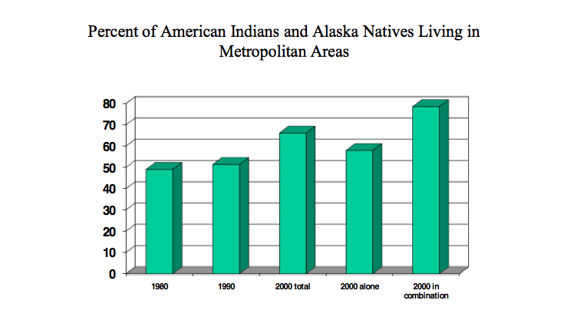
Source of graphic: (Data Symposium, Summary, p. 14)

Is this a trend that’s well-reported? What are some of the policy implications?

